Zambia National Transport Logistics Masterplan
April 2025

Table of Contents
Acronyms and Abbreviations 8
Executive Summary i
1. Background and Introduction 1
1.1 The Importance of a Transport Logistics Masterplan to Zambia 2
1.2 Socio-Economic Outlook 4
2. Zambia’s Trade Profile 6
3. Policy Environment 8
3.1 Trade Policy 8
3.1.1 Tariffs 8
3.2 Trade Agreements 9
3.2.1 World Trade Organisation 9
3.2.2 African Continental Free Trade Agreement 9
3.2.3 COMESA 10
3.2.4 SADC 10
3.2.5 Generalised System of Preferences 11
3.3 Transport Policy 13
4. Trade Facilitation and Logistics Legislation 15
4.1 Border Management and Trade Facilitation Act, 2018 15
4.2 Customs and Excise (Amendment) Act, 2018 15
4.3 Zambia Chartered Institute of Logistics and Transport Act, 2014 15
4.4 Standards Act (Act No. 4, 2017) 16
4.5 Other Indirectly Relevant Acts 16
5. Investment Environment 17
5.1 ZDA and Investment Incentives 17
5.2 PPP Regulatory Environment 18
5.3 Multi-Facility Economic Zones 19
6. Stakeholders in Transport and Trade Logistics 21
6.1 Government Departments, Agencies and SOEs 21
6.1.1 National Trade Facilitation Committee (NTFC) 21
6.1.2 Ministry of Transport and Logistics 21
6.1.3 Ministry of Commerce, Trade and Industry 22
6.1.4 Ministry of Infrastructure, Housing and Urban Development 23
6.1.5 Industrial Development Corporation (IDC) 23
6.1.6 SMART Zambia Institute 24
6.2 Private Sector Organisations 24
6.2.1 Zambia Chamber of Commerce and Industry (ZACCI) 24
6.2.2 Zambia Association of Manufacturers (ZAM) 25
6.2.3 Zambia Chamber of Mines 25
6.2.4 Customs Clearing Agents and Freight Forwarder Associations 25
6.2.5 Truckers Association of Zambia (TAZ) 25
7. Transport Infrastructure and Management 26
7.1 Road and Road Transport 26
7.1.1 Road Sector Management 26
7.1.2 Core Road Network Classification 27
7.1.3 Road Sector Funding and Expenditure 29
7.2 Railway Transport 29
7.2.1 Zambia Railways Limited (ZRL) 29
7.2.2 Tanzania-Zambia Railway (TAZARA) 33
7.3 Air Transport 35
7.3.1 Air Transport Infrastructure 35
7.3.2 Air Transport Strategy 35
7.4 Water Transport 35
7.5 Tanzania-Zambia Mafuta (TAZAMA) Pipeline 37
8. Logistics of Agriculture and Agro-Processing 38
8.1 National Agricultural Policy 2012-2030 38
8.2 Agricultural Production, Area Planted, and Fertiliser Use 38
8.2.1 Fertiliser 38
8.2.2 Wheat Production 39
8.2.3 Soya Bean Production 40
8.2.4 Maize Production 41
8.3 Perishable Products Value Chain 43
8.4 Farm Blocks 44
8.5 Farmer Input Support Programme (FISP) 46
9. Metal Mining and Processing 48
9.1 Mining Policy, Laws and Regulations 48
9.2 Copper, Cobalt and Gold 48
9.3 Nickel, Zinc, Lead and Manganese 52
10. Regional Transport Corridor Infrastructure 54
10.1 Corridor Ports, Roads, Railways, and Dry Ports 56
10.2 Zambia’s Border Posts 62
10.3 Air Transport Corridors/Routes 76
11. Zambia Trade Flow Model 77
12. Masterplan Hard Infrastructure Projects 89
12.1 Project Identification 89
12.2 Project Preparation 89
12.3 Roads 91
12.4 Railways 93
12.4.1 Zambia Railways Limited (ZRL) 93
12.4.2 TAZARA Concession (CCECC) 94
12.4.3 Lobito Corridor Railway Project 95
12.4.4 Track Expansion to Kazungula and Sesheke 97
12.5 Inland Waterways - Mpulungu Harbour 97
12.6 Logistics Hubs 98
12.7 Aviation 98
12.8 Warehouses and Silos 99
13. Masterplan Soft Infrastructure Issues 105
13.1 Coordination of Logistics Related Policies and Regulations 105
13.1.1 Public Private Partnerships 105
13.1.2 Railway Policies and Regulation 107
13.1.3 Mining and Minerals Policies and Regulation 110
14. Recommendations 114
Recommendation 1: Lead the Process of Operationalising a Corridor Management Institution 114
Recommendation 2: Design and Implement a Cross-Border Trade Facilitation Programme 116
Recommendation 3: Review the Road Sector PPP Financing Model 118
Recommendation 4: Implement a Vertical Separation Model in the Railway Sector and Recapitalise the Rail Sector 119
Recommendation 5: Modernise Mpulungu Harbour 120
Recommendation 6: Restructure the Air Freight Business for Perishable Products 121
Recommendation 7: Construct Dry Ports and MFEZs at Strategic Locations 122
References: 124
Websites and Portals: 128

Figures
Figure | Title | Page
1.1 | Zambia population Density | 1
2.1 | Zambia Exports 2022 (USD14.8B) | 6
2.2 | Zambia Imports 2022 (USD10.2B) | 6
2.3 | Export Destinations 2022 (USD14.8B) | 6
2.4 | Import Origins 2022 (USD10.2B) | 7
3.1 | United States Trade in Goods with Zambia since 2000 | 12
7.1 | Governance Structure of Zambian Road Sector | 26
7.2 | Core Road Network Categories in Zambia | 28
7.3 | ZRL Track Condition Summary | 31
7.4 | Route Map of TAZARA | 33
7.5 | TAZARA and Calabash Freight | 34
7.6 | Cargo Throughput at Mpulungu Harbour by Year and Cargo | 36
8.1 | Map of Wheat Production in Zambia (2023-24) | 39
8.2 | Map of Soya Production in Zambia (2023-24) | 40
8.3 | Map of Maize Production in Zambia (2023-24) | 42
8.4 | Farm Block locations in Zambia | 45
10.1 | Map of the Transport, Trade and Transit Corridors linking Zambia to the World. | 54
11.1 | Regional Africa Freight Model traffic Zones | 78
12.1 | Project Preparation and Percentage of Total Project Costs | 90
12.2 | Guiding Steps for Unsolicited Proposals | 91
12.3 | Overall PPP Portfolio and Corridors Proposed under RoadSIP III | 92
12.4 | Map of Lobito Corridor | 95
12.5 | Map of Zambia Lobito Railway showing the route and Zambian Copper Mines | 96
14.1 | Investment Risk of Various Railway Investments | 118

Tables
Table | Title | Page
3.1 | MFN and Preferential Tariff Rates | 8
3.2 | Zambia’s 2023 Preference Utilisation Rate by HS Section under the COMESA FTA | 10
3.3 | Zambia’s 2023 Preference Utilisation Rate by HS Code under the SADC FTA | 11
7.1 | Performance Metrics for ZRL 2020-2023 | 30
8.1 | Fertiliser use by year | 38
8.2 | Wheat production and area planted | 40
8.3 | Soybean production and area planted | 41
8.4 | Maize production and area planted | 41
9.1 | Mopani Copper and Cobalt Mines | 48
9.2 | Konkola Copper and Cobalt Mines | 49
9.3 | Chibuluma Copper Mine | 49
9.4 | Luanshya Copper Mine – Baluba Mine | 49
9.5 | Kalumbila Copper Mine | 49
9.6 | Kansanshi Copper and Gold Mine | 50
9.7 | Lumwana Copper mine | 50
9.8 | Chambishi Copper Mine | 50
9.9 | Chambishi Copper Smelter | 50
9.10 | Chambishi Metals | 51
9.11 | Chambishi Southeast Project | 51
9.12 | Mwambashi Copper Mine | 51
9.13 | Lubambe Copper and Cobalt Mine | 51
9.14 | Other Copper, Cobalt and Gold Mines and Processing Plants | 52
9.15 | Nickel, Zinc and Lead Mines and Processing Plants | 52
10.1 | Corridor Ports, Roads, Railways and Dry Ports | 56
11.1 | Zambia International Cargo (2025 and 2050) | 79
11.2 | DR Congo International Transit Trade via Zambia (2025 and 2050) | 81
11.3 | Zambia Domestic Trade by Corridor (2025 and 2050) | 82
11.4 | Zambia Domestic Trade by Broad Traffic Zone (2025 and 2050) | 83
11.5 | International and Regional DRC Transit and Domestic Trade (2020 and 2050) | 85
11.6 | Preliminary Modal Split Estimate (2025 and 2050) | 86
11.7 | Preliminary Rail Split Estimate (2025 and 2050) | 89
12.1 | GRZ CRN-PPP Targets vs Viability | 93
12.2 | Viable PPP projects | 93
12.3 | Summary of Transport and Logistics Infrastructure Projects | 100
13.1 | Fees charged at Beitbridge border (Zimbabwe) for Crossing the Border | 105

Acronyms and Abbreviations
8NDP | Eighth National Development Plan
AFC | Africa Finance Corporation
AfCFTA | Africa Continental Free trade Area
AfDB | African Development Bank
AGL | Africa Global Logistics
AGOA | Africa Growth and Opportunity Act
AIPH | Adani International Ports Holdings
ARSO | African Regional Standards Organisation
ASTA | Agri-food Systems Transformation Accelerator
BEV | Battery and Electric Vehicle Initiative
BBR | Beit Bridge Railway
BBRA | Business Regulatory Review Agency
CASP | Comprehensive Agricultural Support Programme
CAA | Civil aviation authority
CCECC | China Civil Engineering Construction Corporation
COMESA | Common Market for Eastern and Southern Africa
CRN | Core Road Network
CTMS | Corridor Trip Monitoring System
D-compound | Basal dressing that improves soil health. Biodiversity and water retention.
DAP | Diammonium phosphate(fertiliser)
DCT | Durban Container Terminal
DFC | Development Finance Corporation
DMMU | Disaster Management and Mitigation Unit
DP World | Dubai Ports World
DR Congo | Democratic Republic of the Congo
EA-SA | East and Southern African Region
EAC | East African Community
EBA | Everything-But-Arms
EPA | Economic Partnership Agreement
EU | European Union
FAO | Food and Agricultural Organisation
FBDP | Farm Block Development Programme
FISP | Farmer Import support Programme
FCFASA | Federation of Clearing and Forwarding Associations of Southern Africa
FQM | First Quantum Minerals
FSP | Fertiliser Support Programme
FTA | Free Trade Agreement
GDP | Gross Domestic Product
GATT | General Agreement on Tariffs and Trade
GRZ | Government of the Republic of Zambia
GSP | Generalised System of Preferences
Ha | Hectares
HS | Harmonised System
ICAO | International Civil Aviation Organisation
ICT | Information and Communication Technology
IDC | Industrial Development Corporation
LAR | Lobito Atlantic Railway
LDC | Least Developed Country
LGAs | Local Government Authorities
MCTI | Ministry of Commerce, Trade and Industry
MFEZ | Multi-Facility Economic Zone
MFN | Most Favoured Nation
MHCL | Mpulungu Harbour Corporation Limited
MMD | Movement for Multiparty Democracy
MoLGRD | Ministry of Local Government and Rural Development
MOTL | Ministry of Transport and Logistics
MMDA | Mines and Minerals Development Act,
MSC | Mediterranean Shipping Company
MT | metric tonnes
MVAF | Motor Vehicle Accident Fund
NCC | National Council for Construction
NCZ | Nitrogen Chemicals of Zambia’s
NMC battery | nickel, manganese and cobalt battery
NPK | nitrogen, phosphorus, and potassium (fertiliser)
NQI | National Quality Infrastructure
NRFA | National Road Fund Agency
NRZ | National Railways of Zimbabwe
NTFC | National Trade facilitation Committee
OEC | Observatory of Economic Complexity
OEM | Original Equipment Manufacturer
OSBP | One Stop Border Post
PACRA | Patents and Companies Registration Agency
PFR | Primary Feeder Roads
PGI | Partnership for Global Infrastructure and Investment
PPP | Public Private Partnership
PTA | Public Transport Agency
RDA | Roads Development Agency
RMI | Road Maintenance Initiative
RSZ | Railway Systems of Zambia
RTSA | Road Transport and Safety Agency
RUCs | Road User Charges
SADC | Southern Africa Development Community
SARPs | Standards and Recommended Practices
SI | Statutory Instrument
SOEs | State Owned Enterprises
SPV | Special Purpose Vehicle
sq.km. | square kilometres
TAZ | Truckers Association of Zambia
TAZAMA | Tanzania Zambia Mafuta Pipeline
TAZARA | Tanzania Zambia Railway
TEU | Twenty-foot Equivalent Unit (container)
TFA | Trade Facilitation Agreement
TFR | Trans-Freight Railway
TICTS | Tanzania International Container Terminal Services Limited
TMD | Trunk, Main and District (Roads)
TRIPS | Transport Registers and Information Platform
TTTFP | Tripartite Transport and Transit Facilitation Programme
UA | Unit of Account
UFC | United Capital Fertiliser Company Limited
UN | United Nations
UNCTAD | United Nations Conference on Trade and Development
UNECA | United Nations Economic Commission for Africa
INIDO | United Nations Industrial Development Organisation
UN-OHRLLS | United Nations Office of the High Representative for the Least Developed Countries, Landlocked Developing Countries and Small Island Developing States
USD | US Dollar
WBNLDC | Walvis Bay-Ndola-Lubumbashi Development Corridor
VLMIS | Vehicle Load Information Management System
WTO | World Trade Organisation
ZACCI | Zambia Chamber of Commerce and Industry
ZACL | Zambia Airports Corporation Limited
ZAM | Zambian Association of Manufacturers (
ZamCargo | Zambia Cargo and Logistics Limited
ZBS | Zambia Bureau of Standards
ZCCM | Zambia Consolidated Copper Mining
ZCILT | Zambia Chartered Institute for Logistics and Transport
ZCM | Zambia Chamber of Mines
ZCSA | Zambia Compulsory Standards Agency
ZDA | Zambia development Agency
ZESCO | Zambia Electricity Supply Corporation
ZIAMIS | Zambia Integrated Agricultural Management Information System
ZipBCC | Zambian (IP) Border Crossing Company
ZLR | Zambia Lobito Corridor
ZNFU | Zambia National Farmers Union
ZRL | Zambia Railways limited

Executive Summary
Zambia is a country of great, but mostly unrealised, potential, especially in the mining, agricultural and renewable energy sectors.
Zambia is, however, a net importer of staple foods such as chicken, fish, and vegetable oil, despite its inherent capacity to be a regional production hub for these commodities. Additionally, consumers pay food prices which are significantly higher than international levels.
Some of the possible reasons for this current inability to realise Zambia’s production potential could be the high cost of logistics (including transport) which makes imported inputs prohibitively expensive which means that, for example, many farmers cannot afford to buy imported agricultural inputs, such as fertiliser, pesticides and herbicides, or farm equipment needed to mechanise, or irrigation equipment needed to get at least double cropping or as an insurance in drought years.
Zambia’s Vision 2030 foresees equitable economic growth as being the key to lifting millions of Zambians out of poverty and for this economic growth to be based on an industrialisation programme.
Industrialisation in a global economy requires firms and producers to integrate into regional and global value chains. In Zambia this means businesses import raw materials or intermediate products and add value through further processing, before distribution.
In an inter-connected world, minimising trade restrictions is crucial. To achieve Zambia’s vision of becoming a middle-income country, it is essential to establish an efficient cross-border trade and transport logistics system well before 2030.
Zambia is a part of six or seven, depending on how they are defined, regional road, rail and multimodal transport, trade and transit corridors.
In terms of traffic volumes and value of cargo, the North-South Corridor, a road and rail corridor, is the most important corridor, although most freight on the North-South Corridor is transported by road rather than rail.
The Dar es Salam Corridor, including the Tanzania-Zambia Railway (TAZARA), is also an important corridor and, with the recently signed MoU with China Civil Engineering Construction Company (CCECC) paving the way for a public-private partnership to be signed between the governments of Zambia and Tanzania and CCECC, and with recent concessioning of components of Dar es Salaam port, the Dar es Salaam Corridor and the Tanzania-Zambia Railway (TAZARA) is becoming more prominent in terms of freight carried. The road corridor has been an important corridor for many years, especially for freight going to DR Congo from Dar es Salaam port and Tanzania, with most of this cargo passing through Kasumbalesa. The Dar Corridor is also an important route for exports of copper in particular but also manganese. Zambia uses this corridor to predominantly import fuel, fertiliser and containerised cargo.
The port of Mpulungu is also an important component on the logistics network. However, Mpulungu port is not utilised as much as it could be to service the markets in the south-east of DR Congo and the Great Lakes region because of, mainly, port infrastructure challenges.
There is considerable interest being shown in the development of the Lobito Corridor, especially in the existing railway lines that run between the port of Lobito and the border of DR Congo in Angola and the line that connects the DR Congo Copperbelt to the border with Angola and runs onto Lobito port. Some interest has been shown in developing a greenfield railway that connects the Zambian Copperbelt, from Chingola, through Solwezi, across the border with Angola and joining the existing railway line to Lobito but, although this is an important strategic corridor for Zambia, it has yet to prove that it can be at least economically viable.
The Walvis Bay Corridor, which is a road corridor, is also an important corridor for DR Congo and Zambia, mainly used for imports of project cargo for the mines and as an export route for copper.
The Beira Corridor is an important link for Zambia to the Indian Ocean and which is used to import mainly fertiliser and fuel.
Another corridor servicing Zambia is the Nacala Corridor but, in terms of cargo volumes and values, this is of lesser importance than the corridors mentioned above.
A zero-draft of a detailed freight demand model has been compiled, with the underlying data being drawn from the detailed Regional African Freight Model (RAFM) developed by the Wits Innovation Centre, in South Africa in 2021. In summary, the model presents trade flows by cargo type to/from traffic zones by regional corridor for the benchmark years of 2019 (base year), 2025 (projection) and 2050 (projection)
The main conclusions from the model, which are very much dependent on the data used, are as follows:
- In 2025 it is expected that Walvis Bay will account for 30 per cent of Zambia’s international trade, Beira 28.5 per cent, Dar es Salaam 23.3 per cent and the North South Corridor 18.3 per cent. Exports will account for 56.6 per cent of Zambia’s international trade, while imports will account for 47.7 per cent of Zambia’s international trade.
- In 2050 it is expected that Walvis Bay will account for only 23.3 per cent of Zambia’s international trade, Beira will account for the highest percentage, at 30.1 per cent, Dar es Salaam will grow to 29 per cent and the North South Corridor will drop to 17.6 per cent. Exports will account for 45.8 per cent of Zambia’s international trade, while imports will grow to account for 54.2 per cent of Zambia’s international trade.
- In 2025, the dominant corridor to be used for International, Regional, DR Congo Transit and Domestic trade (so all road and rail trade moving through Zambia) is the North-South (57.3 per cent) followed by Dar es Salaam (22 per cent), Other (13 per cent), Beira (4 per cent) and Walvis Bay (3.7 per cent). This will stay more or less the same, with the dominant corridor being North-South (51.8 per cent), followed by Dar es Salaam (22.3 per cent), Other (12.8 per cent), Beira (7.5 per cent) and Walvis Bay (5.5 per cent) in 2050.
- Overall growth rises from 50.3 million tonnes (mt) in 2025 to 84mt in 2050, an overall growth of 33.7mt, with the largest growth estimated to be on the North-South Corridor (14.6mt), followed by Dar es Salaam (7.7mt), Beira (4.3mt), Other (4.2mt) and Walvis Bay (2.8mt).
There are projections on mode of transport, but these projections not based on current infrastructure and other interventions taking place in the road and rail sector in particular.
In preparing the Transport Logistics Masterplan, projects have been identified from different sources, including the Eighth National Development Plan; Draft Transport Infrastructure Masterplan; Zambia Railways Limited 2025-2040 Strategic Plan; RoadSIP III; and Mpulungu Harbour Corporation Limited Strategic Plan.
In the road sector the main infrastructure investments taking place are public-private partnerships (PPPs) such as the dualization of the Lusaka-Ndola Road; the Chingola-Mutanda Road, via Solwezi
There are also many road PPPs that have been concessioned through unsolicited bids, which is the main way PPPs are being awarded, which have not proved themselves to be financially viable with current and projected traffic flows and so have not reached financial closure, meaning that, although the concession has been awarded, work on improving infrastructure has yet to start. There are also road concessions that have been awarded but which have not raised sufficient capital for the whole project but, because the concession has been awarded, the concessionaire is receiving toll revenue, and this recurrent expenditure is being used to improve infrastructure rather than capital raised prior to the concession being awarded. In addition, the tolls have invariably been raised, sometimes by 600 per cent, so costs of using the roads, and costs of transport per ton kilometre, are increasing even before the infrastructure has been improved.
Border posts, such as Chirundu Border Post, Chingola-Kasumbalesa Road and Border have also been concessioned, the rationale being that the public sector does not have sufficient resources to develop the border posts into modern, fit-for-purpose, border posts. The challenges with concessioning border posts is that infrastructure works that are proposed by the concessionaire are not always required to make the border post efficient. The functions of border agencies, such as Customs, Immigration, Port Health, Police, State Security, etc. cannot, by law, be concessioned to the private sector, so all that a private sector concessionaire can supply are facilities such as buildings and parking facilities. However, the most efficient border crossing procedures, whether this is importing (so final clearance), exporting or goods in transit, are those done “behind -the-border” which ensures all checks and clearance procedures are done before the goods and the vehicle carrying the goods are not stopped at the border and, if they are stopped, it is only for a cursory check on the driver and the vehicle, which should take minutes. On the other hand, it is in the interests of the concessionaire to delay a truck and driver so that that concessionaire can change for the use of the buildings and parking facilities that have been built. Achieving a no-stop border is aspirational for border agencies such as Customs but they are working towards this with digitisation of procedures and joining up systems through an electronic single window. It is difficult to see how the current approach to concessioning will assist border agencies to make the transiting, importing or exporting processes more efficient.
Combined border post and road concessions awarded include the Kasomeno-Mwenda Road, Bridge and One Stop Border Post; Lumwana-Kambimba Road and Border Post; Katete-Chanida Road and Chanida Border; and the Ndola-Sakania Road and Border and Ndola-Mufulira Road. There are more combined border post and road concessions expected. The danger is that the overall effect of these concessions may well increase the costs of crossing the border without providing any time-saving benefits, so lower the efficiency of firms in Zambia on regional and international markets producer and lower the efficiency of Zambia as a transit hub.
The railway sector is undergoing reform and the current process of implementing transport and logistics projects in this sector is rapidly changing the efficiency of the sector, such that rail transport is projected to capture a significantly larger share of the freight movement market, which has many environmental and efficiency benefits. The main reform taking place in the rail transport sector is the push, at the policy level, to achieve a vertical separation of track ownership, rehabilitation and maintenance from train operations (or provision of services). The is allowing Zambia Railways Limited (ZRL) and the Industrial Development Corporation (IDC), ZRL’s shareholder, to structure a financing option, supported by grant financing, that allows ZRL to secure a loan to initially rehabilitate the track so that all temporary speed restrictions (TSRs) are removed. This is a pre-condition for any efficient service provision, irrespective of whether it is a private sector train operator or ZRL providing the rail freight service. Once the track is rehabilitated to a condition that allows freight trains to move at an average speed of about 50km/hr along the entire mainline network, and once the inter-mine rail track is rehabilitated, private sector train operators can be licensed to provide a freight rail service and the income generated from track access fees, which will be payable to ZRL as the track owners, will service the loans taken out to rehabilitate the track. As use of the railway to move freight, which will target new opportunities as well as moving freight off the road, revenue from access fees will increase. This will allow ZRL to further improve the mainline track as well as support financing of planned new lines, with the focus being on adding new lines that are economically viable rather than those which have a strategic importance only.
Another major development in the rail sector is the concessioning of the Tanzania-Zambia Railway (TAZARA) to China Civil Engineering Construction Corporation (CCECC), who have announced that they intend to invest about USD1 billion in rehabilitation of the entire track between Dar es Salaam and Kapiri Mposhi and to invest about USD400,000 in new locomotives and rolling stock. One of the conditions of the concession awarded to CCECC is that CCECC must allow open access, which will ensure that the railway line is utilised in the most efficient way possible, with private sector operators, such as Calabash Freight, who already provide a freight rail service on the TAZARA line, are able to offer freight rail services alongside TAZARA.
As part of the United States’ and European Union’s desire to secure access to critical minerals in the southern and central Africa region, in particular DR Congo and Zambia, feasibility studies and environmental and social impact assessment studies have been carried out on a greenfield investment in a railway track between Chingola in Zambia and Luacano in Angola. This proposed railway line would link Chingola and Solwezi and then extend westwards from Solwezi and cross the border between Zambia and Angola somewhere south of Jimbe and join the existing railway line linking the port of Lobito to the Congolese border at Dilolo at Luacano. The railway line it will join at Luacano is concessioned to the Lobito Atlantic Railway company, a Trafigura-Mota Engil-Vecturis consortium. The feasibility studies show that this greenfield investment is neither economically nor financially feasible, although the railway line remains an important strategic investment for Zambia and possibly for the United States and the European Union.
Zambia has one inland port, which is Mpulungu Harbour, wholly owned by industrial Development Company. It has traditionally been used as a port for where sugar, cement, clinker and coal has been exported to Bujumbura port in Burundi. Fuel was also shipped to Bujumbura when the port was concessioned to a private sector company. However, the volume of cargo being shipped through Mpulungu has been relatively small for many years and usually well below 200,000 tons per annum. The equipment and infrastructure available to the port is inadequate for Mpulungu to provide an efficient service to its customers and demand for its services and ships calls continue to decline. This is exacerbated by the fact that there have been major investments cement and clinker production in DR Congo that are more easily able to supply eastern DR Congo markets and the Great Lakes region, and the economic challenges being faced by Burundi. These low volumes of cargo passing through Mpulungu means that there is no possibility of using the company’s balance sheet to finance purchase of new equipment or investing in much needed infrastructure such as new piers. Despite this, there is an emerging important freight logistics role for Mpulungu Harbour to play which involves linking eastern DR Congo, via a multi-modal transport and logistics solution to the port of Dar es Salaam via the soon-to-be revamped TAZARA mainline. This will allow the opening up of Northern Province to the markets of DR Congo as well as providing an alternative supply route for fast moving consumer goods, mining supplies and fuel via Mpulungu and Kalemie ports. It will also allow an alternative route for miners to evacuate metals and lithium (primarily from the Manono project site just west of Kalemie) to Dar es Salaam primarily but also to other ports on Africa’s eastern seaboard. This supply route will also relieve the pressure off the main border crossing between DR Congo and Zambia at Kasumbalesa.
In the air transport sector Zambia is opening up more airports, both international airports such as the airports located in Lusaka, on the Copperbelt (between Ndola and Kitwe) and Livingstone and new domestic airports. However, the main focus of these new facilities is on catering for passengers rather than air freight. In the 1990s and early 2000s Zambia had markets for vegetables and cut flowers in Europe which were reliant on airfreight, both using passenger planes (with vegetables and cut flowers carried in the holds of passenger planes) and dedicated air freighters. However, a combination of factors, including the unavailability of affordable air freight, have decimated this market, so that Zambia now has only one producer of cut flowers exporting via air into Europe. The masterplan suggests that efforts should be made to upgrade the airfreight perishable logistics supply chain, and this could be done using a combined approach which examines policy and regulatory issues, infrastructural issues and strategic partnerships. For example, Zambia Airways is jointly owned by IDC (55 per cent) and Ethiopian Airways (45 per cent) and it may be possible to enter into a strategic partnership with Ethiopian Airways which benefits from the very large and efficient cool chain infrastructure at Bole International Airport and so gain access into the Ethiopian Airways network serviced from Bole International Airport.
The Tanzania Zambia Mafuta (TAZAMA) pipeline runs from Dar es Salaam port to Ndola in Zambia, a distance of about 1,710km. Zambia has switched from importing crude feedstock to refined imported petroleum products from Dar es Salaam, Mozambique, South Africa, and Namibia, which rendered the TAZAMA pipeline obsolete. However, in 2022, the pipeline was modified and upgraded to transport diesel fuel. Talks have started between Zambia and Tanzania to construct a new 12-inch diameter pipeline from Dar es Salaam to a point in Zambia at an estimated cost of USD2.5 billion. This is in the concept stage still.
There are a few dry ports being constructed, such as the dry ports at Chipata and Kapiri Mposhi, but there does need to be a plan made to strategically locate dry ports. For example, if there is a change in mode of transport a dry port would be a useful facility. If the multi-modal transport link between Dar es Salaam and DR Congo is to be made efficient there would need to be dry ports at Kasama (assuming the planned railway line from Nseluka to Mpulungu is not constructed) and Mpulungu (at least until the planned MFEZ was operational, which would include a dry port facility). There would need to be dray ports in other locations along the supply line, but these would not be in Zambia.
In addition to hard infrastructure projects in the road, rail, inland waterways, logistics hubs, aviation and warehousing and silos sectors there is also a need to address soft issues such as policy coherence and coordination, regulatory issues and trade facilitation issues. The main soft infrastructure projects identified include:
- Coordination of Logistics Related Policies and Regulations especially as they relate to PPPs in the Roads and Border Posts Sectors
- Coordination of Railway Policies and Regulations
- Coordination of Mining and Minerals Policies and Regulation
The main recommendations made are as follows:
Recommendation 1: Zambia needs to be pro-active in addressing its freight transport logistics challenges and one way in which this could be done is to establish a Corridors Sub-Committee within the National Trade Facilitation Committee (NTFC) to ensure that Zambia’s main trade, transit and transport corridors will be addressed in a multi-sectoral way. The work of the Corridors Sub-Committee would include:
- Carrying out a detailed assessment of what corridor logistics initiatives, in all modes of transport, are taking place in neighbouring counties, including Angola, Botswana, DR Congo, Malawi, Mozambique, Tanzania, Zimbabwe and South Africa and what possible impact this may have on the Zambian freight logistics industry.
- Carrying out a detailed SWOT analysis involving all relevant stakeholders on Zambia’s main corridors to the sea and make recommendations on how Zambia’s strengths be leveraged, how to mitigate identified weaknesses, what the main opportunities are and how they can be taken advantage of and how threats can be mitigated. This SWOT analysis should be complemented with a PESTEL analysis that will examine, in detail, specific types of issues that impact on implementation of projects and identify the political, economic, social, technological, environmental and legal factors and identifying trends.
- Construct a freight projection model, using data compiled from Zambian sources such as cross-border data from Zambia Revenue Authority, data collected at toll booths and data collected at weigh bridges, that addresses multiple scenarios that are highlighted from the SWOT and PESTEL analysis.
- On the basis of the freight projection model, prioritise investments in transport modes and trade and transport facilitation issues.
- Work with regional like-minded states to establish a regional Corridor Management Institution (CMI) which would need to be a rules-based institution rather than the normal African CMIs which are based on “best effort”, meaning that there are no penalties or sanctions applied to parties who do not implement agreed policies, regulations and programmes. The regional Corridor Management Institution would need to have supra-national authority so that it has the power to ensure that what regional policies and agreements are in place are actually implemented and if they are not implemented then the Corridor Management Institution needs to have the power and authority to impose sanctions on institutions that are not complying with agreed policies and agreements.
Recommendation 2: Implementation of the Transport Logistics Masterplan should include a project to design and implement a system that allows all goods at the border to pre-clear, whether these goods are exports, imports or goods in transit. In addition, there is need to engage Transport and Transit Corridor Countries to devise a system where all border posts along all Transport and Transit Corridors should implement pre-clearance systems for all cargo and, as envisioned in Article 12 of the Trade Facilitation Agreement and share data between Customs in different countries.
Recommendation 3: Carry out a study to:
- Clarify how the current PPP model will apply to the remaining 44 roads that are either not viable as PPPs or which require Viability Gap Funding.
- Review the Ministry of Finance and National Planning’s Dismantling of Domestic Arrears Strategy of 2024-2029 to ensure that the debt dismantling programme is sufficient to clear historic debts over six years and that it takes account of “pipeline” debt which is not yet showing up as a NRFA creditor. The reason for this study is to ensure that the roads debt balance does not exponentially increase because of higher than projected interest rates and because of lower income into the National Road Fund because the most profitable roads have been concessioned as PPPs and the State is left to pay for the unprofitable roads.
Recommendation 4: for the Rail Sector
- Base economic and financial assessments of railway projects on accurate demand studies to make sure that the projects are at least economically viable if not financially viable. If non-viable railways are promoted as strategic railway corridors this will have a detrimental effect on the viable railways in that it will divert resources and attention away from the financially and economically viable railway infrastructure investments and viable railway operations. In the same way, priority should be given to existing railways, especially track maintenance, to ensure the nation maximises its return on investment. Prioritising greenfield projects delays the rehabilitation of existing assets.
- Operate the nation’s railways as vertically separated, public infrastructure and private operator systems.
- Find innovative funding solutions. Zambia cannot provide sovereign guarantees and cannot increase the level of public sector debt. Nor is ZRL or TAZARA considered to be credit worthy by private sector financiers or by DFIs. Under these circumstances Zambia has few options other than use a PPP model to invest in the track.
- Update and renegotiate interchange agreements with neighbouring rail operators.
- Pilot Block Trains: One possible solution to have trains running from origin to destination could be to promote a “block train” solution. A block train is defined as an end-to-end (terminal to terminal), scheduled (regular service), standardised (20ft containers), seamless (in-bond), non-stop (stopping only for normal operational requirements like refuelling) operation along an entire Corridor and across borders.
Recommendation 6: Secure financing to significantly revamp Mpulungu Harbour’s infrastructure, including new piers, warehouses, office building and workshop, container depot and a level working surface throughout the port and a MFEZ within the port. This could be done in phases, as could the purchase of fit-for-purpose equipment such as forklifts, tractors and trailers, reach stackers and mobile cranes for the port to become fully mechanised and automated and a modern port. Mpulungu Harbour Corporation Limited (MHCL), through its holding company, IDC, should explore find innovative ways to raise the necessary funds to modernise the port so that it can take advantage of the new transport and logistics opportunities now available in DR Congo.
Recommendation 7: Restructure the Air Freight Business for Perishable Products by:
- Improving the facilities at Kenneth Kaunda International Airport and other relevant airports to support efficient handling of perishable goods, including better cold storage facilities and more efficient cargo handling systems. Also develop Strategic Partnerships by collaborating and building partnerships with airlines to secure better rates and more frequent flights and work with experienced freight forwarders who specialise in perishable products to ensure efficient logistics and handling.
- Carry out an in-depth study on how to optimise the cold chain and transport networks from origin to destination so that Zambia can take advantage of exports of perishable products to regional markets as well as emerging markets in the Middle East and elsewhere.

Background and Introduction
Zambia is a country of great, but mostly unrealised, potential, especially in the mining, agricultural and renewable energy sectors.
Zambia covers 750,000 square kilometres, usually has abundant water resources (both surface water and underground aquifers) and an estimated population of 23 million people although not evenly distributed. (Figure 1.1).
Figure 1.1: Zambia population Density
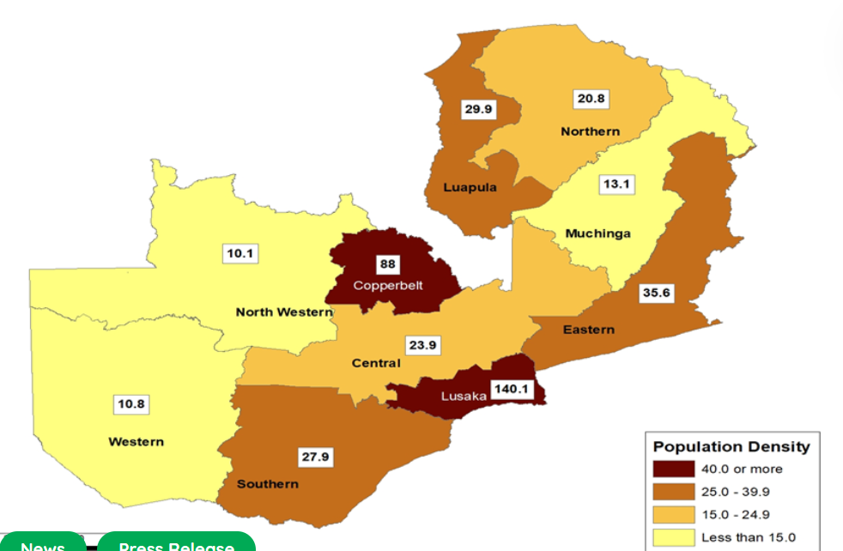
Source: Zamstat: https://www.zamstats.gov.zm/population-density-by-province-zambia-2022/
An estimated 420,000 sq.km of the 750,000 sq. km. is arable and, of this arable land, about 15 per cent is presently under cultivation, and less than 5 per cent is dedicated to crop production, the majority being allocated to livestock grazing. According to a report entitled “Building competitive agricultural markets for Zambia: Unlocking export potential”, if Zambia were to utilise just half of its currently fallow arable land, realise yields at half of their attainable levels and focus on poultry and fish farming, this would yield an additional USD32 billion in exports, providing low-priced fish and chicken for local markets and maize and vegetable oil as by-products. The additional combined food exports would be four times Zambia's copper exports.
Zambia is, however, a net importer of staple foods such as chicken, fish, and vegetable oil, despite its inherent capacity to be a regional production hub for these commodities. Additionally, consumers pay food prices which are significantly higher than international levels.
Some of the possible reasons for this current inability to realise Zambia’s production potential could be the high cost of logistics (including transport) which makes imported inputs prohibitively expensive which means that, for example, many farmers cannot afford to buy imported agricultural inputs, such as fertiliser, pesticides and herbicides, or farm equipment needed to mechanise, or irrigation equipment needed to get at least double cropping or as an insurance in drought years.

The Importance of a Transport Logistics Masterplan to Zambia
Zambian officials and politicians have often stated the need for Zambia to transform itself into a regional logistics hub. For example, at the Southern African Railway Associations conference and exhibition, the Minister of Transport and Logistics stated that “Our vision in the transport sector is to create an efficient and integrated intermodal transport system which will provide for interlinkages among four modern means of transport, namely rail, road, air and water and ultimately transform Zambia into a regional transport hub, taking advantage of Zambia’s geographical position in the region, Zambia is ready to play a pivotal role.”
Similarly, in a meeting with DP World in January 2024, the Minister responsible for Commerce Trade and Industry, Hon. Chipoka Mulenga, stated that the government had decided that Zambia should be a logistics hub.
Zambia’s Eighth Nation Development Plan (8NDP) for 2022-2026 notes that “Zambia aspires to become “A Prosperous Middle-Income Nation by 2030”. As such by 2030, Zambians look forward to living in a strong, dynamic, competitive and self-sustaining middle-income industrialised country, which is resilient to external shocks and provides opportunities for improving the wellbeing of all”.
Strategy 5 of the Eighth National Development Plan (8NDP) is to improve transport and logistics, with the focus being on positioning the country as a regional transport and logistics hub. This will be done through the maintenance, development, modernisation and integration of road, rail, air and water transport infrastructure. Infrastructure to support cross border trade in border areas will be put in place. Government will take deliberate steps to ensure that at least 30 percent of bulk cargo is moved off the roads to the railway line through improvements to rail infrastructure. With the interventions proposed in the 8NDP government expects that the transport and logistics sub-sector will register an annual average growth rate of 5.5 percent from an annual average of 0.6 percent over the 2011-2020 period. The transport and logistics programmes envisioned in the 8NDP are:
- Aviation development;
- Road development and maintenance;
- Rail development and maintenance;
- Inland water transport development and maintenance;
- Inland dry ports development;
- Trade centre development; and
- Warehousing development.
Zambia’s Vision 2030 foresees equitable economic growth as being the key to lifting millions of Zambians out of poverty and for this economic growth to be based on an industrialisation programme.
According to the Zambia Manufacturing Association’s 2024 Manufacturing Sector Profile, the Manufacturing Sector contributed 8.3 per cent to the country’s Gross Domestic Product (GDP) in 2023 against a GDP contribution target of 36.1 per cent by 2030 as envisioned in the Vision 2030.
Industrialisation in a global economy means that firms and other producers need to be part of regional and global value chains where firms or producers based in Zambia import raw materials or intermediate products and, through further processing, add value to the imported product. It is not necessarily the case that the output will be a finished product. For example, if a firm were to import the components of an electronic, or solid state, switch and manufactures and exports the electronic switch to a third country to be installed into a building’s climate control system, the manufacturer of the electronic switch imports component parts to manufacture a component of another system and, in the process, adds value.
Conversely, an OEM motor vehicle manufacturer will import component parts of a motor vehicle and will assemble, or manufacture a finished product, such as a vehicle, and possibly export that vehicle.
In such a joined-up world it is essential that there are as few restrictions to trade as possible. If a potential investor in a manufacturing plant in Zambia sees that he or she will need to contend with inefficient and unreliable, and so costly, cross-border supply chains, it is unlikely that such an investor will follow through with his or her investment and will take that investment to somewhere where there will be less challenges in the supply chain and so a better return on the investment.
It is, therefore, essential for the attainment of Zambia’s vision to be a middle-income country, and for the required economic growth to be based on agro-processing and industrial production, that it has an efficient cross-border trade and transport logistics system in play well before 2030.
According to UN-OHRLLS, compared with coastal countries, it costs landlocked countries double the amount and takes them almost twice as long to import or export goods. Thus, the high costs and long lead times incurred by landlocked countries reduce their competitive advantage in the international market.
The fact that Zambia is a land-locked country, with no seaport of its own, means that the efficiency of Zambia’s freight logistics is a function of the efficiencies of ports, railways, road transport systems, and border crossing systems in regional countries as well as the efficiency of Zambia’s freight consolidation and deconsolidation systems, border posts, railways, and road transport system in Zambia itself. Dry ports are also integral parts of the import–export chain, particularly in landlocked countries, and are defined as ports that are located inland where the temporary storage of cargo, inspection and customs clearance take place.
As most countries’ economic growth is dependent on trade, especially those countries that have small domestic markets and small levels of purchasing power, the economic wellbeing of these countries is dependent on how much they can produce and sell to people in other countries. To sell to people in other countries the products need to be competitive in quality and price. For this to happen, Zambia needs a well-developed and well-functioning transport and trade logistics system. This is not a “nice-to-have” feature but a feature that is essential to the economic growth of Zambia and the well-being of all Zambians.

Socio-Economic Outlook
In the short-term, according to the African Development Bank’s Zambia Economic Outlook the economy is projected to grow at 4.5 per cent in 2024 and 2025, as the mining, services, and manufacturing sectors continue to recover, and global copper prices rebound. Inflation is expected to decelerate from 9.3 per cent in 2024 to 7.0 per cent in 2025, driven by falling food and fuel prices. Fiscal deficits are projected to narrow to 5.2 per cent of GDP in 2024 and 3.4 per cent in 2025 in response to ongoing fiscal reforms.
Copper contributed disproportionately to GDP in 2022 (12.9 per cent) and to export revenues (70 per cent). The service sector contributed about 57 per cent of GDP, while industry contributed 33.8 per cent, with manufacturing contributing just 8.1 per cent. Construction, utilities, and industrial activities accounted for about 10.9 per cent of GDP. Agriculture’s contribution to GDP shrank from 9.3 per cent in 2012 to 3.3 per cent in 2022, even though the sector employs 24 per cent of the labour force (58.5 per cent men and 41.5 per cent women). Productivity is low, as evidenced by widening productivity gaps between sectors.
Structural transformation will require USD3.5 billion in annual financing, along with improvements in institutional quality and sustained policy reforms.
Zambia has an unstainable level of public debt which it is managing by agreeing a debt restructuring programme with private sector Eurobond holders (March 2024) and agreeing a restructuring deal with official bilateral creditors in 2023. Completion of negotiations with other commercial creditors will bring a final resolution to Zambia’s debt crisis.
According to the UN’s World population Dashboard, Zambia’s 2024 population is estimated at 21.1 million, with 42 per cent of the population being 14 years of age or less. The fertility rate per woman is about 4.1 and the population will double in size by 2050. According to mid-range population projections, at least 375,000 young people on average will enter the workforce each year to 2030. Between 2030 and 2050 this average number doubles to 747,000 jobs per year, just to keep the present-day rates of labour force participation and employment fixed.
Zambia will need to move toward more targeted sectoral and regional policies focusing on vulnerable population groups. To reach a large enough number of poor Zambians, a job rich and inclusive growth path will need to be designed around agro-value chains, and cross border export trade in these products. Zambia has abundant land resources, a very low population density, land borders with 8 neighbouring countries, and relatively close proximity from different regions to major commercial centres in Harare, Lilongwe and Lubumbashi, meaning that there are ready markets in the region for higher value agro produce.

Zambia’s Trade Profile
Figure 2.1: Zambia Exports 2022 (USD14.8B)
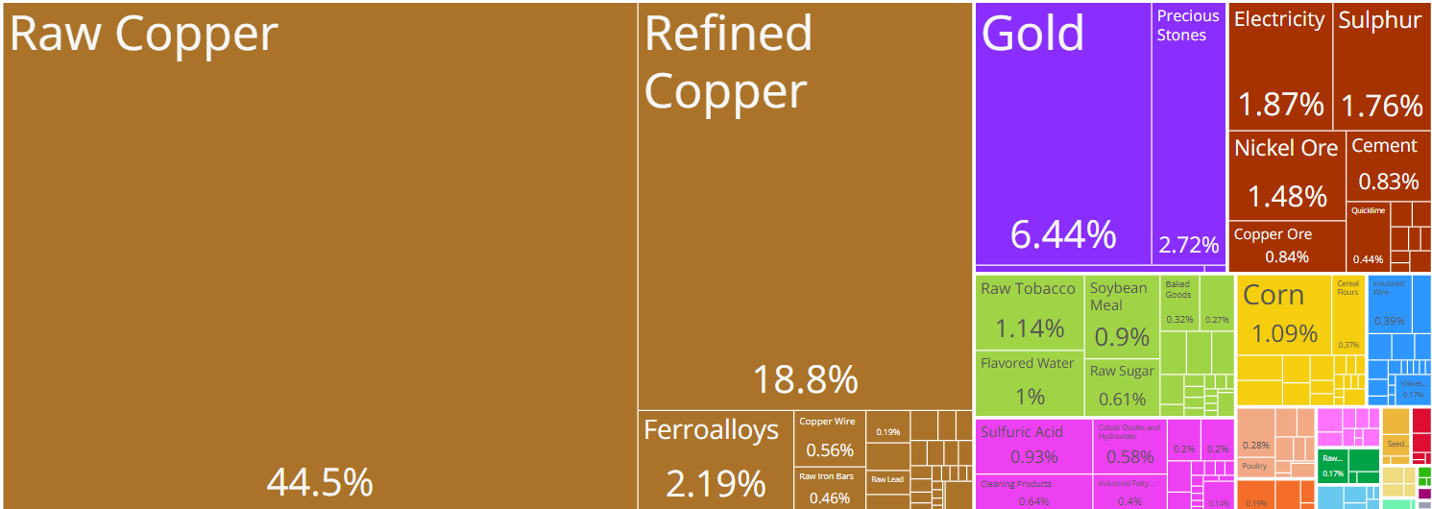
Source: https://oec.world/en/visualize/tree_map/hs92/export/zmb/all/show/2022

Figure 2.2: Zambia Imports 2022 (USD10.2B)
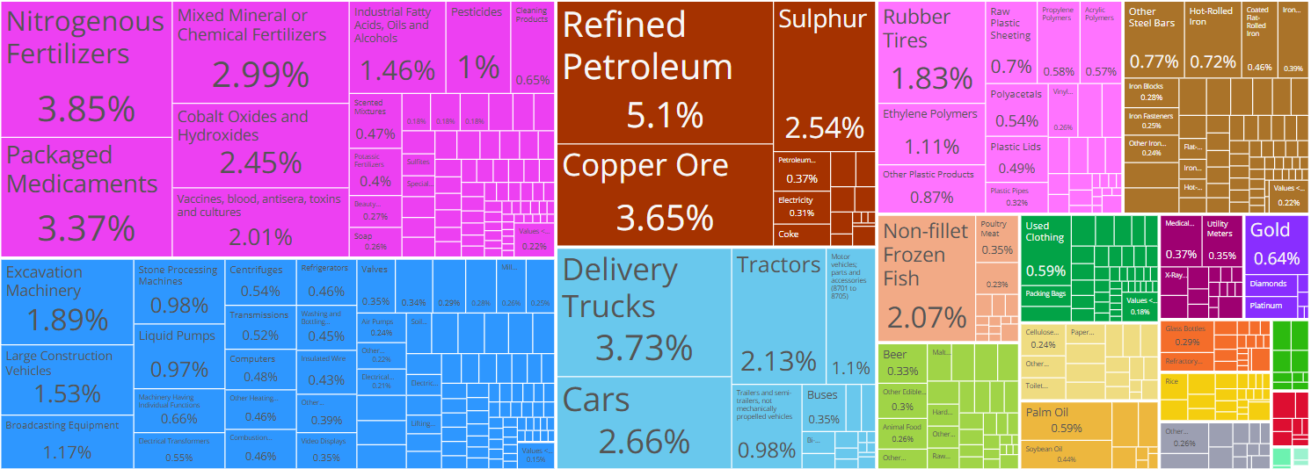
Source: https://oec.world/en/visualize/tree_map/hs92/import/zmb/all/show/2022

Figure 2.3: Export Destinations 2022 (USD14.8B)
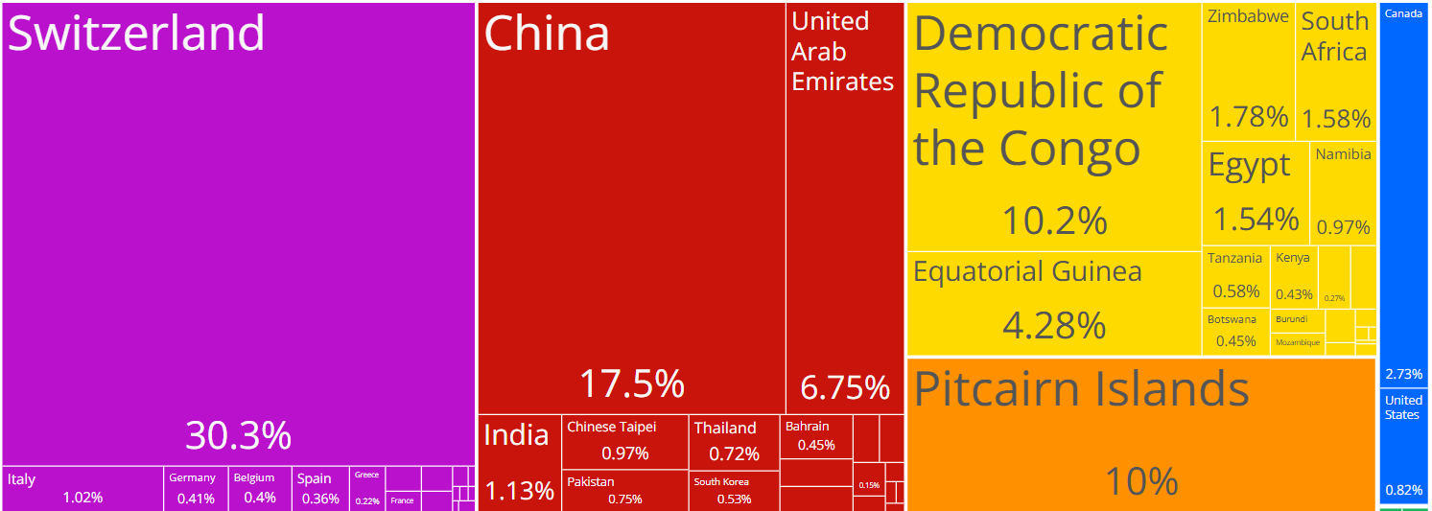
Source: https://oec.world/en/visualize/tree_map/hs92/export/zmb/show/all/2022

Figure 2.4: import Origins 2022 (USD10.2B)
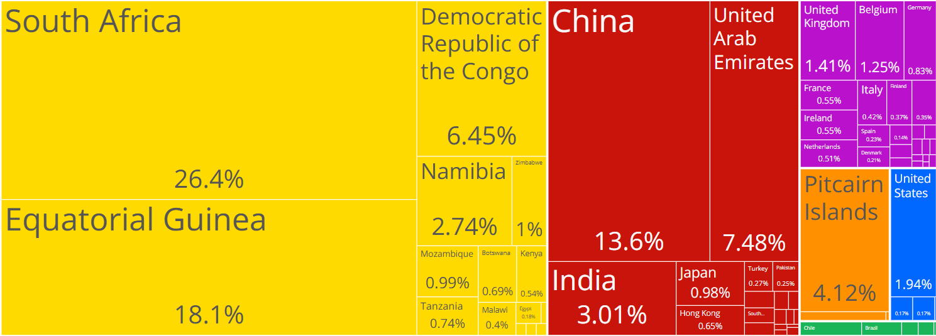
Source: https://oec.world/en/visualize/tree_map/hs92/import/zmb/show/all/2022

The Observatory of Economic Complexity (OEC) gives the main exports of Zambia, as at 2022, as raw copper (USD6.6B), refined copper (USD2.78B), gold USD955M), precious stones (USD403M), and Ferroalloys (USD325M), exporting mostly to Switzerland (USD4.5B), China (USD2.6B), Democratic Republic of the Congo (USD1.51B), Pitcairn Islands (USD1.49B), and United Arab Emirates (USD1B).
The top imports of Zambia are Refined Petroleum (USD519M), Nitrogenous Fertilizers (USD391M), Delivery Trucks (USD380M), Copper Ore (USD372M), and Packaged Medicaments (USD343M), importing mostly from South Africa (USD2.69B), Equatorial Guinea (USD1.84B), China (USD1.38B), United Arab Emirates (USD761M), and Democratic Republic of the Congo (USD656M).
The Bank of Zambia’s December 2023 Direction of Trade Report notes that, in the third quarter of 2023, export earnings were USD2.7 billion, a 7.2 percent reduction from the same period in 2022. This is attributed to a 7.5 per cent decline in copper earnings driven by lower export volumes occasioned by low ore grades and operational challenges at some mines. Non-traditional exports (NTEs) fell by 1.0 percent to USD888.3 million, largely reflecting reduced earnings from electricity, maize and maize seed, iron and steel as well as various types of sulphur.

Policy Environment

Trade Policy
Since its independence in 1964, Zambia has been overly dependent on the production and export of copper and, initially, a few agricultural exports such as tobacco, maize and timber. With the coming into power of the MMD government in 1991, and with its focus on structural reform, the range and diversity of non-traditional exports increased but were limited to auxiliary activities related to copper mining, primary agricultural products and processed products from agriculture, timber and non-metal products and almost no service exports. Zambia still faces difficulty in diversifying the economy into new high-value industries.
The country’s broad developmental strategy is to pursue an outward-oriented export-led trade strategy based on open markets and international competition. However, to benefit from outward-oriented export-led trade strategy Zambia needs to reduce the costs of trade, meaning that the costs of imports (which are required as intermediate inputs in manufacturing a final product for export) and the cost of exports need to be reduced so that Zambian products are price competitive on the markets these products are being sold in, as well as being competitive in terms of quality of the final product.

Tariffs
Zambia’s tariff rates for its imported goods are low and moderate. In general, they are simple and have a flat structure and are ad valorem. There are four bands of 0, 5, 15 and 25 per cent for raw materials, capital goods, intermediate goods and finished goods. Zambia has also introduced a 40 per cent tariff on items such as imported fish (presumably as a way to protect local fish production), but, in general, tariffs are mainly in the 0, 5, 15, 25 bands
In general, the higher tariffs are on processed goods and the lower tariffs are on primary and intermediate goods with low value addition. More importantly, primary, intermediate and capital goods contribute to the cost of production. These ultimately tend to lower costs and make domestic production competitive.
Table 4.1 shows Zambia’s MFN and Preferential Tariff Rates by the main chapters of the Harmonised System
Tabe 3.1: MFN and Preferential Tariff Rates
Section Code | Section Description | Simple Average |  |  | Trade weighted
Section Code | Section Description | MFN | COMESA | SADC | MFN | COMESA | SADC
I | Live animals and animal products (fresh/frozen) | 30.86 | 15.40 | 0 | 34.75 | 0.00 | 0.00
II | Vegetable products | 19.72 | 9.85 | 0 | 15.17 | 0.00 | 0.00
III | Animals or vegetable Fats and oils | 15.85 | 7.92 | 0 | 7.31 | 0.00 | 0.00
IV | Prepared Foodstuffs; spirits, vinegar, beverages, tobacco | 21.86 | 10.93 | 0 | 19.58 | 0.73 | 0.00
IX | Wood | 38.91 | 19.46 | 0 | 39.95 | 0.00 | 0.00
V | Mineral products | 8.25 | 3.84 | 0 | 18.03 | 0.01 | 0.00
VI | Chemicals | 5.60 | 2.70 | 0 | 2.44 | 0.17 | 0.00
VII | Plastics | 8.48 | 4.16 | 0 | 8.31 | 0.00 | 0.00
VIII | Leather | 19.64 | 9.82 | 0 | 24.98 | 0.11 | 0.00
X | Pulp and paper | 11.50 | 5.59 | 0 | 9.21 | 0.00 | 0.00
XI | Textiles and clothing | 16.81 | 8.40 | 0.01 | 17.69 | 0.50 | 0.04
XII | Footwear | 22.50 | 11.25 | 0 | 22.06 | 0.00 | 0.00
XIII | Stone, glass, cement | 14.58 | 7.27 | 0 | 11.81 | 0.15 | 0.00
XIV | Jewellery | 19.18 | 9.59 | 0 | 23.40 | 0.01 | 0.00
XIX | Arms | 18.50 | 9.25 | 0 | 15.92 | 0.00 | 0.00
XV | Base metals | 11.58 | 5.77 | 0 | 11.87 | 3.37 | 0.00
XVI | Machinery | 9.07 | 4.51 | 0 | 9.68 | 0.07 | 0.00
XVII | Transport equipment | 9.12 | 4.42 | 0 | 16.47 | 0.94 | 0.00
XVIII | Optics | 11.38 | 5.69 | 0 | 10.40 | 0.00 | 0.00
XX | Miscellaneous manufactured articles | 21.99 | 11.00 | 0 | 24.06 | 0.09 | 0.00
XXI | Works of Art | 20.00 | 0.38 | 0 | 16.65 | 0.00 | 0.00
XXII | Other products | 25.00 | 12.50 | 0 | 25.00 | 11.72 | 0.00
Source: COMESA Secretariat
Zambia applies export taxes on some selected export goods, usually unprocessed raw materials, such as wood (40 per cent), base metals (25 per cent), jewellery (15 per cent) and mineral products (10 per cent)
To expand non-traditional exports, Zambia has been implementing a duty drawback scheme since 1988. The aim is to provide incentives for exporters to increase their production and exports by making their products competitive in export markets. This is done by reducing costs by refunding the duty levied on imports of raw materials and intermediate goods used in export production.

Trade Agreements

World Trade Organisation
Zambia has been a member of the World Trade Organisation since 1st January 1995 and a member of the General Agreement on Tariffs and Trade (GATT) since 10th February 1982.

African Continental Free Trade Agreement
The African Continental Free Trade Area (AfCFTA) is flagship project of the African Union’s Agenda 2063. The main objective of the AfCFTA is to create a single market for goods and services, facilitated by movement of persons.
Under the AfCFTA the State Parties have committed themselves to progressively eliminate tariffs and non-tariff barriers. They have also committed themselves to progressively liberalise trade in services. The AfCFTA also has clauses which commit State Parties to cooperate on investment, intellectual property rights and competition policy. The AfCFTA also recognises the positive impact trade facilitation will play in deepening continental trade and has annexes detailing what has been agreed to facilitate trade and deepen Customs cooperation.
Zambia deposited its instrument of ratification of the AfCFTA with the Africa Union Commission on 5th February 2021.
As at mid-2024 the AfCFTA has not been fully ratified because not all tariffs and rules of origin are agreed. However, trade in goods for which rules of Origin have been agreed and finalised can take place under the tabled tariff offers.

COMESA
The Common Market for Eastern and Southern Africa (COMESA) currently has twenty-one State Parties as its members, mainly on the eastern side of Africa, from the north to the south of Africa. COMESA was formed in December 1994, replacing a Preferential Trade Area (PTA) which had existed since 1981. Zambia was amongst the first of COMESA’s members to sign up to the COMESA Free Trade Area in 2000. Under the COMESA FTA Zambia can take advantage of zero tariffs on originating goods, with originating goods defined in the rules of origin.
Zambia’s Preference Utilisation Rate under the COMESA Free Trade Agreement ranges from a high of 93 per cent for footwear to 20 per cent of less for mineral products, chemicals, jewellery, base metals, machinery, optics, works of art and other goods.
Table 3.2: Zambia’s 2023 Preference Utilisation Rate by HS Section under the COMESA FTA
HS Section | Section Description | Value of Imports from COMESA (USD) | Imports Covered by COMESA Preference  (USD) | Imports receiving COMESA FTA (USD) | COMESA Utilization Preference Rate (per cent)
I | Live animals & animal products | 1,404,235 | 1,404,235 | 1,160,529 | 83
II | Vegetable products | 5,816,791 | 5,816,791 | 3,472,985 | 60
III | Animals or vegetable Fats and oils | 9,282,799 | 9,282,799 | 8,365,459 | 90
IV | Prepared Foodstuffs; spirits, vinegar, beverages, tobacco | 25,128,821 | 25,128,821 | 11,487,244 | 46
IX | Wood | 5,414,913 | 5,414,913 | 4,126,060 | 76
V | Mineral products | 185,625,855 | 185,625,855 | 26,325,101 | 14
VI | Chemicals | 28,524,034 | 28,524,034 | 4,203,436 | 15
VII | Plastics | 22,357,316 | 22,357,316 | 8,860,396 | 40
VIII | Leather | 82,536 | 82,536 | 53,418 | 65
X | Pulp and paper | 9,347,534 | 9,347,534 | 6,016,284 | 64
XI | Textiles and clothing | 5,406,296 | 5,406,296 | 2,718,458 | 50
XII | Footwear | 1,806,401 | 1,806,401 | 1,684,469 | 93
XIII | Stone, glass, cement | 2,730,183 | 2,730,183 | 2,172,881 | 80
XIV | Jewellery | 74,561 | 74,561 |  | 0
XIX | Arms | 1,231 | 1,231 | 271 | 22
XV | Base metals | 43,867,555 | 43,867,555 | 2,798,603 | 6
XVI | Machinery | 42,864,245 | 42,864,245 | 5,757,672 | 13
XVII | Transport equipment | 6,226,001 | 6,226,001 | 1,908,080 | 31
XVIII | Optics | 2,470,229 | 2,470,229 | 124,660 | 5
XX | Miscellaneous manufactured articles | 5,224,874 | 5,224,874 | 2,812,549 | 54
XXI | Works of Art | 14,691 | 14,691 |  | 0
XXII | Other products | 276,292 | 276,292 |  | 0
Source: Calculations by Authors

SADC
The main goals of the Southern African Development Community (SADC) are to form common political interests and support greater trade and investment flows between Member States. The SADC Free Trade Area (FTA) is key to achieving these goals. By January 2008 twelve of the fourteen SADC Member States established an FTA. The SADC FTA creates a regional market worth USD360 billion with a total population of 170 million and includes economies growing by up to 7 per cent a year. Angola and the Democratic Republic of Congo are set to join the FTA adding a further USD71 billion and 77 million people to the SADC market.
Zambia’s Preference Utilisation Rate under the SADC Free Trade Agreement ranges from a high of 97 per cent for live animals and animal products to 20 per cent or less for mineral products, 0 per cent for Arms and other products.
Table 3.3: Zambia’s 2023 Preference Utilisation Rate by HS Code under the SADC FTA
Section | Section Description | Value of Imports from SADC (USD) | Imports Covered by SADC Preference (USD) | Imports receiving SADC Preferences (USD) | SADC Utilisation Preference Rate (per cent)
I | Live animals & animal products | 192,344,535 | 192,344,535 | 186,808,518 | 97
II | Vegetable products | 81,285,111 | 81,285,111 | 51,202,617 | 63
III | Animals or vegetable Fats and oils | 27,538,131 | 27,538,131 | 21,007,072 | 76
IV | Prepared Foodstuffs; spirits, vinegar, beverages, tobacco | 182,096,813 | 182,096,813 | 163,048,396 | 90
IX | Wood | 25,526,958 | 25,526,958 | 17,682,106 | 69
V | Mineral products | 485,355,141 | 485,355,141 | 84,686,276 | 17
VI | Chemicals | 199,446,307 | 199,446,307 | 150,020,391 | 75
VII | Plastics | 90,758,892 | 90,758,892 | 53,629,402 | 59
VIII | Leather | 1,143,736 | 1,143,736 | 231,835 | 20
X | Pulp and paper | 84,634,329 | 84,634,329 | 59,939,173 | 71
XI | Textiles and clothing | 41,874,281 | 41,874,281 | 20,435,744 | 49
XIII | Stone, glass, cement | 31,131,747 | 31,131,747 | 27,031,503 | 87
XIV | Jewellery | 301,835 | 301,835 | 70,759 | 23
XIX | Arms | 394,047 | 394,047 | 32,015 | 8
XV | Base metals | 163,892,805 | 163,892,805 | 92,119,525 | 56
XVI | Machinery | 318,736,624 | 318,736,624 | 115,590,164 | 36
XVII | Transport equipment | 326,994,060 | 326,994,060 | 127,809,668 | 39
XVIII | Optics | 21,758,806 | 21,758,806 | 6,825,699 | 31
XX | Miscellaneous manufactured articles | 36,414,177 | 36,414,177 | 24,665,602 | 68
XXI | Works of Art | 78,672 | 78,672 | 17,778 | 23
XXII | Other products | 789,050 | 789,050 | 69,659 | 9
Source: Calculations by Authors

Generalised System of Preferences
The Generalised System of Preferences (GSP), instituted in 1971 through UNCTAD, assists with the creation of an enabling trading environment for developing countries. Zambia mainly benefits from the European Generalised System of Preference – the Everything-but-Arms (EBA) GSP and the United States of America – the Africa Growth and Opportunity Act (AGOA).
European Union’s Everything but Arms (EBA)
Zambia has chosen not to implement the Economic Partnership Agreement with the European Union but has, instead, opted for the GSP EBA. The main benefit of the EBA as opposed to the EPA is that the EBA, as a GSP is not reciprocal, meaning that Zambia has duty-free, quota free market access for originating goods into the European Union but the European Union faces Most Favoured Nation (MFN) tariffs when exporting into Zambia. The disadvantages of the GSP EBA compared to the EPA are:
- The EPA is a negotiated trade agreement whereas preferences and rules of origin for a GSP are determined only by the country providing the benefits, so not negotiable.
- There would be opportunity for Zambia to cumulate (so commodities and goods originating from neighbouring countries, under certain conditions, are deemed to have originated in Zambia) under an EPA than under a GSP, which makes the process of qualifying for duty-free, quota free market access into the European Union 9and the UK) much simpler than under EBA (or GSP).
- As an EPA is a negotiated agreement it cannot be arbitrarily removed or changed as is a binding contractual agreement.
Fifteen countries grant GSP preferences to Zambia, these being: Armenia, Australia, Belarus, Canada, European Union, Iceland, Japan, Kazakhstan, New Zealand, Norway, the Russian Federation, Switzerland, Turkey, United Kingdom and the United States of America.
United States’ Africa Growth and Opportunity Act (AGOA)
Zambia is one of 35 sub-Saharan African countries that benefit from preferential access to the United States market under the African Growth and Opportunity Act (AGOA), which grants +- 6,700 products duty-free status into the US. These preferences are currently available until end September 2025, unless the AGOA legislation is extended or replaced by another arrangement beyond that date.
Since 2021, Zambia has exported more to the USA than it has imported, indicating a positive trade balance for Zambia for goods traded under AGOA, meaning that the goods conform to the AGOA rules of origin (Figure 3.1)
Figure 3.1: United States Trade in goods with Zambia since 2000
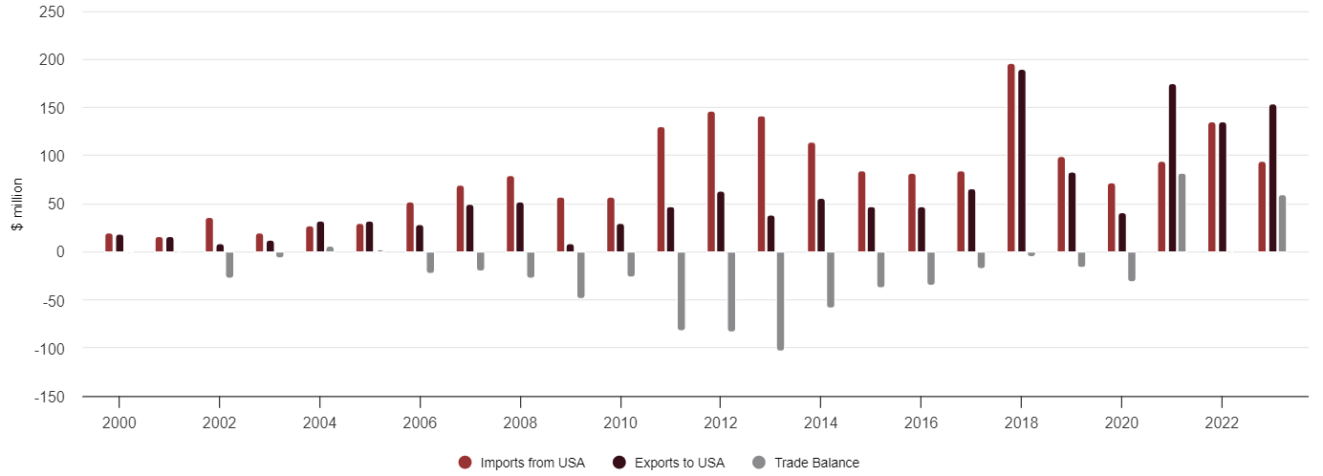
Source: AGOA and Zambia Brochure

Transport Policy
The 2019 National Transport Policy proposes the following legislative changes:
- Road Transport: The Government will harmonise the Public Road Act No.12 of 2002, the Road Traffic Act No.11 of 2002, the National Road Fund Act No. 13 of 2002 and Local Government Act Cap 281 and other auxiliary policies and/or legislation to streamline the responsibilities of the relevant institutions and create a Fund to adequately finance the development of all transport modes.
- Public Transport Authority: Government will promulgate legislation for the establishment of the Public Transport Authority (PTA) in all local authorities. This will be phased starting with designated City Councils, followed by Municipal Councils and eventually District Councils.
- Railway Transport: The Railways Act, of 1982 will be amended to create an appropriate legal and institutional framework for the railway sub-sector. This will include authorisation, regulation and licensing functions.
- Railway Development, Regulation and Operations: The Government will develop a legal and institutional framework for the development and maintenance of the railway infrastructure, including railway operations and regulation.
- Maritime and Inland Waterway Transport: The Government will develop a legal and institutional framework for the development and maintenance of the Maritime and Inland Waterways infrastructure including operations and regulation.
- Air Transport Regulations: Government will develop regulations under the Civil Aviation Act No 5 of 2016 in line with ICAO Standards and Recommended Practices (SARPs).
- Intermodal Transport Legislation: The Ministry will facilitate the development of a National Transport Act to encompass all modes of transport.
- Resource Mobilisation and Financing: Government will mobilise finances for the implementation of the National Transport Policy from domestic revenues, bilateral and multilateral Development Partners and the Private Sector. Through this Policy, Government will vigorously pursue innovative resource mobilisation using the Public Private Partnerships (PPP) framework. For domestically mobilised resources, Government will enhance the application of the user-pays principle. This will include amongst others, funds generated from the Motor Vehicle Accident Fund (MVAF), fuel levies, road toll fees, road licences, and freight tariffs.
- Monitoring and Evaluation: The Ministry will establish a sector wide Monitoring and Evaluation system that will provide evidence for assessing the impact of the implementation of the national Transport Policy. The system will be linked to the Government Wide Monitoring and Evaluation system which is currently being developed. Regular policy reviews will be conducted to ensure responsiveness to the changes in the transport sector.

Tripartite Transport and Transit Facilitation Programme
The lack of an integrated and liberalised road transport market in the East and Southern African (EA-SA) region poses numerous obstacles to trade by causing severe delays and increased transport costs, as well as challenges to road safety and durability.
The EU funded Tripartite transport and Transit Facilitation Programme (TTTFP) has supported improvements in the transport and transit sectors throughout the COMESA, East African Community (EAC) and SADC region through harmonisation of road transport policies, laws, regulations and standards with the aim of improving the efficiency of cross border road transport and transit and logistics services and to support the development of a competitive integrated and liberalised regional road transport market in the COMESA, EAC and SADC region, based on the principles of variable geometry.
The TTTFP closed in 2023 but achieved the following:
- Statutory Frameworks of two Multilateral Agreements and six Model Laws have been adopted by the Tripartite Ministerial Committees on Infrastructure and Legal Affairs and these are awaiting adoption by the Council of Ministers and Heads of State.
- Model Laws and Regulations are being customised for promulgation.
- Twelve African Continental Standards published by African Regional Standards Organisation (ARSO) and a further 45 are under development by ARSO.
- The Tripartite has validated standard specifications for the National Transport Information System, Vehicle Load Management Information System (VLMIS), Transport Registers and Information Platform (TRIPS) and Corridor Trip Monitoring System (CTMS) systems; vehicle and driver testing, weigh stations facilities and curricula, modules, units and e-Learning for the training toolkit.

Trade Facilitation and Logistics Legislation
The following is a summary of the main pieces of legislation covering trade facilitation and logistics issues in Zambia.

Border Management and Trade Facilitation Act, 2018
The 2018 Border Management and Trade Facilitation Act covers the following issues:
- Coordinated border management and control for the efficient movement and clearance of goods;
- Gives effect to the provisions of agreements on one-stop border posts;
- Provides for simplified arrangements with adjoining states relating to the movement and clearance of goods;
- Establishes control zones and provides for powers of officers in control zones in border areas;
- Provides for the development, management and maintenance of border infrastructure;
- Authorises the application of the laws of Zambia and adjoining states in one-stop border posts to repeal and replace the One-Stop Border Control Act, 2009; and
- Provides for matters connected with or incidental to the foregoing.
The 2018 Border Management and Trade Facilitation Act repealed and replaced the 2009 One-Stop Border Control Act.

Customs and Excise (Amendment) Act, 2018
The 2018 Customs and Excise (Amendment) Act, 2018 provides for the imposition, collection, and management of customs, excise and other duties, the licensing and control of warehouses and premises for the manufacture of certain goods, regulating, controlling, and prohibiting of imports and exports, the conclusion of customs and trade agreements with other countries, forfeitures and for other matters connected therewith or incidental thereto.

Zambia Chartered Institute of Logistics and Transport Act, 2014
The Zambia Chartered Institute of Logistics and Transport Act, 2014:
- Providers and powers and functions of the Zambia Chartered Institute of Logistics and Transport;
- Establishes the National Council for the Institute and provides for its functions, powers, and qualifications for membership of the institute;
- Registration of members to practice as logisticians or transporters; and
- Disciplinary committee and other committees of the institute.
This Act was supposed to also lay out the management of logistics in Zambia, but it focuses mainly on establishing the Zambia Chartered Institute of Logistics and Transport. With the enactment of the Act, it is a legal requirement that everyone working or practicing in the supply chain, logistics and transport sectors must be qualified professionals registered in accordance with the Act. This is against the backdrop of Zambia’s vision of becoming the hub of logistics and transport by the year 2028.

Standards Act (Act No. 4, 2017)
This Act entails the following:
- Continues the existence of the Zambia Bureau of Standards and redefined its powers and functions;
- Provides for standardisation and quality assurance of products and services through the setting of national standards and provision of conformity assessment services for products and services;
- Repealed the Standards Act, 1994; and
- Provides for matters connected with or incidental to the foregoing.

Other Indirectly Relevant Acts
Other Acts and regulations that are indirectly related to trade policy and trade facilitation are:
- Business Regulatory Act, 2014 and Business Regulatory (Amendment) Act, 2018, which are designed to put in place an efficient, cost-effective, and accessible business licensing system.
- Metrology Act, 2017 to ensure that metrology contributes to the quality of goods entering the country conform to international standards.
- Zambia Development Agency Act, 2006, which fosters economic growth and development by promoting trade and investment in Zambia through an efficient, effective, and coordinated private sector-led economic development strategy.
- Zambia Revenue Authority Act, 1993 which established the Zambia Revenue Authority and defined the functions and powers of the Governing Board of the Authority.
- Tolls Act, 2011 which establishes and provides for the operation of toll roads.
- The Public-Private Partnership Act No. 14 of 2009 and the Public-Private Partnership (Amendment) Act No. 9 of 2018 which promotes and facilitates the implementation of privately financed infrastructure projects and effective delivery of social services by enhancing transparency, fairness and long-term sustainability and removing undesirable restrictions on private sector participation in the provision of social sector services and the development and operation of public infrastructure.

Investment Environment

ZDA and Investment Incentives
The Zambia Development Agency (ZDA) Act No. 11 of 2006 offers exemptions and concessions for companies investing in a priority sector as stipulated in the ZDA Act, which are granted after ZDA approves an application.
The Investment License is valid for 10 years from the date of issue. Once an investor has received the certificate of registration, and confirmation of the project has been approved with tax incentives, as stated in section 56 and section 57 of the Act, the investor is eligible for customs duty exemptions on capital equipment and machinery, corporate tax incentives for projects operating in a manufacturing sector in the MFEZ or rural area from first year of operation.
The specific fiscal incentives investors enjoy by virtue of their registration with the Agency in accordance with the ZDA Act include zero percent import duty rate on capital equipment and machinery for five years; and accelerated depreciation on capital equipment and machinery.
Investors that set up in a Multi Facility Economic Zone or Industrial Park are eligible for additional tax incentives, including zero percent tax on dividends declared on profits made on exports for the first 10 years; zero percent tax on 50 per cent of dividends for years 11 to 13; and zero per cent tax on dividends on 25 percent tax on dividends for years 14 and 15.
The priority sectors are:
- Manufacturing: The tax incentives apply only if an investor is located in an MFEZ, a rural area or Industrial Park according to the Income Tax Amendment Act No. 16 of 2017.
- Construction and establishment of infrastructure excluding renovation, expansion and refurbishment particularly:
  - Education: Construction of education and skills training institutions;
  - Health: Construction of health centres’ as defined under the Health Professions Act of 2009; and
  - Housing: Development of fifty (50) or more houses erected or maintained under one management or control on land developed specifically for the citing of such houses in accordance with a comprehensive plan which provides for the laying out of roads and the furnishing and availability of services essential or ancillary to the use of such building as houses.
- Agriculture: construction of crop and grain storage facilities; and any form of agro processing.
- Tourism: Construction and establishment of hotels, convention centres, exhibition centres, museums, theme parks, art galleries, theatres, large retail complex containing a variety of ten or more stores, restaurants or other business establishments housed in a series of connected or adjacent buildings or in a single large building.
- Energy and Water Development: Building and installation of power stations and processing and refinery plants for biofuel; construction of petroleum refineries, pipelines and rural filling stations.
- Water Supply: Construction of dams, irrigation canals and water and sewerage treatment plants.
Fiscal incentives only apply to investments with an investment capital of not less than USD500,000 for foreign investors and USD50,000 for local investors.

PPP Regulatory Environment
The Zambian Public-Private-Partnership environment is governed by Public-Private Partnership Act No. 14 of 2009, which was amended by the Public-Private Partnership (Amendment) Act No. 18 of 2023. A Public Private Partnership (PPP) is described as a contractual arrangement where government and the private sector partner to deliver public infrastructure projects and related services using private financing. The Zambian 2009 PPP Act defines a PPP as an investment through private sector participation in an infrastructure project or infrastructure facility.
PPPs typically involve a private party undertaking to perform an institutional function on behalf of a public body and/or use State-owned property for commercial purposes to achieve the public body and private party’s objectives. It also involves transfer of risk to the private party in exchange for direct payments from the public body and/or charging user fees for the use of the project for its services.
In terms of developing new (greenfield or brownfield) infrastructure investments in Zambia, PPPs have become almost the norm in Zambia, mainly because the balance sheets of State-Owned-Enterprises (SOEs) are not healthy enough to implement “traditional” public sector procurement where the SOE defines what is required to deliver a project and finances the project from its budget. This is also the case for government-controlled agencies and government departments, such as the Roads Development Agency (RDA) and National Road Fund Agency (NRFA) and logistics companies under the Industrial Development Corporation (IDC) such as Zambia Railways Limited (ZRL), Mpulungu Harbour Corporation Limited (MHCL) and Zambia Cargo and Logistics Limited (ZamCargo), which have limited access to public finances and not enough to upgrade roads to dual carriage and highway standards or to rehabilitate rail track or buy new locomotives and rolling stock or to upgrade a port or establish new inland container depots and logistics hubs.
The selection of a PPP project is determined by the project’s viability and whether it is a bankable project or not. The public partner needs to be sure that it can meet any financial commitments incurred or likely to be incurred under the PPP agreement; that there is a net benefit to the Contracting Authority or consumers; and that there is a transfer of technical, operational and financial risk to the private party/concessionaire.
The First Schedule of the PPP Act describes 16 different types of PPP arrangements : Build and Transfer (BT), Build, Lease and Transfer (BLT), Build, Operate and Transfer (BOT), Build Own and Operate (BOO), Build, Own, Operate and Transfer (BOOT), Build, Transfer and Operate (BTO), Contract and Operate (CAO), Develop, Operate and Transfer (DOT), Rehabilitate, Operate and Transfer (ROT), Rehabilitate Own and Operate, Build Own Operate and Maintain Contract, Lease Management Contract, Management Contract, Service Contract, Supply Operate and Transfer and Supply Operate and Transfer. The Act also allows for government to enter into agreements or arrangements that incorporate any of the arrangements enumerated in the First Schedule or any other arrangements as are necessary or expedient for a specific project.
The Act makes provision for:
- Solicited Proposal. A solicited proposal is a proposal relating to a PPP project submitted in response to a request or solicitation issued by a Contracting Authority which could be government ministries, State-Owned-Enterprises, Local Authorities and government agencies.
- Unsolicited proposal. A proposal relating to a PPP project, initiated by a private entity and submitted to a Contracting Authority. If an unsolicited proposal complies with the requirements of the Act the Contracting Authority shall, subject to the approval of the PPP Department, proceed to advertise the proposal and so receive competing proposals and a preferred bidder is then selected.
After the evaluation of an unsolicited proposal the Contracting Authority either accepts the unsolicited proposal and rejects any competing proposals; or requests the originator of the proposal to match any competing proposal and, if this s done, the project is awarded to the originator of the proposal; or reject the unsolicited proposal and accept the comparable competing proposal; or accept both the unsolicited proposal and a competing proposal; or reject the unsolicited proposal and any competing proposal.
The PPP Act establishes three institutional bodies to handle the management of PPPs in Zambia, these being the PPP Council (responsible for the approval of PPP projects and award of agreements); the PPP Technical Committee (plays advisory role to the PPP Council and Department); and the PPP Department (in the Ministry of Finance and is responsible for facilitating, coordinating, administering and monitoring PPP projects).

Multi-Facility Economic Zones
The Government introduced multi-facility economic zones (MFEZ) in 2005 to enhance Zambia’s competitiveness and industrialisation. The zones were initiated to foster an attractive business environment, promote exports, and enhance domestic trade.
The enactment of the Zambia Development Act which mandated the creation of the Zambia Development Agency (ZDA) provided the framework for the management of investment facilitation activities within the country. The Act also endorsed the development of MFEZs.
Another important objective of the MFEZs is to promote the development of Small and Medium Sized Enterprises (SMEs), especially through integrating SMEs in the value or supply chains of large enterprises within the zones. The MFEZs are established to overcome the binding constraints faced by the private sector, including land, infrastructure, business climate (such as inefficiency of the public services, cumbersome customs clearance and taxation systems, etc.)
Currently, MFEZs include:
- Chambishi MFEZ: A multi-functional zone that's open to both foreign and domestic investors. Priority sectors include mining, engineering equipment assembly, construction materials, fertilizers, agriculture, and service sectors.
- Lusaka East MFEZ: A 520ha zone with 10 companies operating in it.
- Lusaka South MFEZ: A 2100ha zone with 11 companies operating in it.
- Lumwana MFEZ: A 1300ha zone.
- Ndola MFEZ: A 130ha zone that hosts the Sub-Saharan gemstones exchange.
- Roma Industrial Park: A 113ha industrial park.
- Jiangxi Multi-Facility Economic Zone (Chibombo MFEZ)
Other MFEZs in Zambia include the Kalumbila MFEZ and the Kafue Iron and Steel MFEZ.

Stakeholders in Transport and Trade Logistics

Government Departments, Agencies and SOEs

National Trade Facilitation Committee (NTFC)
As a member of the World Trade Organisation (WTO) Zambia has ratified the WTO’s Trade Facilitation Agreement and, as such, has complied with the provision of the WTO Trade Facilitation Agreement (TFA) to establish a National Trade Facilitation Committee (NTFC). According to Article 23.2 of the WTO Trade Facilitation Agreement “Each Member shall establish and/or maintain a national committee on trade facilitation or designate an existing mechanism to facilitate both domestic coordination and implementation of the provisions of this Agreement”.
Zambia established its National Trade Facilitation Committee in 2016 to assist with the reduction of trade barriers to streamline customs procedures and to ensure improved cooperation and coordination among the different government agencies, the private sector and other stakeholders involved in trade as well as promoting good relations with Customs of neighbouring countries.
The NTFC is chaired by the MCTI Permanent Secretary and includes, as its public sector members, Ministries of Agriculture/Livestock; Transport and Logistics, Finance and government agencies such as the Zambia Environmental Agency, Zambia Revenue Authority (Customs) Zambia Development Agency, Zambia Bureau of Standards, Zambia Compulsory Standards Agency, SMART Zambia and the Bank of Zambia.
Members who are from the private sector include ZACCI, the Chamber of Mines, TAZ, Cross-Border Traders Association, Associations of Customs Clearing Agents and Freight Forwarders and Zambia National Farmers Union.
The Zambian NTFC has about 18 members from public sector institutions and about 7 members from private sector institutions.

Ministry of Transport and Logistics
The Ministry of Transport and Logistics (MOLT) was created in September 2021 following the realignment of the mandate and functions of the Ministry of Transport and Communications. Government Gazette Notice No.1123 of 2021 mandates the Ministry to coordinate the development, policy and regulation of the transport and logistics sector. Specifically, the Ministry is responsible for control of government transport; the aviation sector (airports, aerodromes and airstrips, aviation training, civil aviation and airways policy, flight services); railway policy; road transport policy; road traffic policy; government fleet management; and government printing and gazetting; pontoons and mechanical services; canals and waterways.
The statutory bodies under the Ministry of Transport and Logistics include:
- Civil Aviation Authority (CAA): established by Act No. 7 of 2012, as an autonomous Aviation Regulator. This was in line with international best practice and to enable the creation of an effective safety oversight authority in Zambia. The CAA seeks to provide effective and efficient regulatory services to the aviation industry, ensure legal compliance and provide safety assurance with value for money for all air transport users in Zambia. In its oversight capacity, the CAA is guided by its core values in pursuance of its corporate objectives. The Civil Aviation Authority regulates: Aircraft Operations; Personnel Licensing; Air Traffic Management; Airworthiness; Aerodromes and Ground Aids; Aviation Security; Aeronautical Information Services; Communications, Navigation and Surveillance and Safety Management Systems.
- Road Transport and Safety Agency (RTSA): established under the Road Traffic Act No. 11 of 2002 and became fully operational in 2006 with a mandate to:
  - effectively implement policy on transport, traffic management and road safety; effectively and efficiently register motor vehicles and trailers in accordance with the Road Traffic Act;
  - timely issue licenses and permits in accordance with the Road Traffic Act;
  - implement international protocols and treaties on road transport efficiently;
  - pay out such percentages of money into the road fund from revenues collected in a transparent and accountable manner;
  - conduct effective road safety education;
  - coordinate road safety programs effectively; and
  - approve and monitor the effectiveness of road safety programs undertaken.
- Zambia Airports Corporation Limited (ZACL) is a public limited company responsible for developing, maintaining, and managing four international airports (Kenneth Kaunda, Simon Mwansa Kapwepwe, Harry Mwaanga Nkumbula, and Mfuwe), and providing air navigation services throughout Zambia.
- Zambia Chartered Institute of Cargo and Logistics (ZCILT): The Zambia Chartered Institute for Logistics and Transport Act provides for the establishment of the Zambia Chartered Institute for Logistics and Transport and provides for its powers and functions; constitutes the National Council; provides for the qualifications for membership of the Institute; provides for the registration of members to act as “logisticians or transportants”; and provides for the constitution of the Disciplinary Committee. According to the Act, the functions of the Institute are to promote, encourage, and coordinate the study of the science and art of logistics and transport in all branches.

Ministry of Commerce, Trade and Industry
The Ministry of Commerce, Trade and Industry (MCTI) is charged with the responsibility of formulating and administering policies as well as regulating activities in the Commercial, Trade and Industrial sectors to enhance the sectors’ contribution to sustainable social economic growth and development for the benefit of the people of Zambia.
MCTI is responsible for the following statutory bodies:
- The Business Regulatory Review Agency (BRRA): established through the Business Regulatory Act, No. 3 of 2014, to create and promote a conducive business regulatory environment. The mandate of BRRA is to review and approve proposed policies and laws that affect business activity to ensure they are legitimate and serve the intended purpose as well as coordinate development and implementation of appropriate government-to-business interventions aimed at reducing the regulatory burden on businesses.
- Competition and Consumer Protection Commission: a statutory body with the dual mandate of protecting the competition process in the Zambian Economy and protecting consumers under the Competition and Consumer Protection Act (CCPA) No. 24 of 2010.
- Patents and Companies Registration Agency (PACRA): The mandate of PACRA is to provide Business Registration and Intellectual Property protection services under the Patents and Companies Registration Agency Act No. 4 of 2020. PACRA confers Intellectual Property Rights and serves as a legal repository for Business Registration and Intellectual Property information.
- Zambia Bureau of Standards (ZABS): The Zambia Bureau of Standards is a statutory body under MCTI, established in 1982. It implements the Standards Act No. 4 of 2017 of the laws of Zambia which repealed CAP 416 of 1994. Under CAP 416 ZABS was responsible for the development of standards, enforcement of compulsory standards, testing certification and metrology services. With the realignment of the National Quality Infrastructure (NQI) in 2018, to international best practices, ZABS role is now more focused towards supporting industry to implement standards that enhance the quality of products and services for industry growth and competitiveness.
- Zambia Compulsory Standards Agency (ZCSA): The ZCSA mandate is to administer, maintain and ensure compliance with compulsory standards for the purpose of public safety and health, consumer protection, and environmental protection.
- Zambia Development Agency (ZDA): The ZDA draws its mandate from the Investment, Trade and Business Development (ITBD) Act No. 18 of 2022 to foster economic growth and development by promoting trade, business development and investment in the Republic through an efficient, effective and coordinated private sector led economic development strategy
- Zambia Metrology Agency (ZMA): a Statutory Body, established by the Metrology Act No. 6 of 2017, to oversee the service provision of Scientific, Industrial, and Legal Metrology in Zambia in accordance with the Law.

Ministry of Infrastructure, Housing and Urban Development
The mandate of the Ministry of Infrastructure, Housing and Urban Development is to oversee the designing, procurement, construction, maintenance and management of public infrastructure and to improve planning, coordination, standardisation, quality and efficiency of infrastructure development. The Roads Development Agency reports to the Ministry of Infrastructure, Housing and Urban Development.

Industrial Development Corporation (IDC)
The Industrial Development Corporation (IDC) Limited is a State-Owned Enterprise (SOE) charged with the mandate to spearhead the Zambian Government's commercial investments agenda aimed at strengthening Zambia's industrial base and job creation.
The IDC was incorporated in January 2014 and is wholly owned by the Government through the Minister of Finance pursuant to the Minister of Finance (Incorporation) Act Cap 349 of the Laws of Zambia.
The IDC was established to create and maximise long-term shareholder value as an active investor and shareholder of successful state-owned enterprises, as well as undertake industrialisation and rural development activities through the creation of new industries.
Part of IDC’s portfolio of logistics companies include:
Zambia Railways Limited
ZRL was formerly a region of Rhodesia Railways until the dissolution of the Federation of Rhodesia and Nyasaland in 1963. Rhodesia Railways operated as a Unitary Railway System with assets remaining jointly owned by Zambia and Southern Rhodesia until 1967 when the Zambian Government passed the Railways Act which created the Zambia Railways Board. In 1978, the Government transferred the Zambia Railways Board to Zambia Industrial and Mining Corporation (ZIMCO) Limited and dissolved the Zambia Railways Board and Zambia Railways was incorporated as a limited company through the Railways Act of 1982. The company was a parastatal until 2013 when it was concessioned to Railway Systems of Zambia (RSZ) but in September 2012 Government repossessed ZRL from RSZ because of the concessionaire’s poor performance. The company is now wholly owned by the Industrial Development Company of Zambia and all shares are owned by the government.
ZRL was the main carrier of bulk cargo and passengers but lost this market position to road transport in the 1990s.
Zamcargo
Zambia Cargo and Logistics Limited (ZamCargo) is a freight and forwarding service provider which has been in operation since 1st April 2001. The Company was initially formed to provide freight forwarding services to the former Zambia Consolidated Copper Mining (ZCCM) conglomerate but later transformed to become a provider of those services in an open market with a strategic intent to develop trade corridors and inland dry ports and offer freight logistics services to GRZ and its spending units and the general Zambian public at large.
Mpulungu Harbour Development Corporation
Mpulungu port was built in 1930 and in 2015 the Zambian government transferred its shareholding to the Industrial Development Corporation (IDC). Mpulungu port is the only operational commercial inland waterway port in Zambia.

SMART Zambia Institute
The SMART Zambia Institute is a Division in the Office of the President which is charged with the responsibility of managing and promoting electronic Government services and processes; facilitating access to electronic Government services to improve service delivery to enhance citizens access to Government services; and coordinating e-government, information and communication technology matters in public bodies. The Division draws its mandate from the Electronic Government Act No. 41 of 2021.

Private Sector Organisations

Zambia Chamber of Commerce and Industry (ZACCI)
The Zambia Chamber of Commerce and Industry (ZACCI) is the umbrella organisation representing businesses across the country and all sectors of the economy. ZACCI was established in 1933 and registered on 11 October 1990 under the Registrar of Societies Act with the mandate of advocating for a business environment that promotes business growth.

Zambia Association of Manufacturers (ZAM)
The Zambian Association of Manufacturers (ZAM), established in 1985, is a registered organisation that represents the interests of the Zambian manufacturing sector and other related economic and/or production sectors. ZAM's major objective is to promote the manufacturing sector through policy advocacy, dialogue, lobbying and technology upgrading of the production process as a way of improving productivity and competitiveness in the industry, its goal being for manufacturing to have a 20 percent contribution to GDP by 2030, which is in line with the National 2030 Vision

Zambia Chamber of Mines
The Zambia Chamber of Mines (ZCM) is registered as an association for mining and allied companies. The Chamber is governed by a constitution while the policy making body is the Council drawn from member companies. Membership to the Chamber is classified into four categories (Class A, Class B, Class C and Associate), defined by the type of mining licence that a particular mine possesses, large, small, exploration, service provision etc. the Chamber’s mission is to advance the interests of its members, local communities, the country and its stakeholders whilst promoting sustainable and responsible mining.

Customs Clearing Agents and Freight Forwarder Associations
The Federation of Clearing and Forwarding Associations of Southern Africa (FCFASA) lists three Customs Clearing Agent Associations in Zambia as its members, these being Zambia Customs Clearance and Freight Forwarders Agents Association, Zambia Customs and Forwarding Agents Association and Zambia Freight Forwarders Association. Freight Forwarders handle the movement of goods from point to point on behalf of the cargo owner while a Customs Clearing Agent (sometimes referred to as a Customs Broker – the term used in the United States) clears goods through Customs on arrival into a country on behalf of the cargo owner. The larger Customs Clearing Agents are often Freight Forwarders and Customs Clearing Agents

Truckers Association of Zambia (TAZ)
The Truckers Association of Zambia (TAZ) is a membership-based road transporters' association and the leading representative voice of the members, providing a platform to influence the sector policy, regulations and practice. TAZ actively engages with government bodies and stakeholders to shape policies that benefit truckers and improve the working environment. It also maintains an up-to-date driver database that helps companies verify driver credentials, enhancing transparency and accountability and provides regular updates on industry trends, regulations, and challenges that affect the trucking sector, helping members stay ahead of changes.

Transport Infrastructure and Management

Road and Road Transport

Road Sector Management
The responsibility for roads is governed by five Acts of Parliament:
- The National Road Fund Act 13/2002 establishes the NRFA to manage the Road Fund.
- The Public Roads Act 12/2002 refers to the “road network” and sometimes to “public roads”, which are responsibility of the Roads development Authority (RDA), although it may delegate responsibilities on roads.
- The Local Government Act 56/2019 deals with “public streets”, which are the responsibility of the Ministry of Local Government and Rural Development.
- The Tolls Act 14/2011 (supported by the Public-Private Partnership Act 18/2023) authorises the Minister of Finance to concession toll roads.
- The Road Traffic Act 11/2002 created the Road Transport and Safety Agency (RTSA) to implement policy on road transport, traffic management and road safety and carry out related matters.
The statutory corporations that have been created by Parliament to manage the road transport structure in Zambia are:
- The Road Development Agency (RDA) with a mandate to manage and care for the Zambian road network;
- The National Road Fund Agency (NRFA) to collect fees and charges from users to finance the maintenance, upgrading and safe operation of the Zambian road network;
- The Road Transport Safety Agency (RTSA) to ensure the safe operation of the infrastructure and users of the Zambian road network; and,
- The National Council for Construction (NCC) to provide control over the registration and licensing of contractors carrying out construction work in Zambia.
The governance structure that links these four organizations is illustrated in Figure 7.1. The RDA, NRFA and RTSA report to the Committee of Ministers on the Road Maintenance Initiative (RMI).
Figure 7.1: Governance Structure of Zambian Road Sector
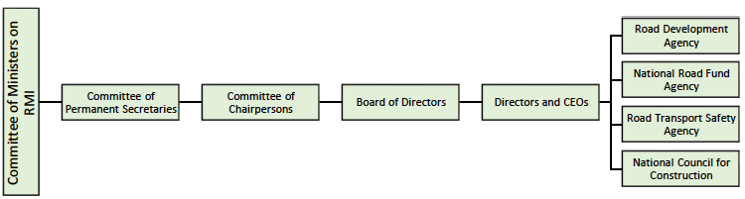
Source: RoadSIP III, 2024

Core Road Network Classification
The road network in Zambia encompasses a Core Road Network (CRN) and the non-CRN. The CRN (about 40,000 km) comprises Trunk, Main and District (TMD), Urban and Primary Feeder Roads (PFR). The non-CRN (about 27,000 km) is made up of Secondary and Tertiary Feeder, Park, Community and ‘Not Properly Documented’ Roads.
The RDA is responsible for the whole of the CRN, except for some Trunk Roads that are delegated to Toll Operators. The Ministry of Local Government and Rural Development (MoLGRD) is responsible for some PFR and Urban Roads and the non-CRN roads. Some roads are on-delegated by MoLGRD to Local Government Authorities (LGAs) and to Special Interest Companies.
RoadSIP III gives a further categorisation of the CRN which differentiates between the importance of different types of core roads:
- Core 1: Paved minimum standard, maintained in good-fair condition - roads connecting main borders, provincial centres and strategic economic regions.
- Core 2: Paved minimum standard, maintained in good-poor condition - Roads connecting cities/municipalities or connecting more than two district centres; or connecting important economic areas and smaller border crossings; or connecting important tourism areas, notably national parks; and roads providing important interconnectivity between Core 1 roads.
- Core 3: Gravel minimum standard, maintained through regular re-gravelling - roads connecting one or two district centres and roads connecting smaller tourism sites.
- Core 4: Unpaved standard - all remaining core roads, except urban roads.
The application of these criteria to the CRN identifies 5,200 km of Core 1 roads, 2,600 km of Core 2 roads, 3,400 km of Core 3 roads and 24,000 km of Core 4 roads (excluding urban roads).
The Core 1 roads include all trunk roads as well as approximately half the main roads and a small number of district roads that connect provincial centres and provide important connectivity across the country. The Core 2 roads include the remaining main roads as well as approximately 10 percent of the district roads that connect several district centres and smaller border crossings. The Core 3 roads include approximately 20 percent of the district roads and 5 percent of the PFRs that connect smaller tourism sites and one or two district centres. The Core 4 roads include all the remaining core roads that do not provide specific connectivity. Figure 7.2 illustrates this refined categorisation of the CRN in Zambia.
A Road Condition Survey in Zambia was last conducted in 2015. Within the CRN, between 80 per cent and 90 per cent of the TMD Paved Road Network was in good condition and between 60 per cent and 65 per cent of the PFR and Urban Road network was in good condition. Between 80 and 95 per cent of the TMD Unpaved Road Network was in poor condition and between 80 and 90 per cent of the PFR and Urban Road network was in poor condition. No formal road condition survey has been conducted on the non-CRN, but visual inspections indicated that the entire network is in poor condition.
Since 2015 funding for maintenance has been steadily decreasing, so road conditions on both the paved and unpaved CRN have deteriorated.

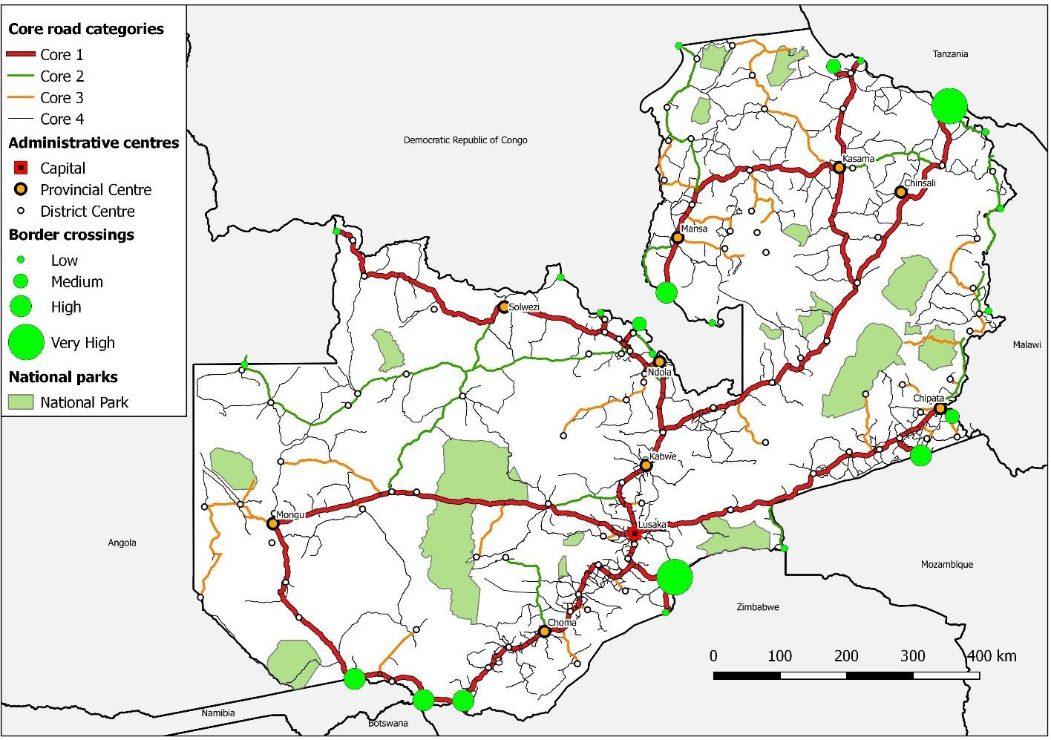
Figure 7.2: Core Road Network Categories in Zambia
Source: RoadSIP III, 2024

Road Sector Funding and Expenditure
Funding for the Road Fund comes from four sources, these being:
- Appropriations from the national budget approved by Parliament;
- Road User Charges (RUCs) paid by road users on a ‘user-pays principle;
- Commercial loans taken out by the NRFA from domestic financing entities; and,
- International loans and grants negotiated by the National Treasury on behalf of the GRZ.
Budget appropriations, RUCs and domestic loans are defined as local funding, while international loans and grants are defined as external funding. As a general rule, funding for the road sector has declined; road sector debt has increased; routine maintenance has declined; and capital investment in the roads remains dependent on external revenue.

Railway Transport

Zambia Railways Limited (ZRL)
Zambia Railways Limited (ZRL) is wholly owned by the Government of the Republic of Zambia through the Industrial Development Corporation (IDC). The Company was incorporated in 1982 and is mandated under the Railways Act of 1984 to operate both passenger and freight trains.
ZRL has the following business units:
- Freight Business: ZRL’s main revenue generator. The company provides freight train services on the mainline and branch lines from Livingstone to Ndola and on to Chingola; from Livingstone to Mulobezi; the inter-mine system on the Copperbelt and the Chipata-Mchinji line.
- Passenger Services: ZRL operates two passenger trains per week on the mainline between Livingstone and Kitwe and two mixed trains per week between Livingstone and Mulobezi, with about 100,000 passenger trips per year.
- Engineering Services: ZRL provides engineering and workshop services to support train operations for its operations and other rail operators. It also provides engineering services to 3rd party clients to generate revenue.
- Real Estate Business: ZRL owns buildings and bare land in different locations from Livingstone to Chililabombwe. The company generates revenue from some of the rented-out property.
ZRL has Interchange Agreements with:
- National Railways of Zimbabwe (NRZ): Valid. Compliant to terms and conditions
- SNCC: Contract expired (but new one being negotiated).
- Tanzania Zambia Railway Authority (TAZARA): Valid Contract. Generally compliant with terms and conditions
- Trans-Freight Railway (TFR): Contract expired (but new one being negotiated). Need to formally renew. Although the contract has expired ZRL still hires locomotives from TFR.
- Beit Bridge Railways (BBR) of Zimbabwe: Valid contract in place. Compliant to terms and conditions.
ZRL also has an agreement to hire locomotives from various companies such as Trans Zambezi Rolling Stock Solution, Zambia Furnace Supplies limited, Bridge/CL Steinweg, Reload, Impala and Smart Logistics.
Table 8.1: Performance Metrics for ZRL 2020-2023
Performance Indicators | 2020 | 2021 | 2022 | 2023
Freight movements (tons) | 1,013,617 | 884,771 | 727,715 | 804,213
Revenue (ZMW million) | 411.59 | 343.02 | 371.99 | 481.75
Operating Costs (ZMW million) | 545.65 | 512.07 | 592.89 | 464.39
Source: Zambia Railways Limited
Challenges for Zambia Railways Limited
- Poor Track Condition: The ZRL track is now, generally, in poor condition because of a lack of investment in infrastructure and in maintenance of the track, as is shown, in summary, in Figure 8.3.
- Poor Condition, and Access to Locomotives and Rolling Stock:
- Poor Balance Sheet: Under the Strategic Business Plan 2021-2025 ZRL tried to raise USD25 million but was not able to do this because local banks would not lend to ZRL on the basis of its balance sheet. For ZRL the solution to this would be to clean and enhance the ZRL balance sheet to make ZRL bankable to the funding institutions and to look for external funding.
- Passenger Traffic: ZRL has reduced capacity to carry passengers because of a limited number of serviceable coaches and estimates that it currently has about 2 per cent of the passenger market.
- Non-Compliance with SI No. 98 of 2020: SI No. 98 of 2020 directs that 30 per cent of heavy and bulk cargo movements in Zambia should be moved by rail but, in 2023, only 4 per cent of heavy and bulk cargo moved by rail, which is a result of ZRLs lack of capacity. ZRL does move about 120,000 tons of sugar and wheat, 204,000 tons of coal, 24,000 tons of cement and 12,000 tons of gypsum per year.

Figure 7.3: ZRL Track Condition Summary
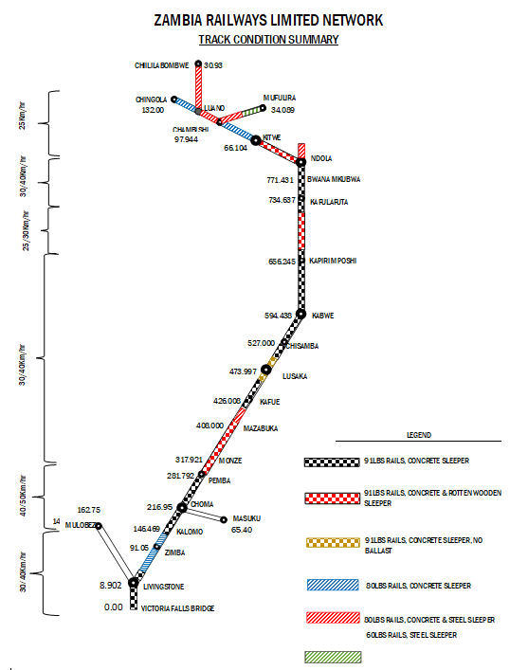
Source: Zambia Railways limited

The 2025-2028 ZRL Strategic Plan includes the following recommendations to:
- Improve Corporate Governance:
  - By 31st December 2024:
    - Reviewing the National Transport Policy reviewed in relation to open access;
    - Fuel levy exemptions; and
    - attain passenger train support from GRZ.
- By 31st December 2026
    - Railways Act reviewed by GRZ; and
    - have the railway fund established by GRZ.
- Recapitalise:
  - Implement efficiency improvements to enhance equipment turnaround, revenues, and cash flow.
  - Liquidation of non-core assets to redeploy into track rehabilitation.
  - Balance Sheet Restructuring to enhance solvency and debt carrying capacity.
  - Engage shareholder (IDC) and the GRZ for funding in form of equity and grants respectively.
  - Secure commercial and concessional loans.
  - Partner with existing customers to rehabilitate wagons.
  - Sell property and use revenue generated to procure equipment.
- Improve Liquidity:
  - Enter into long term offtake agreements.
  - Utilise trade and structured finance instruments to finance applicable operational costs such as fuel and lubricants and equipment including forward contracts to improve certainty.
- Review open access policy and develop open access framework that outlines procedures for operationalisation, including pricing, rights and obligations of operators in consultation with all stakeholders.
- Review pricing policy to have best practice cost reflective structures for determining operational and capital costs and devise two-part tariff structure (reserved rolling stock and actual usage).
- Leverage ICT innovations to install a signalling and rolling stock tracking system focussing on local home-grown solutions and create a platform for real time data collection on operational performance variables.
- Improve performance:
  - By 31st December 2024:
    - To develop and implement a new Pricing Policy.
    - To develop and implement Monitoring and Evaluation system
  - By 31st December 2025:
    - increase annual freight cargo hauled from 800,000 tonnes to 2,600,000 tonnes;
    - increase average mainline locomotive availability from four to thirteen;
    - improve Mainline Freight Transit Times from 74hrs to 43hrs;
    - improve wagon utilization from baseline of 1.5 per month to 3 per month.
    - To improve locomotive reliability from the baseline of 3,500km per failure to an average of 10,000km per failure.
  - By 31st December 2026:
    - To improve wagon availability from 800 to at least 1,500 to meet targeted freight haulage volumes.
    - To enhance Railway line capacity at key stations.
    - To achieve 100 per cent availability of critical spares in ZRL workshops by
- by 31st December 2028;
- eliminate all current Temporary Speed Restrictions on the mainline by 31st December 2026.

Tanzania-Zambia Railway (TAZARA)
The Tanzania-Zambia Railway line (TAZARA), which links the port of Dar es Salaam in Tanzania to Kapiri Mposhi, and the Zambia Railways network in Zambia, was built between 1970 and 1975, and paid for, by the government of China to assist Zambia to avoid shipping goods through South Africa during the days that sanctions were being imposed on the apartheid government of the time. It was built for strategic reasons rather than economic reasons and has yet to operate at levels which are profitable.
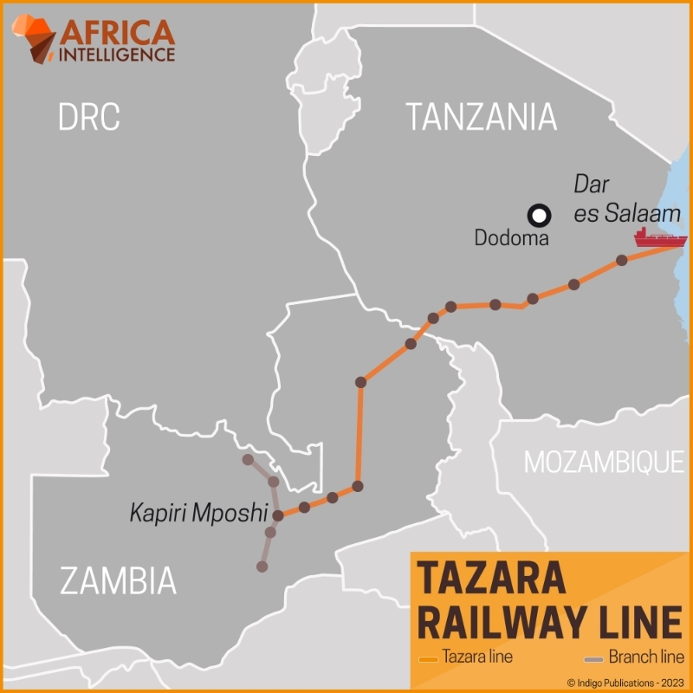
TAZARA operates as a statutory body established by the national legislatures of both Tanzania and Zambia, through the TAZARA Act of 1975, amended by the TAZARA Act of 1995. The governance structure, as provided for by the TAZARA Act, comprises a Council of Ministers, Board of Directors and Management.
Figure 7.4: Route Map of TAZARA

TAZARA has had operational difficulties from its start and has been kept running with continued assistance from China, several European countries, and the United States. Freight traffic peaked at 1.2 million tons in 1986 but began to decline in the 1990s and reached an all-time low of 88,000 metric tons is 2014-15, with the railway carrying less than 2 per cent of its design capacity.
Source: Africa Intelligence
In 2019-20 TAZARA carried 182,302mt and TAZARA’s partner, Calabash Freight, carried 196,676mt so the total line capacity utilisation was 378,978mt (See Figure 7.5)

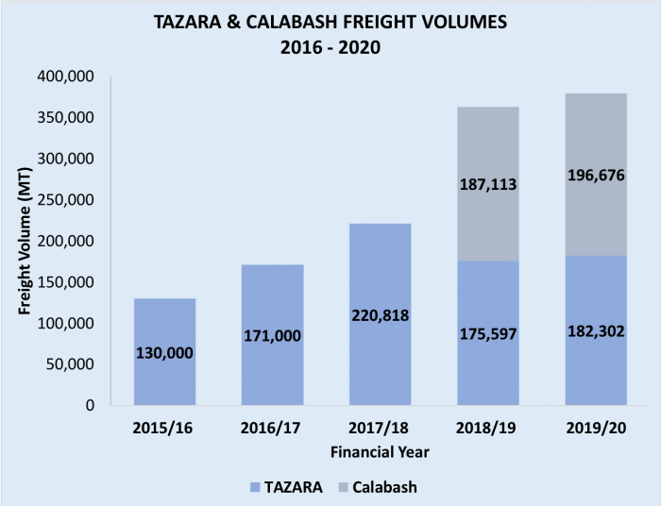
Source: https://tazarasite.com/performance-results-20192020

Source: Africa Intelligence
Figure 7.5: TAZARA and Calabash Freight Volumes
Source: Africa Intelligence

In March 2025 TAZARA announced that China Civil Engineering Construction Corporation (CCECC) will invest over USD 1.4 billion in TAZARA to revitalise the railway infrastructure and operations as part of its concession agreement. The investment will be done over the 30-year concession period, with USD 1.0 billion allocated to the full rehabilitation of TAZARA’s railway track infrastructure, enhancing safety, efficiency and capacity, implemented in the first 3 years of the concession period, and USD 0.4 billion allocated to procurement of 32 new locomotives and 762 new wagons. In addition, periodic major overhauls, alongside continuous maintenance, will be conducted throughout the concession period.

Air Transport

Air Transport Infrastructure
Zambia has four international airports and forty-six aerodromes. The Kenneth Kaunda International Airport is Zambia’s main airport. it is complimented by three smaller international airports at Ndola, Livingstone and Mfuwe, as well as secondary airfields at Chipata, Kitwe, Kasama, Mongu, Solwezi and Mansa, Kasaba Bay.
Government has decided to construct an airport at Nakonde. This is a greenfield project, with the contract being awarded to Zambia National Service. The estimated cost is ZMK2.8 billion
The International Airports in Zambia are operated by Zambia Airports Corporation Limited (ZACL) in cooperation with the Civil Aviation Authority (CAA) under the Ministry of Transport and Logistics.
Zambia Airways is Zambia’s flag carrier. Originally, the airline was founded in April 1964 but was liquidated by Government in December 1994. The national carrier was revived in December 2021 in partnership with Ethiopian Airlines. Government, through the Industrial Development Company (IDC) has taken a 55 per cent stake in Zambia Airways, with Ethiopian Airlines owning the remaining 45 per cent of the shares.
Proflight Zambia is a privately run airline with regional flights to South Africa.

Air Transport Strategy
The Aviation Strategy has six objectives:
- Promote Safety and Security.
- Create a Competitive Environment to Promote Economic Development of Air Transport
- Increase Passenger and Air Cargo Traffic
- Improve Operational Effectiveness and Efficiency
- Enhance Capacity in the Aviation Sector
- Promote Transparent Stakeholder Collaboration
Implementation of the Aviation Strategy will take a multi sectorial approach involving all stakeholders at national and international levels, including various ministries, government agencies, private sector players and all other stakeholders.
The Aviation Strategy assumes that Government will mobilise finances for implementation of the strategy from domestic revenues, bilateral and multi-lateral development partners and the private sector. It is also assumed that the Ministry of Transport and Logistics will establish a sector-wide monitoring and evaluation mechanism that will provide evidence for assessing the impact of the implementation of the Strategy.

Water Transport
Zambia has one inland waterways port, this being Mpulungu port, which is at the southernmost tip of Lake Tanganyika and managed by Mpulungu Harbour Corporation Limited (MHCL) which is a company wholly owned by the Industrial Development Corporation (IDC).
Mpulungu port is primarily used to move cargoes into DR Congo and Burundi across Lake Tanganyika. Kalemie in DR Congo and Bujumbura in Burundi are the main points of delivery.
Mpulungu port has storage capacity inside warehouses and outside. There are three cranes, one with a maximum lift of 300 metric tonnes and two with maximum lifts of 20 metric tonnes.
The main products handled by the port are cement, clinker, sugar, coal, and maize. Most cargo handled at the port is export cargo.
Figure 7.6 gives details on the cargo throughput at Mpulungu port by year and cargo type. Cargo volumes decreased from 2017 to 2019 and then increased to 2021 and started to decrease again in 2022, with this decrease attributed to the economic decline associated with the COVID-19 epidemic.
What can also be seen from Figure 7.6 is the change in the composition of cargo going out of Mpulungu. Up until 2020, sugar was a major commodity being exported out of Mpulungu but its importance as a cargo has steadily declined since then. This does not reflect a lack of demand for sugar from Zambia’s neighbours but a change in market access conditions in that Zambia’s sugar producers now find the domestic market more attractive than the regional export market. However, the total volumes of cargo through Mpulungu port are low and the port needs to attract significantly more cargo to generate enough revenue to allow it to finance a port modernisation programme if the modernisation is to be financed from MFCL’s balance sheet.
There are no ships registered in Zambia and all ships calling at Mpulungu port are registered in either DR Congo or Burundi or Tanzania. Figure 7.6: Cargo Throughput at Mpulungu Harbour by Year and Cargo

Products | 2019 (mt) | 2020 (mt) | 2021 (mt) | 2022 (mt) | 2023 (mt) | 2024 (mt)
Sugar | 50,050.00 | 61,285.00 | 29,980.00 | 16,450 | 27,001.70 | 8,878.90
Maize | 0 | 0 | 1376.89 | 9198.8 | 6,285.35 | 5,628.65
Cement | 15,005.40 | 34,304.15 | 105,373.00 | 101,275.50 | 113,286.00 | 76,274.25
Chilanga Clinker | 109,870 | 102,949.00 | 80,482 | 46,910 | 14,150.00 | 1611.1
Steel | 187.8 | 65 | 414 | 90 | 109.25 | 186.57
Wharfage | 2,193.80 | 4,895.85 | 2,924.11 | 2,097.00 | 1,449.00 | 3,523.96
Dangote Clinker | 4,440.00 | 890 | 0 | 0 | 1,290
Coal | 0 | 1,200.00 | 11,330.00 | 9,780.00 | 11,790.51 | 21,200.22
Total | 181,747.00 | 205,589.00 | 231,880.00 | 185,801.30 | 175,361.81 | 117,303.65
Source: MHCL

Tanzania-Zambia Mafuta (TAZAMA) Pipeline
The Tanzania Zambia Mafuta (TAZAMA) pipeline runs from Dar es Salaam port to Ndola (Indeni) in Zambia, a distance of about 1,710km. For 954km the pipeline has a diameter of 8 inches (200 mm), and for the remaining 798 kilometres the pipeline diameter is 12 inches (300 mm). When installed in 1968, the pipeline had a carrying capacity of 1.1 million tonnes annually, but this has steadily decreased to an estimated 600,000 tonnes or less annually.
Under the government’s reform plan, Zambia switched from importing crude feedstock to refined imported petroleum products from Dar es Salaam, Mozambique, South Africa, and Namibia, which rendered the TAZAMA pipeline obsolete. However, in 2022, the pipeline was modified and upgraded to transport diesel fuel.
Zambia and Tanzania have initiated government-to-government talks to construct a new 12-inch pipeline parallel to the existing pipeline to transport oil to Zambia and the southern parts of Tanzania. The new pipeline would be 1,710km and need an investment of about USD2.5 billion.

Logistics of Agriculture and Agro-Processing

National Agricultural Policy 2012-2030
The vision of the Zambia National Agricultural Policy 2012-2030 is to develop a competitive and diversified agricultural sector driven by equitable and sustainable agricultural development. The focus is on:
- Promoting sustainable increase in agricultural productivity of major crops with comparative advantage;
- Continuously improving agricultural input and product markets so as to reduce marketing costs and increase profitability and competitiveness of agribusiness;
- Increasing agricultural exports as a way of fully utilising the preferential markets (regional and international) and increasing the sector’s contribution to foreign exchange earnings;
- Improving access to productive resources and services for small scale farmers, especially women and young farmers; and
- Continuously strengthening public and private sector institutional capabilities to improve agricultural policy implementation, resource mobilization, agriculture research, technology dissemination, and implementation of regulatory services.
The policy aims to improve food security and make agriculture, forestry and fisheries more productive and sustainable, through promoting environmentally friendly farming systems; strengthening capacity building for small scale farmers; strengthening the capacity of farmer organizations; improving secure access to land; promoting irrigation; and promoting production of cash crops in rotation with food crops.
A commitment to open trade in agriculture is central to Zambia’s efforts to transform the economy to support economic growth and facilitate job creation. However, Zambia has a long history of import and export restrictions of agricultural commodities, maize in particular. Analytical work done by the World Bank Group demonstrates that Zambia has a lot to gain from committing to open agricultural trade.

Agricultural Production, Area Planted, and Fertiliser Use

Fertiliser
The trend in fertiliser use in Zambia continues to increase (Table 8.1). In 2024 Zambia used 483,038 metric tons of fertiliser (basal plus top dressing), 436,673 MT in 2023, 351,247MT in 2022 and 388,519MT in 2021.
Table 8.1: Fertiliser use by year
Year | Basal fertiliser (MT) | Top fertiliser (MT)
2024 | 252,314 | 230,724
2023 | 226,009 | 210,664
2022 | 184,329 | 166,945
2021 | 199,270 | 189,249
Source: Zamstat
In terms of domestic production of chemical fertiliser, Nitrogen Chemicals of Zambia (NCZ) facilities were designed to produce ammonium nitrate (with ammonia from coal gasification) for explosives and fertilisers, as well as to produce NPK fertilisers. A programme to rehabilitate the facilities in the late 1980s was not completed successfully, and inefficient operation together with underutilisation of capacity meant that the fertiliser produced was costly and could not compete with imports. Production has been reduced and is inconsistent, and dependant on government contracts to provide fertiliser for the fertiliser subsidy scheme (FISP). Government attempts to privatise the facilities have not met with success.
There has been an increase in domestic production of fertiliser, with the most notable investment being that of the Wonderful Group of companies, under United Capital Fertiliser Company Limited (UFC) who opened a new USD600 million urea fertiliser and ammonia plant in 2023 in Chilanga. The plant is a vertically integrated fertiliser enterprise with capacity to supply up to 300,000 metric tons per year of Urea, Diammonium Phosphate (DAP), Nitrogen, Phosphorus and Potassium (NPK) and other customised blended fertilisers. The plant has a production capacity of 135,000 metric tonnes per annum for fertiliser and 80,000 metric tonnes per annum for ammonia bicarbonate. Once the plant is operational, the company will be able to supply 80 per cent of the total percentage of urea demand and 60 per cent of the total percentage of D compound required for the country. The plant would also produce ammonia that would be supplied to Nitrogen Chemicals of Zambia (NCZ). The Group also stated that all the raw materials, which include coal and phosphate, would be acquired locally in Southern Province. This new domestic production capacity will have an obvious logistics impact in that it should reduce import of fertiliser, but this may be replaced with export opportunities and may also alter the logistics of local fertiliser distribution.

Wheat Production
Figure 8.1 shows where wheat is grown in Zambia by province, with most wheat being grown in the Central Province, followed by the Lusaka, Copperbelt and Southern Provinces, with small amounts grown in Northwestern and Muchinga Provinces.
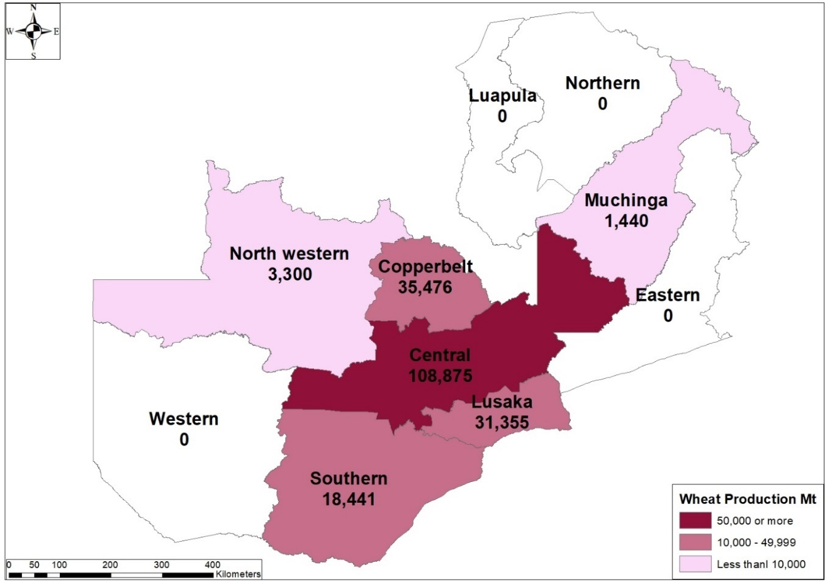
Figure 8.1: Map of Wheat Production in Zambia (2023-24)
Source: ZamStat
Production of wheat in Zambia is dependent on many factors but probably the most important factor has been the cost and access to electricity from ZESCO. Wheat is a winter crop and, as the winter season in Zambia is the dry season, wheat is grown under irrigation. The decline in wheat production in 2024 from 277,492MT, grown on 36,645ha to and expected 198,886MT grown on 28,052 of land (Table 8.2) is probably a direct result of the lack of access by commercial farmers to electricity from the grid (ZESCO). However, according to the Presidential Delivery Unit (PDU), the government is now aiming to achieve a wheat production target of 1 million tonnes by 2027, which will have implications on domestic logistics such as transport (whether transport is in bulk or break bulk, the amounts to be transported and the origin and destination of transport) and storage (whether the storage is in bulk, so in silos, or in bags, so it warehouses, and warehouse managements systems).
Table 8.2: Wheat production and area planted
Year | Area planted (HA) | Production (MT)
2024 | 28,052 (est) | 198,886 (est)
2023 | 36,645 | 277,492
2022 | 33,568 | 234,925
2021 | 30,319 | 205,882
Source: Zamstat

Soya Bean Production
Figure 8.2 shows where Soya Beans are grown in Zambia by province, with most soya being grown in the Central Province, followed by the Copperbelt and Eastern Provinces, with small amounts grown in Northwestern and Muchinga Provinces.
Figure 8.2: Map of Soya Production in Zambia (2023-24)
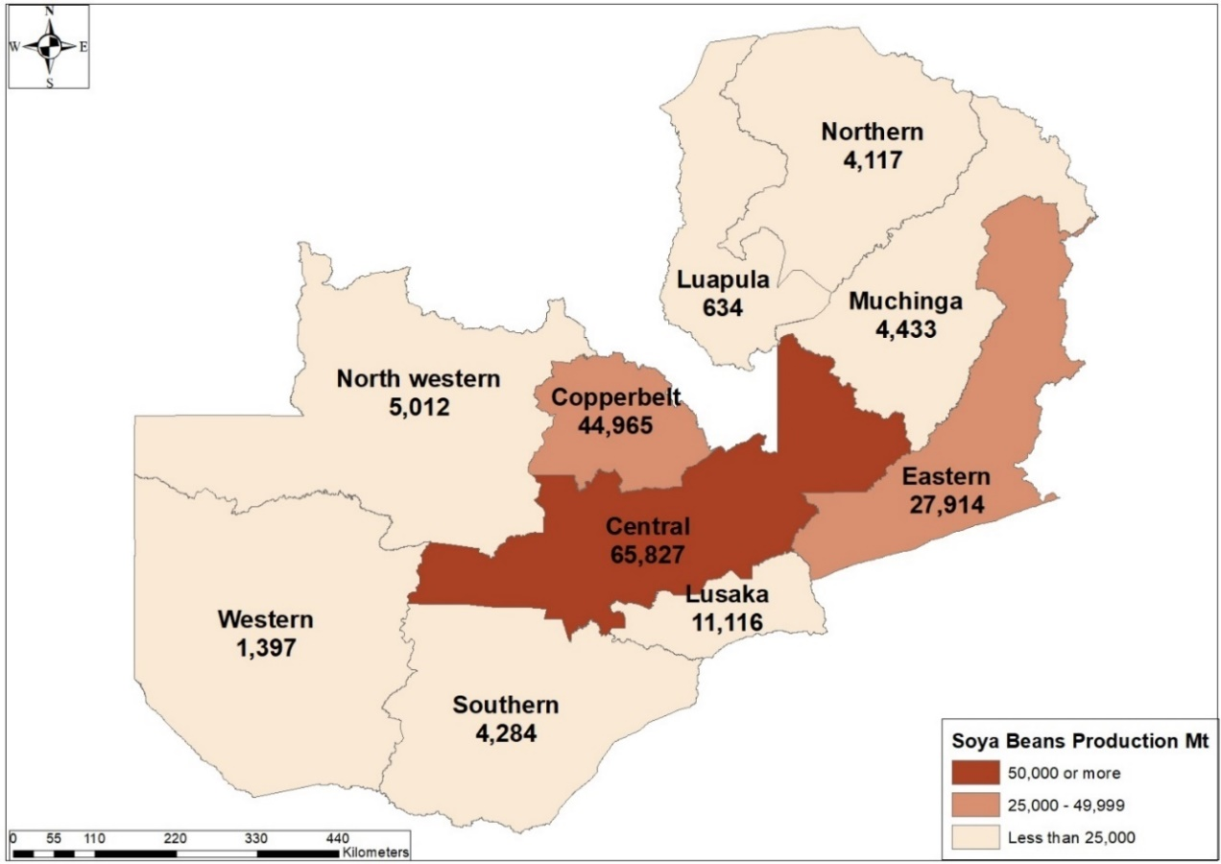
Source: ZamStat

Production of soya beans increased from 475,353MT to 760,067MT from 2022 to 2023, an increase of 60 per cent year on year, but then decreased to 169,700MT (estimated) in 2023, a year on year decrease of 78 per cent (Table 8.3). This decline can most probably be attributed to the 2023-24 drought which affected the main soyabean production areas the most. Soya bean production is still thought to have high potential, particularly soya beans grown by small-scale farmers. Government in partnership with the Agri-food Systems Transformation Accelerator (ASTA), a joint initiative between the Food Agriculture Organisation (FAO) and the United Nations Industrial Development Organisation (UNIDO), is working to increase soya bean production to one million tonnes. This target is to be achieved through implementing the 2023-2032 Zambian Soybean Up-grading Strategy which focuses on increasing the efficiency and competitiveness of the sector through accelerated private and public investments.
Table 8.3: Soybean production and area planted
Year | Area planted (HA) | Production (MT)
2024 | 376,051 (est) | 169,700 (est)
2023 | 701,324 | 760,067
2022 | 424,440 | 475,353
2021 | 327,492 | 411,115
Source: Zamstat
This could result in an increase in export volumes of soya beans and soya cake as well as other soya products such as edible oil, and an increase in the domestic supply of soya bean cake from 50,000 tonnes in 2023 to 200,000 tonnes. Soya-based products and edible oil are expected to increase from 168,000 tonnes to 450,000 tonnes and exports would rise from 26,000 tonnes to 250,000 tonnes.
The increased production of soya beans and increased exports of soya bean products would have an impact on domestic transport, storage, production and other logistics systems.

Maize Production
The growing of maize in all parts of the country has been encouraged by governments in power since independence in 1964, when the population stood at 3.4 million and the demand for maize was estimated at about 395,000MT. In 2024, the population of Zambia is estimated at about 21.3 million, with a growth rate of 2.85 per cent per year with an estimated demand for maize meal being 2.8 million MT in 2023-24 and 2.54 million MT in 2024-25.
The production of maize (Table 8.4) is estimated to be about 1.5 million MT in 2023-24, down from 3.26 million MT in 2022-23. The reduction in production can be mainly attributed to extreme drought conditions associated with the El Niño event. The production volume of maize in 2023-24 will be the smallest maize crop produced in Zambia over the past 15 years. The season started off well with a 20 percent upsurge in planted area, driven by elevated domestic price and probably at the expense of soybean area. Prolonged dry spells, with February 2024 being the driest and hottest month since 1981, resulted in total crop failure in many regions of Zambia. The provinces that were severely impacted by the drought included, Central, Copperbelt, Eastern, Lusaka, Northwestern, Southern and Western which, together, account for about 75 percent of Zambia’s maize production in a normal year. Almost a million hectares of maize out of an estimated 2.3 million hectares of planted area have been destroyed by the drought.
Table 8.4: Maize production and area planted
Year | Area planted (HA) | Production (MT)
2024 | 2,209,160 | 1,511,143 (est)
2023 | 1,896,482 | 3,261,686
2022 | 1,507,441 | 2,706,244
2021 | 1,687,929 | 3,620,244
Source: Zamstat
Figure 8.3 shows where maize is grown in Zambia by province. Maize, as Zambia’s staple crop, is grown throughout Zambia but most maize is grown in Northern, Central, Copperbelt and Eastern Provinces, with less grown in Northwestern, Luapula and Muchinga Provinces. Even smaller amounts are grown in the most southernly Provinces of Western, Southern and Lusaka.
Figure 8.3: Map of Maize Production in Zambia (2023-24)
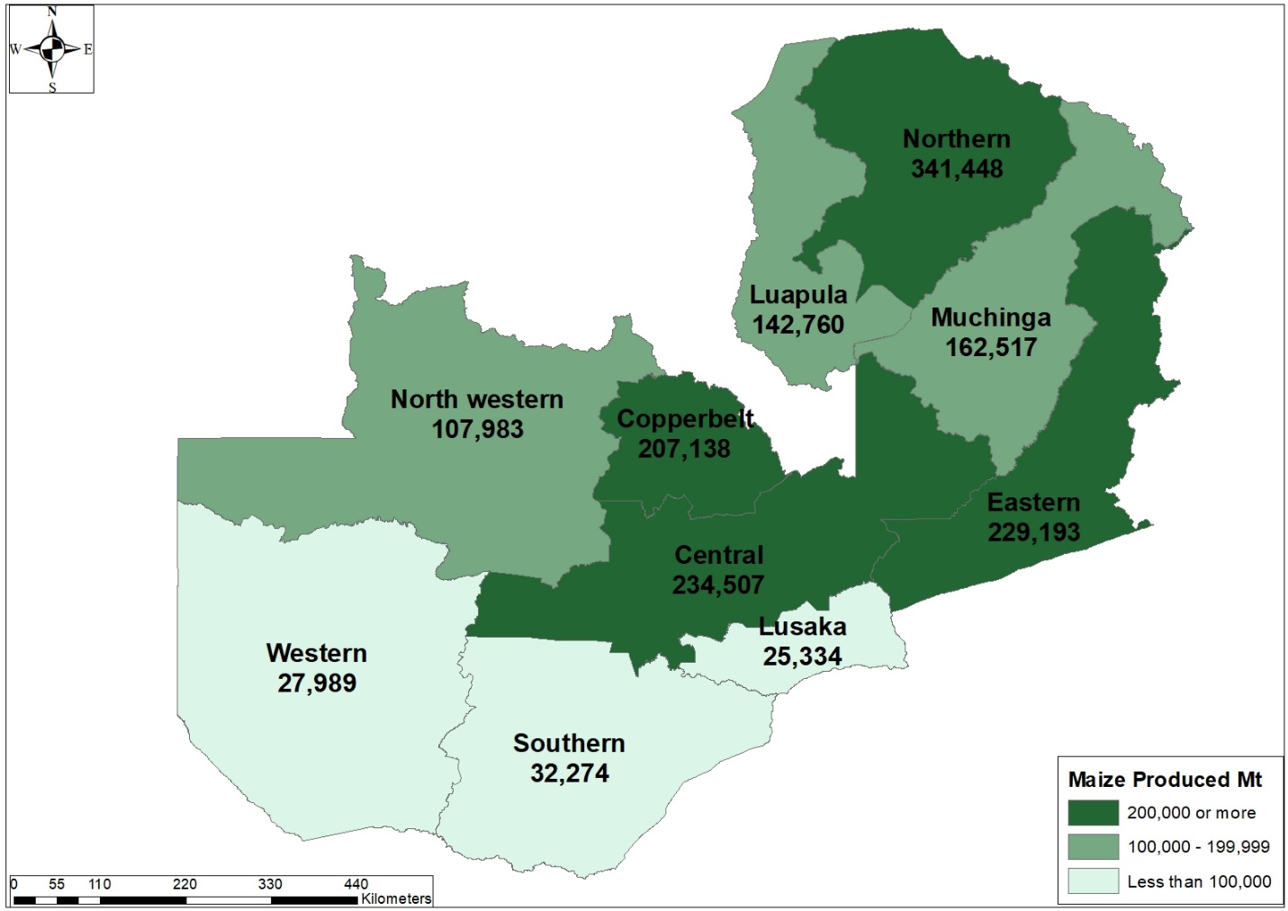
Source: ZamStat
In response to the drought, President Hakainde Hichilema, declared a National Disaster and Emergency on 29th February 2024 and, in April 2024, the government authorised the private sector to import white and yellow maize, while maintaining the ban on import of genetically modified maize. The ban on genetically modified maize effectively limits Zambia’s maize imports to Tanzania. Maize imports from South Africa are excluded because South Africa grows mainly (about 85 per cent) genetically modified maize and maize from Argentina and Brazil is almost exclusively genetically modified.
The shortage of maize in Zambia and the restrictions on the type of maize that can be imported (and so the source of the imports) brings with it a unique set of logistics challenges and opportunities. For example, in August 2024, the Disaster Management and Mitigation Unit (DMMU) entered a public-private partnership with First Quantum Minerals (FQM) to import maize from Tanzania as a backhaul for returning copper anode export, with delivery to maize storage depots in Kapiri Mposhi and the Copperbelt. Also, as part of the Zambian government's procurement of 650,000 tonnes of maize that it bought from Tanzania in June 2024, TAZARA is transporting from Makambako and Vwawa in Tanzania to Kalomo in Zambia, which will involve Zambia Railways Limited (from Kapiri Mposhi to Kalomo) as well as TAZARA (from Makambako and Vwawa to Kapiri Mposhi).

Perishable Products Value Chain
The perishable products value chain, from harvesting to air freight export is as follows:
- Harvesting and Preparation:
  - Farmers/Producers: The process starts with farmers or producers harvesting the cut flowers or vegetables. They must ensure that the products are harvested at the optimal time for freshness and quality.
  - Post-Harvest Handling: The harvested products are cleaned, sorted, and packed. This step often includes quality checks to remove any damaged items.
- Packaging
  - Packhouse Operators: Specialised packhouses handle the packaging of the perishable goods. Proper packaging is crucial to maintain freshness during transit. This includes using materials that regulate temperature and humidity.
  - Cold Chain Management: Packaging often involves refrigeration or cooling systems to maintain the cold chain, which is essential for perishable goods.
- Transport to Airport
  - Local Transporters: Once packed, the products are transported from the packhouse to the airport. This may involve refrigerated trucks to ensure the goods remain at the correct temperature.
  - Export Documentation and Customs
- Exporters/Export Agents: Exporters or export agents prepare the necessary documentation, including phytosanitary certificates (to confirm the products are free from pests and diseases), invoices, and air waybills.
- Customs Authorities (Zambia): The products must clear Zambian customs, which involves submitting documentation and undergoing inspection if required.
- Air Freight
  - Airlines/Air Cargo Carriers: The products are then flown from Lusaka’s Kenneth Kaunda International Airport to the destination airport in Europe. Airlines specializing in cargo or dedicated freight carriers handle the transport.
  - Handling Agents: At the airport, handling agents ensure that the products are properly loaded onto the aircraft and that the temperature-controlled environment is maintained throughout the flight.
- Arrival and Customs Clearance in Europe
  - Customs Authorities (Destination Country): Upon arrival in Europe, the products must clear customs, which involves additional documentation and possibly inspections to comply with European Union regulations.
  - Importers: Importers or distributors in Europe manage the customs clearance process and coordinate with the next stakeholders in the supply chain.
- Transportation to Distribution Centres or Markets
  - Local Transporters (Europe): Once cleared, the products are transported to distribution centres or directly to markets. This involves handling and possibly further temperature control to ensure freshness.
- Distribution to Retailers or End Customers
  - Distributors and Wholesalers: Distributors or wholesalers manage the distribution to retailers or directly to end customers. They play a key role in ensuring that the products reach the market promptly and in optimal condition.
  - Retailers: Retailers sell the products to consumers, and their handling practices also affect the final quality of the goods.
- Final Delivery
  - Retailers/Market Stalls: Depending on the market, the products may reach supermarkets, florist shops, or local markets where they are displayed for sale.
The following processes are crucial in managing the value chain:
- Temperature Control: Maintaining the cold chain throughout the process is crucial for perishable products. Any break in the cold chain can lead to spoilage.
- Compliance: Adhering to both Zambian export regulations and European import regulations is essential. This includes quality standards, phytosanitary requirements, and packaging norms.
- Timing: Speed is of the essence in air freight for perishable goods to ensure they reach their destination in the freshest condition possible.
In summary, the air freight process for perishable products from Lusaka to European markets involves a well-coordinated effort among various stakeholders including farmers and/or packhouse operators, transporters, airlines, customs authorities, and distributors. Each stakeholder plays a critical role in ensuring the products are handled properly and arrive fresh and market ready.

Farm Blocks
In 2002 the government initiated the Farm Block Development Programme (FBDP). Farm Blocks were targeted for development in each Province and the total catchment area for each Farm Block is between 45,000 hectares and 100,000 hectares. Each Farm Block was designed to have four categories of farms these being Small Scale, Medium, Commercial and a Core Venture.
The current government administration has prioritised agriculture as the engine for economic development, job creation and growth and the farm block development programme is a key component of this programme. Figure 8.4 is a map of the designated farm blocks in Zambia

Figure 8.4: Farm Block locations in Zambia
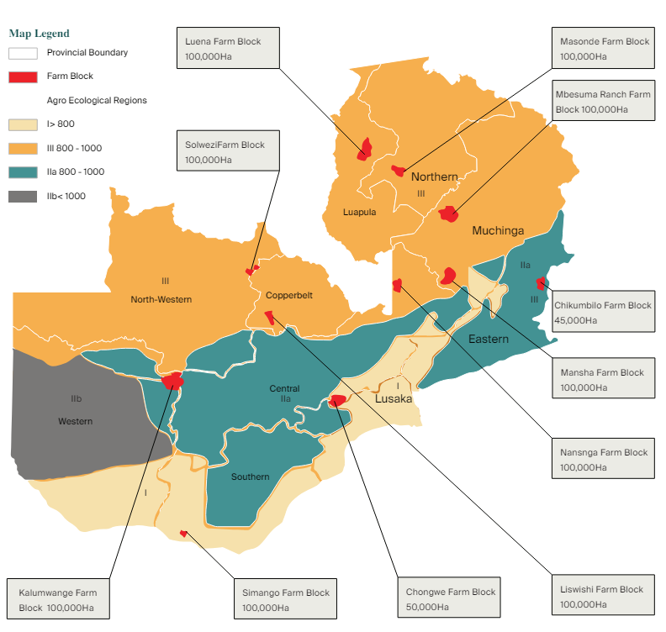
Source: Knight Frank Zambia Agri Market Update 2022/2023

Farm blocks are expected to accelerate agricultural growth, value addition and generation of much needed export earnings for the benefit of surrounding communities and the country.
The targeted farm blocks include Nansanga in Central Province, Luena in Luapula Province, Mushindamo in North-Western Province, Kalumwange in Western Province, Luswishi in Copperbelt Province, Manshya in Muchinga Province, Musokotwane in Southern Province, Chikumbilo in Eastern Province, Shikabeta in Lusaka, and Kalungwishi in Northern Province.
The AfDB supported the Farm Blocks Development Plan between 2016 and 2019 with a sovereign loan of UA720,000. The project supported 11 Farm Blocks earmarked for development totalling a gross area of 895,000 hectares. The main procurement under this support was a consultancy services for the conduct of a feasibility and detailed design study.

Farmer Input Support Programme (FISP)
The Farmer Input Support Programme (FISP) is a component of the Comprehensive Agricultural Support Programme (CASP), the main components of which include, infrastructure development, irrigation development, livestock development, extension services support, farm block development and climate change adaptation.
The Fertiliser Support Programme (FSP) was introduced in 2002 as a subsidy to supply agricultural inputs to support 120,000 vulnerable, but viable small-scale farmers. The subsidy focused on the distribution of maize seed and fertiliser to farmers as a way of contributing to increased household food security and income for the farmers. The number of beneficiaries steadily grew over the years and by 2008-09 farming season, the programme had 500,000 beneficiaries with the programme providing 8 x 50kg bags of fertiliser and 20kg of maize seed for farmers for them to cultivate 1 hectare of maize.
In the 2009-10 farming season, the Fertiliser Support Programme (FSP) was renamed to Farmer Input Support Programme (FISP) and reformed to increase the number of beneficiaries from 500,000 to 1,000,000 but the input package was reduced from 8 x 50kg bags to 4 bags of fertiliser and 10kg of maize seed and other seed (rice, sunflower, sorghum, groundnuts and soyabean) were added to the package. The cost of FISP to Government remained unchanged.
In 2015, the Electronic Voucher system was introduced with a pilot programme in 13 districts and 234,101 beneficiaries, using the Zambia Integrated Agricultural Management Information System (ZIAMIS) in collaboration with SMART Zambia. The idea was to give choice to the farmers to select the inputs required to support crop diversification and promote livestock production. Implementation of the programme resulted into lower cost of implementing the FISP by leveraging private sector participation in input distribution.
The E-voucher system was applied to all beneficiaries in the 2017-18 but there were too many flaws in the system and Government reverted back to the Direct Input Supply method. However, Government aims to fully administer FISP through electronic platforms and plans to do this over a 3-year period, commencing with the 2023-24 agricultural season as follows:
- Increased Private Sector Participation: The Electronic agricultural input system will rely on Agro dealers to spearhead the distribution of agricultural inputs.
- Network Coverage: Districts will require sufficient network coverage of equal to or above 80 per cent to qualify for full migration to the electronic support agricultural system for the first year. Government will facilitate the expansion of communication towers and increase connectivity in rural areas by establishing partnerships with mobile service providers.
- Transparent selection of beneficiaries: Cleaning and updating of the farmer register by Government; including upgrading to a biometric identification system will enhance transparency in the electronic agricultural input support system.
- Availability of funds at redemption: Government will constitute a procedure for transfer of subsidy money to commercial bank(s) for immediate payments and where banks are absent engage financial institutions for mobile payments of input supplies upon redemption.
- Usage throughout the year: To promote diversification and all year-round production the new mode of delivery will ensure all year use of the electronic system.
- Graduation Plan: Ministry of Agriculture and Ministry of Livestock will develop a clear graduation policy for farmers from the Input Support Programme for beneficiaries who become self-sustaining to lessen the pressure on the treasury.
- Equity principle: Government will ensure that the E-Voucher beneficiaries located in remote areas relative to Lusaka, receive more in monetary value than the beneficiaries located in urban areas.
Changes in the FISP system has implications for transport logistics in the agricultural sector.

Metal Mining and Processing

Mining Policy, Laws and Regulations
The primary law governing the mining sector in Zambia is the Mines and Minerals Development Act, No. 11 of 2015 (MMDA) as read together with the Mines and Minerals Development (Amendment) Act, No. 14 of 2016 and the Mines and Minerals Development (Amendment) Act, No. 29 of 2022. The MMDA deals with mining rights, licences, large-scale mining in Zambia, gemstone mining, health and safety, environmental protection, and geological services in respect of analysis, royalties and charges.
The policy objective of government is to achieve the production of 3 million metric tonnes of copper by 2032 amongst other objectives in the extractive/mining industry. According to the 2024 Parliamentary budget speech, to attract targeted investment and expedite mineral exploration projects across Zambia, the government plans to initiate a high-resolution countrywide geophysical survey in 2024. During the budget speech it was also announced that preliminary geological surveys have unearthed lithium deposits (a recognised critical mineral).
Zambia’s critical minerals strategy was approved in 2023 and includes the declaration of several minerals as strategic, including copper, cobalt, lithium, tin, graphite, coltan, manganese, rare earth elements, gold, sugilite, emeralds and diamonds.
Another component of the Zambian policy on critical minerals is for government to establish a state-owned investment firm that will hold at least a 30 per cent share in the production of critical minerals from future mining projects. The proposed SPV will be instrumental in Zambia’s investment in critical minerals, incorporating a “production sharing mechanism” to secure a minimum 30 per cent of output from new mines.

Copper, Cobalt and Gold
Zambia’s copper, cobalt and gold mining and processing companies are summarised in Tables 9.1 to 9.14.
Table 9.1: Mopani Copper and Cobalt Mines
Year opened | 1932
Current owner(s) | - Delta Mining Limited, a subsidiary of International Resource Holdings (IRH) 51 per cent  - ZCCM Investment Holdings (ZCCM-IH) 49 per cent
Facility type | - Ore mine to smelter
Products | - Copper metal  - Cobalt metal
Capacity | - Nkana Mine: 5,500,000 tons of copper ore.  - Mufulira Mine: 2,500,000 tons of copper ore.  - Mufulira (ISASMELT) smelter: 200,000 tons of copper anode.  - Mufulira refinery: 275,000 tons of copper cathode.  - Nkana solvent extraction plant: 15,000 copper cathode.  - Nkana cobalt plant: 7,000 tons of cobalt metal.
Location(s) | - Kitwe, Copperbelt (HQ)  - Mufulira, Copperbelt
Status | - Active

Table 9.2: Konkola Copper and Cobalt Mines
Year opened | - 1957
Current owner(s) | - Vedanta Resources Plc
Facility type | - Ore mine to smelter
Products | - Copper anodes  - LME A grade copper cathodes
Capacity | - Chingola open pit A and Nchanga open pit: 4,500,000 tons of copper ore  - Nchanga underground mine: 2,800,000 tons of copper ore  - Konkola Mine (KDMP): 2,400,000 tons of copper ore  - Nchanga tailings leach plant: 80,000 tons of copper cathode per annum  - Nchanga copper smelter: 311,000 tons of copper anode (blister copper) per annum and 3,000 tons of copper-cobalt alloy  - Nkana Copper Electrowinning Refinery: 300,000 tons of copper cathode
Location(s) | - Konkola Mine, Chililabombwe, Copperbelt  - Nchanga Copper mine, Chingola, Copperbelt  - Nkana Refinery, Kitwe, Copperbelt
Status | - Active

Table 9.3: Chibuluma Copper Mine
Year opened | - 1961
Current owner(s) | - Jinchuan Group 85 per cent  - ZCCM Investment Holdings (ZCCM-IH) 15 per cent
Facility type | - Ore Mine to  - Concentrator
Products | - Copper concentrate
Capacity | - 10,000 tonnes per annum
Location(s) | - Kalulushi, Kalulushi District, Copperbelt.
Status | - Active

Table 9.4: Luanshya Copper Mine – Baluba Mine
Year opened | - 1973
Current owner(s) | - China Nonferrous Metal Mining Co (CNMC) 80 per cent  - ZCCM Investment Holdings (ZCCM-IH) 20 per cent
Facility type | - Ore mine to smelter
Products | - Blister Copper Cathodes
Capacity | - 30,000 tonnes per annum
Location(s) | - Luanshya, Copperbelt Province
Status | - Active

Table 9.5: Kalumbila Copper Mine
Year opened | - 2016
Current owner(s) | - First Quantum Minerals (FQM) 100 per cent
Facility type | - Ore mine to concentrator
Products | - Copper concentrate
Capacity | - 230,000 tonnes per annum
Location(s) | - Kalumbila District, North-Western Province
Status | - Active

Table 9.6: Kansanshi Copper and Gold Mine
Year opened | - 2004 2015
Current owner(s) | - First Quantum Minerals (FQM) 80 per cent  - ZCCM Investments Holdings (ZCCM-IH) 20 per cent
Facility type | - Ore mine to smelter
Products | - Finished Copper Anodes  - Refined Gold
Capacity | - 336,000 tonnes per annum  - 120,000 Oz per annum
Location(s) | - Solwezi, Northwestern Province
Status | - Active

Table 9.7: Lumwana Copper mine
Year opened | - 2009
Current owner(s) | - Barrick Gold
Facility type | - Ore mine to concentrator
Products | - Copper Concentrate  - Unprocessed uranium byproduct
Capacity | - 140,000 tonnes per annum  - Information on uranium not available
Location(s) | - Lumwana, Northwestern Province
Status | - Active

Table 9.8: Chambishi Copper Mine
Year opened | - 1998 2007
Current owner(s) | - Non-Ferrous China Africa Mining Plc (NFCA)/China Nonferrous Metal Mining Co (CNMC) 85 per cent  - ZCCM Investments Holdings (ZCCM-IH) 15 per cent
Facility type | - Ore mine to smelter
Products | - Copper anodes
Capacity | - 24,000 tonnes per annum
Location(s) | - Kalulushi, Copperbelt Province
Status | - Active

Table 9.9: Chambishi Copper Smelter
Year opened | - 2008 2010
Current owner(s) | - China Nonferrous Metal Mining Co (CNMC)
Facility type | - Smelter
Products | - Blister Copper Cathodes  - Copper Anodes
Capacity | - 250,000 tonnes per annum
Location(s) | - Kalulushi, Copperbelt Province
Status | - Active

Table 9.10: Chambishi Metals
Year opened | - 1932
Current owner(s) | - Eurasian Resources Group (ERG) 90 per cent  - ZCCM Investment Holdings (ZCCM-IH) 10 per cent
Facility type | - Ore to mine smelter
Products | - Copper Metal  - Cobalt Metal  - Gypsum
Capacity | - Chambishi cobalt plant: 27,000 tons of copper cathode per annum and  - 6,000 tons of cobalt metal per annum  - Information on gypsum not available
Location(s) | - Chililabombwe, Copperbelt Province
Status | - Care and maintenance

Table 9.11: Chambishi Southeast Project
Year opened | - 2018
Current owner(s) | - China Nonferrous Metal Mining Co (CNMC)
Facility type | - Ore mine to concentrator
Products | - Copper Concentrate  - Cobalt Concentrate
Capacity | - Copper concentrate - 63,000 tonnes per annum  - Cobalt concentrate - 1,000 tonnes per annum
Location(s) | - Kalulushi, Copperbelt Province
Status | - Active

Table 9.12: Mwambashi Copper Mine
Year opened | - 2017
Current owner(s) | - Sino-Metals Leach Zambia Limited owned by SINO Metals of China
Facility type | - Ore Mine to Concentrator
Products | - Blister Copper Cathodes
Capacity | - 10,000 tonnes per annum
Location(s) | - Kalulushi, Copperbelt Province
Status | - Active

Table 9.13: Lubambe Copper and Cobalt Mine
Year opened | - 2013
Current owner(s) | - EMR Capital 80 per cent  - ZCCM Investments Holdings (ZCCM-IH) 20 per cent
Facility type | - Ore Mine to Concentrator
Products | - Copper
Capacity | - 45,000 tonnes per annum
Location(s) | - Chililabombwe, Copperbelt Province
Status | - Active
Notes | - The mine has 200,000 million tonne ore body with a seven million tonnes of copper at a high-grade rate of eight percent and large quantities of cobalt.  - Lubambe copper mine was originally a joint venture between African Rainbow Minerals (ARM) and Vale until EMR Capital acquired controlling interest in 2017.

Table 9.14: Other Copper, Cobalt and Gold Mines and Processing Plants
Muliashi north mine and the Muliashi leach plant | An integrated mining and leaching project in Luanshya, Copperbelt Province.
Kasenseli Gold Mine | In early August 2019, in Mwinilunga, gold deposits were discovered and confirmed by experts from the Ministry of Mines and Mineral Development. The Government, through its subsidiary, ZCCM Investments Holdings (ZCCM-IH), intends to set up a gold mine in Chief Chibwika's area where the gold deposits have been discovered. in March 2020, ZCCM-IH started buying gold from informal miners via ZCCM Gold Company. The extent of the gold reserves is yet to be established and ZCCM Gold Company has injected approximately ZMW45 million (U$2.2 million, 2020 Spot Exchange rate) for the initial phase of the Kasenseli Gold Mine Project. The Central Bank of Zambia (BOZ) has been purchasing doré gold from Kasenseli Mine since December 2020, through the Zambia Gold Company.
Mimbula Copper Project | Mimbula Copper Project is a copper rich oxide and sulphide deposit in Chingola on a mining licence held by Moxico Resources’ Zambian unit. Moxico Resources is a development and exploration mining company incorporated in the UK. Moxico holds an 85 per cent ownership in the license holding company and 15 per cent is held by Moxico's Zambian partners. The mining license was granted in May 2017, with a validity for 25 years. The British firm plans to invest US$100 million in the mine expansion.  In 2021, Moxico Resources began construction of a 10,000 tonne Leach Pad, Solvent Extraction and Electrowinning Plant. The Plant is expected to be operational by Q2 2022 and is planned to be expanded in phases.  Mimbula Mine was commissioned in March 2023. There are plans to expand the project from the current 10,000 metric tons per annum output to 56,000 metric tons.
Chitini Gold Project | Gold exploration Project located halfway between the towns of Kapiri Mposhi and Mkushi, Central Province.
Consolidated Gold Company Zambia | Gold processing and refining in Rufunsa District, Lusaka Province. It is a joint venture between Karma Mining and Mineral Development Company Limited (55 per cent) of Sudan and ZCCM Investments Holdings (ZCCM-IH) (45 per cent) signed in 2020. The plant was set up at a cost of about US$3.5 million. The site has 20 gold milling plants with a combined Capacity of 90 kg per annum and a vat leaching plant with capacity 210 kg per annum

Nickel, Zinc, Lead and Manganese
Zambia’s nickel, zinc and lead mining and processing companies are summarised in Table 9.15.
Table 9.15: Nickel, Zinc and Lead Mines and Processing Plants
Munali Nickel Mine | In September 2006 Albidon Limited of Australia obtained permits and approvals to mine Nickel in Mazabuka, Sothern Province. The initial project development required more than U$180 million, which was funded by debt financing from Barclays Capital and the European Investment Bank and equity from Albidon Limited, JINCHUAN mining group of China and ZCCM Investment Holdings.  Albidon Zambia Limited (AZL) commenced mining and production of nickel concentrates in April 2008. Operations were suspended in 2009 because of poor market conditions. It was briefly owned and run by JINCHUAN mining group of China from 2010. JINCHUAN would invest U$37 million and employ about 350 workers. However, the mine was shut down again in 2011 because of cash flow problems.  A joint venture Mabiza Resources between Consolidated Nickel Mines Plc of the United Kingdom and CE Mining took ownership in 2014 but delayed capital injection which led the government of Zambia to threaten repossession of the asset. From 2015 the JV has placed in U$50 million investment and the mine recommenced operations in 2019.  Munali expected to export about 4,000MT of 10 per cent to 12.5 per cent high quality nickel concentrate in 2021. Although it is billed as a nickel project, Munali also contains commercial quantities of copper, cobalt and platinum group metals (PGMs).
Enterprise Nickel Project | The Enterprise Nickel Project is an open-pit nickel mine, owned by First Quantum Minerals in Kalumbila, located 12 km from the Kalumbila (Sentinel) Mine. The Kalumbila Mine processing facility is used to produce nickel concentrate output. Enterprise became operational in June 2024 with a projected capacity of 30,000 tons of nickel annually.
Kabundi Manganese Mine | Kabundi Manganese Mine is located in Kabundi, Serenje, Central Province and is operated by Kabundi Resources Ltd which is 100 per cent owned by ZCCM Investments Holdings (ZCCM-IH) and encompasses a Large-Scale Exploration Licence for exploration for commodities which include manganese, cobalt, copper, zinc, limestone and precious minerals. It has a capacity of 20,000 tonnes of manganese per annum.
Other Manganese Mines | There are many small-scale manganese mines, including Kampumba Manganese Project in Kapiri Mposhi in Central Province and mines between Mkushi and Serenje in Central Province and between Mansa and Chipili in Luapula Province. Many of these mines and the processing plants are small-scale and difficult to regulate.
Sable Zinc Refinery | Jubilee Metals Group of South Africa has acquired the rights to process the tailings of the now closed Broken Hill lead and zinc mine in Kabwe, Central Province. The Jubilee Metals operation has a capacity to produce 8,000 tonnes per annum of zinc, 1,500tpa of vanadium and 15,000tpa of lead.

Regional Transport Corridor Infrastructure
Zambia is a part of six or seven, depending on how they are defined, road, rail and multimodal transport, trade and transit corridors as shown in Figure 10.1.
Figure 10.1: Map of the Transport, Trade and Transit Corridors linking Zambia to the World.
Source: Authors
In terms of traffic volumes and value of cargo, the North-South Corridor, a road and rail corridor, is the most important corridor, although most freight on the North-South Corridor is transported by road rather than rail.
The Dar es Salam Corridor, including the Tanzania-Zambia Railway (TAZARA), is also an important corridor and, with the recent concessioning of TAZARA to China Civil Engineering Construction Company (CCECC), and with DP World and Adani ports holding concessions to operate the port of Dar es Salaam, the railway corridor, the Tanzania-Zambia Railway (TAZARA) is becoming more prominent in terms of freight carried. The road corridor has been an important corridor for many years, especially for freight going to DR Congo from Dar es Salaam port and Tanzania, with most of this cargo passing through Kasumbalesa border. The Dar Corridor is also an important route for exports of copper in particular but also manganese. Zambia uses this corridor to predominantly import fuel, fertiliser and containerised cargo.
The port of Mpulungu is also an important component on the logistics network. However, Mpulungu port is not utilised as much as it could be to service the markets in the south-east of DR Congo and the Great Lakes region because of, mainly, port infrastructure challenges.
There is considerable interest being shown in the development of the Lobito Corridor, including the existing railway lines that run between the port of Lobito and the border of DR Congo in Angola and the line that connects the DR Congo Copperbelt to the border with Angola, and so connects the Copperbelt by rail to the port of Lobito.
The feasibility of developing a greenfield railway that connects the Zambian Copperbelt, from Chingola, through Solwezi, across the border with Angola and joining the existing railway line to Lobito is also actively being explored. Backed by the African Finance Corporation (AFC) as the lead developer, along with the Partnership for Global Infrastructure and Investment (PGII) led by the EU, US, and other G7 nations, the USD 5.3 billion, 800-kilometer green-field railway project is a strategic infrastructure initiative for the Zambian government.
The Walvis Bay Corridor, which is a road corridor, is also an important corridor for DR Congo and Zambia, mainly used for imports of project cargo for the mines and as an export route for copper.
The Beira Corridor is an important link for Zambia to the Indian Ocean and which is used to import mainly fertiliser and fuel.
Other corridors servicing Zambia includes the Nacala Corridor but, in terms of cargo volumes and values, these are of lesser importance than the corridors mentioned above.

Corridor Ports, Roads, Railways, and Dry Ports
Table 10.1: Corridor Ports, Roads, Railways and Dry Ports
Infrastructure |  | Corridors
 |  | North-South | Dar es Salaam | Beira | Walvis Bay | Lobito
Ports | Durban  The Durban Container Terminal (DCT) has a combined capacity of 3.6 million TEU per annum, which will increase to 4 million TEU after the berth extension and after the completion of the work to deepen terminal draft to 16m. DCT operates as two terminals Pier 1 and Pier 2, handling 65 per cent of South Africa’s container volumes and can handle new generation vessels with 24 containers stowed across the deck. Updated information on anchorage, vessel updates, stack dates list, import storage list, terminal berthing list and terminal performance reports can be sourced from Transnet | X
Ports | Dar es Salaam  Dar es Salaam port is the Tanzania principal port with a rated capacity of 14.1 million tonnes of dry cargo and 6 million tonnes of bulk liquid cargo per annum. The Port has a total quay length of about 2,600 metres with twelve berths. Port facilities include a general cargo berth for break bulk, dry bulk and a RORO berth (to handle vehicles); container terminal berths; grain terminal facility (silos with storage capacity of 30,000 tons); a 150,000 metric tonne Single Point Mooring (for handling refined and crude oil) and the Kurasini oil jetty (for handling refined products).  In January 2023 Adani International Ports Holdings (AIPH) signed a 30-year concession agreement with the Tanzania Ports Authority to operate and manage the four-berth Container Terminal 2 (CT2), with an annual cargo handling capacity of 1 million TEU. CT2 was operated by Tanzania International Container Terminal Services Limited (TICTS) from 2000-22, owned by Hutchison Port Holdings Limited and Harbours Investment Limited.  In October 2023 DP World signed a 30-year concession agreement with Tanzania Ports Authority to manage 4 of Dar es Salaam port’s 12 berths. DP World has committed to construction of a refrigerated storage facility, improvements to the port railway connections and development of a special economic zone.  The TAZAMA pipeline, which terminates at Indeni, Ndola, is connected to the Dar es Salaam port Single Point Mooring. |  | X
Ports | Beira  The Port of Beira is the second largest port in Mozambique, built to replace the port of Old Sofala in the 1890s.  The port is owned by the Mozambican government and Mozambique Ports and Railways (CFM) is responsible for the administration and operations of the cargo and passenger terminals.  Beira has two piers, with a depth between 8 and 12 meters. Access to the port is via the "Macuti channel" which is 31 km in length with a depth of about 11 metres but needs to be regularly dredged. The channel has a minimum width of 60 meters and allows ships of a maximum of 200 meters in length. |  |  | X

Infrastructure |  | Corridors
 |  | North-South | Dar es Salaam | Beira | Walvis Bay | Lobito
Ports | Walvis Bay  Walvis Bay is a deep-water harbour and Namibia’s largest commercial port, receiving about 900 vessels and handling about 8 million tonnes of cargo per annum. It has a container throughput capacity of 750,000 TEUs and can handle ten million tonnes of liquid bulk cargo per annum as well as ten million tons of dry and break-bulk cargo per annum. It comprises 13 commercial berths including a tanker jetty, and a passenger berth. Two new liquid bulk jetties, each of maximum capacity of 90,000 DWT are located at the North port with more than 1,300 hectares of backup land for tank storage of liquid, gas and associated industries. Zambia has a dry port facility at Walvis Bay port, operated by Zamcargo. |  |  |  | X
Ports | Lobito  Africa Global Logistics (AGL, formerly Bolloré Africa Logistics), a subsidiary of MSC, signed the concession to run Lobito port in December 2023. AGL will manage the multipurpose terminal, including the container activity, which has 1,200m of quay, a storage area with a capacity of 12,000 TEUs and handling equipment. AGL has 22 port and railway concessions worldwide and plans to invest USD100m to upgrade Lobito port. |  |  |  |  | X
DRC Roads | Sakania-Kasumbalesa: The DRC has recently completed construction of a 120km road between Kasumbalesa and Sakania via Mokambo. | X | X | X
DRC Roads | Kasumbalesa-Lubumbashi: This is a tolled, surfaced road of about 100km in length. It is concessioned to a Chinese operator and the toll for a truck for a return journey is usd300. The tolls are paid in cash at toll booths along the way and receipts are hand-written, which causes probably unnecessary congestion and delays. | X | X | X
DRC Roads | Lubumbashi-Likasi: This is a tolled, surfaced road of about 124km in length. It is concessioned to a Chinese operator and the toll for a truck for a return journey is usd300. The tolls are paid in cash at toll booths along the way and receipts are handwritten, which causes probably unnecessary congestion and delays. | X | X | X | X | X
DRC Roads | Likasi-Kolwezi: This is a tolled, surfaced road of about 175km in length. It is concessioned to a Chinese operator and the toll for a truck for a return journey is USD300 plus a concession fee of USD100 return to cross the bridge across the Lualaba River. The tolls are paid in cash at toll booths along the way and receipts are handwritten, which causes probably unnecessary congestion and delays. | X | X | X | X | X
DRC Roads | Kolwezi-Sakabinda: A MoU was signed between Zambia and DRC on the construction of 145km road from Kolwezi to Lumwana in Zambia via the Kambimba-Sakabinda border post, which will be an OSBP. The concessionaire on the DRC side is Toha Investment Limited who will construct 60km of road on the DRC side and upgrade border infrastructure. |  |  |  | X

Infrastructure |  | Corridors
 |  | North-South | Dar es Salaam | Beira | Walvis Bay | Lobito
Zambia Roads | Chingola-Solwezi-Mutanda: A PPP project, the concessionaire being Bert motors. The estimated project cost is USD450m. The project involves the construction of a dual carriageway between Chingola and Solwezi, including bypass roads in Chingola and Solwezi. The build-operate-maintain-transfer (BOT) was signed in May 2021. |  |  |  | X
Zambia Roads | Mutanda-Kasempa-Kaoma: (367km). Kasempa to Lunga (90km) is a gravel road and there is a ferry crossing at Lunga. This road is to be concessioned as a PPP although financial closure has not yet been arrived at. Gravel but government has finalised the process of identifying a contractor for the Kasempa-Kaoma Road which will be upgraded and surfaced to enhance economic activities.
Zambia Roads | Kaoma-Mongu: Single-lane surfaced road in good condition |  |  |  | X
Zambia Roads | Mongu – Sesheke: Single Lane surfaced road in good condition |  |  |  | X
Zambia Roads | Kasumbalesa-Chingola: Has been upgraded as a PPP and is concessioned to Turbo Ka-chin and tolled and is in good condition. | X | X
Zambia Roads | Chingola-Kitwe: Dual carriageway both ways, in good condition. The road is tolled. | X | X
Zambia Roads | Kitwe-Ndola: Dual carriageway in good condition. | X | X
Zambia Roads | Lusaka-Kabwe-Kapiri Mposhi- Ndola Dual Carriage Road: (327km) This road is being upgraded to dual carriage way. The upgrade also includes the 45km Luanshya-Fisenge-Masangano road. the road is concessioned to Macro Oceans Investment Consortium as a Design, Finance, Build, Operate, Maintain and Transfer PPP. The cost of the construction is expected to be USD649.9 million | X | X
Zambia Roads | Lusaka-Kafue T2 Turn-Off: Single Lane carriageway both ways, with climbing lanes in strategic sections, in good condition. There is a lot of traffic all the way from the T2 turn off into Lusaka which slows traffic down. The road is tolled. | X | X
Zambia Roads | Kafue T2 Turn-Off and Livingstone: A single lane carriageway both ways, in good condition. There is often a lot of traffic in Monze and Choma, which slows traffic down. The road is tolled. | X
Zambia Roads | Livingstone-Kazungula: Single Lane carriageway both ways, in good condition. | X
Zambia Roads | Kazungula-Sesheke: In poor condition, but efforts have been made to rehabilitate it. At present the bitumen surface, which was heavily potholed, which made driving slow, difficult and dangerous, has been removed and the surface is graded gravel. |  |  |  | X
Zambia Roads | Sesheke-Mongu: The road (M10) from Sesheke to Mongu is a good, tarred road, with bridges spanning the Zambezi River. |  |  |  | X
Zambia Roads | Mongu-Kaoma: (193km) The road between Mongu and Kaoma is a bitumen surfaced road, but the bitumen surface has deteriorated considerably so that the road is now in very bad condition. Rehabilitation work from the Tateyoyo gate to the Katunda/Lukulu junction started in August 2024. |  |  |  | X
Zambia Roads | Kaoma-Kasempa-Mutanda: (371km) Currently, this road is a gravel road, but a public-private partnership has recently been signed with Barotse Highway Limited (BHL), in partnership with First Quantum Limited (FQM), for a 25-year concession. The estimated cost of the project is USD326 million. The project includes surfacing 10km of urban roads in Kasempa and 10km of urban roads in Kaoma town to bituminous standard and the construction of two new bridges at Lalafuta and Luena rivers. The concession agreement was signed in December 2024 and is awaiting financial closure. |  |  |  | X
Zambia Roads | Kolwezi-Kambimba: MoU signed between Zambia and DRC on the construction of 145km road from Lumwana to Kolwezi in DRC via the Kambimba-Sakabinda border post, which will be a OSBP. The concessionaire on the Zambian side is Sandstone Consortium Limited, who will construct 85km of road in Zambia and upgrade border infrastructure. |  |  |  | X
Zambia Roads | Kapiri Mposhi – Mkushi (99km). The Kapiri Mposhi to Mkushi road is part of the T2 road. It is heavily trafficked and needs to be dualised, or at least widened in parts, with climbing lanes and needs rehabilitation. |  | X

Infrastructure |  | Corridors
 |  | North-South | Dar es Salaam | Beira | Walvis Bay | Lobito
Zambia Roads | Mkushi-Serenje (116km). the highway between Mkushi and Serenje has narrow carriageways, s a single-land road, has hard shoulders that have mostly been eroded , has pot holes and is considered a dangerous road to drive on. |  | X
Zambia Roads | Serenje-Chinsali (427km). This road has recently been reconstructed and is now in good condition |  | X
Zambia Roads | Chinsali-Isoka-Nakonde (284km). The rehabilitation works on the Chinsali-Isoka-Nakonde Great North Road are almost complete. The rehabilitation works have been divided into two lots with Lot 1 covering a stretch of 103 km from Chinsali to Isoka, while Lot 2 is a 107 km stretch from Isoka to Nakonde. Works commenced in April 2029, with the contractor for Lot 1 being China State Construction Engineering Corporation and for Lot 2 the contractor is China Railway Seventh Group Company Limited. |  | X
Zambia Roads | Katete-Chanida: The Zambia section of the Beira Road Corridor is between Lusaka (where the road joins the North-South Corridor) and the Chanida border post. The section of the road between Lusaka and the turn-off to Chanida at Katete (the T4 highway) is in fair condition and is a single lane carriageway in both directions. The road from Katete to Chanida is in very poor condition and has a lot of potholes. However, this road is to be reconstructed as part of the concession agreement to be signed by government and Lutembwe Consulting (Sable) Investment. |  |  | X
Zimbabwe Roads | Chirundu-Harare (354km). The Harare-Chirundu Highway in Zimbabwe has been in poor condition. In February 2024 the Zimbabwe Government began a USD550 million upgrade project. The project, which is supposed to be completed in 18 months, includes widening, resurfacing, and reconstruction of the road. The road is a tolled road, with two toll gates between Chirundu Border Post and Harare and heavy goods vehicles are charged USD10 at each toll gate. | X
Zimbabwe Roads | Harare-Masvingo-Beitbridge (580km). This is a tolled road. As of April 2024, 474.5 km of the 580 km Harare-Masvingo-Beitbridge highway had been upgraded and opened to traffic, although there are still sections of road, such as from Nyanda to Chibi Tollgate, that are still in poor condition. There are 6 toll gates between Harare and Beitbridge and a heavy goods truck (foreign registered) is charged USD10 at each toll gate | X
Zimbabwe Roads | Beitbridge-Bulawayo-Victoria Falls (754km) The Beitbridge-Bulawayo-Victoria Falls Road in Zimbabwe is in a poor condition. The road has been damaged mainly by heavy haul trucks, especially those from coal mining operations, and now has many potholes, and, in some stretches, the road surface has collapsed entirely. A rehabilitation project, which is part of the government’s Emergency Road Rehabilitation Programme Phase Two (ERRP 2), is planned, with the planned rehabilitation including upgrading, widening, and dualising the road. | X
Botswana Roads | Kazungula-Nata (304km). this is a good bitumen-surfaced road that is a single-lane carriageway which varies in width, but which has long sections of very wide carriageways and surfaced hard shoulders | X
Botswana Roads | Nata-Francistown (189km). The Nata-Francistown Road is a surfaced bitumen road. It is a single-laned carriageway, but it is soon to be upgraded and reconstructed. | X
Botswana Roads | Francistown-Palapye (169km) While not entirely a dual carriageway across its whole length, the A1 Road in Botswana is currently undergoing major upgrades to convert significant sections of it into a dual carriageway, particularly between Tonota and Francistown, which is being transformed from a single-lane road to a divided dual carriageway with new bridge structures over rivers like Tati, Shashe, and Tholodi. | X
Botswana Roads | Palapye-Martins drift 112km), this is a single carriageway in reasonable condition. However, it was built as a tourist road, expecting light traffic. Instead the road is now heavily trafficked by heavy goods trucks. | X

Infrastructure |  | Corridors
 |  | North-South | Dar es Salaam | Beira | Walvis Bay | Lobito
South Africa Roads | Groblersbrug-Polakwane (204km) The road is a surfaced road generally in fair condition. However the road is not constructed for heavy traffic and is a single carriageway with gravel hard shoulders. | X
South Africa Roads | Beitbridge-Polakwane (213km) This is a tolled dual carriageway in good condition | X
South Africa Roads | Polakwane-Johannesburg (322) This is a tolled dual carriageway in good condition | X
South Africa Roads | Johannesburg-Durban (571km) This is a tolled dual carriageway in good condition | X
Rail | Zambia Railways: The Zambia Railways network is 1,200 km between Livingstone and Sakania on the border with DRC and includes the inter-mine lines on the Copperbelt linking Ndola, Kitwe, Chingola, Mufulira and Chililabombwe. ZRL connects to the TAZARA railway at Kapiri-Mposhi. The Chipata-Mchinji network that connects Zambia to Malawi and Mozambique is also part of the ZR network. The ZRL tracks are in poor condition because of deferred maintenance and aging. The condition of the tracks limits the speed of trains and makes it difficult for ZRL to operate efficiently. ZRL also has insufficient locomotives and hires mainline locomotives. It also has insufficient rolling stock | X
Rail | National Railways of Zimbabwe: Zimbabwe's railways are in poor condition because of a lack of maintenance, poor management, and the country's economic decline. NRZ has seen a decline in services and goods transport. NRZ operates about 4,225km of Cape gauge railway lines, providing freight services.  NRZ has an important transit function. The system links to the Zambia Railways, crossing the Victoria Falls Bridge. To the east, the system links to the Mozambique Ports and Railways. A second line toward Mozambique reaches Maputo. To the west, a connecting line link ups to Botswana Railways to reach the port of Durban. A direct line to South Africa from Bulawayo was opened in 1999 by the Beitbridge Bulawayo Railway. As of May 2023, no passenger services are operated by NRZ. | X
Rail | Transnet Freight Rail: TFR is a freight logistics and passenger transport railway and the largest freight hauler in Africa. TFR comprises GFB Commercial (General Freight Business); the Coal Line, serving coal exporters on the Mpumalanga – Richards Bay line; Ore Export Line – dedicated to iron ore transport on the Sishen to Saldanha line; and Luxrail (the Blue Train). The state of logistics in south Africa continues to deteriorate and a National Logistics Crisis Committee (NLCC) has been established to try to find solutions and make it easier to transport | X
Rail | TAZARA: TAZARA is bi-national railway jointly owned by the governments of Tanzania and Zambia. The 1,860km-railway was built as a turn-key project, with an interest-free loan from China between 1970 and 1975. TAZARA, which became fully operational in July 1976.It is a Cape gauge (1067mm) railway line linking Kapiri Mposhi to Dar es Salaam, with a freight capacity of 5 mill metric tonnes per annum.  TAZARA has cargo termini, complete with gantry cranes and other handling facilities, at Kapiri Mposhi, Kasama, Makambako and Dar es Salaam stations.  In August 2017 TAZARA signed an Open Access Agreement with ZRL and signed an MoU with Calabash Freight Limited. Calabash supplies its own rolling stock and locomotives (Euro4000 or Afro4000), uses a swing-set of containers to reduce loading and offloading times, caboose operations to reduce crew delays and locomotive banking solutions over the escarpment for longer trains.  In October 2023 TAZARA announced that the China Civil Engineering Construction Corporation (CCECC) would be provided with a Build-Operate-Transfer (BOT) concession to operate TAZARA. |  | X

Infrastructure |  | Corridors
 |  | North-South | Dar es Salaam | Beira | Walvis Bay | Lobito
 | Zambia Lobito Railway (ZLR): Proposed greenfield railway project that will link Chingola to the port of Lobito in Angola. The railway is planned as an 829km stretch of new, Cape gauge railway line from Chingola, through Solwezi, to the Zambian and Angolan border south of Jimbe, the existing road border. The railway track will cross the border into Angola and join the existing Benguela railway operated by Lobito Atlantic Railway and onto the port of Lobito. |  |  |  |  | X
Fuel Pipeline | TAZAMA: The Tanzania Zambia Mafuta (TAZAMA) pipeline runs from Dar es Salaam port to Ndola (Indeni) in Zambia, a distance of about 1,710km. For 954km the pipeline has a diameter of 8 inches (200 mm), and for the remaining 798 kilometres the pipeline diameter is 12 inches (300 mm). When installed in 1968, the pipeline had a carrying capacity of 1.1 million tonnes annually, but this has steadily decreased to an estimated 600,000 tonnes or less annually.  Under the government’s reform plan, Zambia switched from importing crude feedstock to refined imported petroleum products from Dar es Salaam, Mozambique, South Africa, and Namibia, which rendered the TAZAMA pipeline obsolete. However, in 2022, the pipeline was modified and upgraded to transport diesel fuel.  Zambia and Tanzania have initiated government-to-government talks to construct a new 12-inch pipeline parallel to the existing pipeline to transport oil to Zambia and the southern parts of Tanzania. The new pipeline would be 1,710km and need an investment of about USD2.5 billion. |  | X
Dry ports and Cargo Termini | Walvis Bay: Namibia has made dry ports available to Botswana, DR Congo, Zambia and Zimbabwe at Walvis Bay port. Zambia’s Dry Port in Walvis Bay port was operated under a concession by Africa Union Finances Services (AUFS) but this concession expired in July 2024. As from August 2023 the Dry Port is being run and managed by ZamCargo, an IDC Company, who have been tasked to develop the dry port into a modern facility that will enhance imports and exports. |  |  |  | X
Dry ports and Cargo Termini | The Dar es Salaam Corridor Group (DCG) and TAZARA have entered into a build-lease-transfer PPP agreement for the development of a Dry Port at Kapiri Mposhi. DCG will operate on a 4.4-hectare piece of land on the northern side of Kapiri Mposhi railway station, with an already installed gantry crane of 36mt lifting capacity, construct the Dry Port, operate (lease) it for 25 years and, thereafter, transfer all the immovable assets to TAZARA. |  | X
Dry ports and Cargo Termini | TAZARA has modern cargo terminus, complete with gantry cranes and other handling facilities at New Kapiri Mposhi, Kasama, Makambako and Dar es Salaam stations. These facilities provide a quick and efficient means for exporters and importers from different regions of Africa to load and offload cargo onto and from TAZARA wagons. New Kapiri Mposhi handles cargo to and from the Southern and Central African regions, whilst Kasama covers the Great Lakes region. Similarly, Mbeya and Makambako cater for cargo from Malawi and some parts of the Great Lakes. With such spread of the TAZARA terminus, cargo is easily relayed from region to region. In addition, there is a privately owned trans-shipment facility at Kidatu that handles the transfer of cargo from the wider gauge (1,067mm) wagons of TAZARA onto the narrower gauge (1,000mm) wagons of the Tanzania Railways Limited (TRL) facilitating interconnectivity amongst Southern, Central and East Africa. |  | X

Zambia’s Border Posts
Border Post | KAZUNGULA
Description:
The Kazungula Bridge and One stop Border Post (OSBP) was officially opened to the public in 2021.
The original plan for the bridge construction, and the subject of the original feasibility study, was to site the bridge at the narrowest point of the river, and to construct a straight bridge. However, because of objections to the siting of the bridge from Zimbabwe, the bridge location was moved further up-stream, and the design of the bridge was changed to a curved extradosed road/rail bridge so that the bridge did not infringe on Zimbabwean territory. The realignment and redesign of the bridge delayed the start of construction and significantly increased the cost of bridge construction.
The Kazungula OSBP is designed as a juxtaposed one stop border post. North-bound traffic, coming from Botswana into Zambia, does not stop in Botswana but goes across the bridge and enters the control zone on the Zambia side of the border, where the processes for exit of Botswana and entry into Zambia are performed. For southbound traffic, all procedures for persons, vehicles and goods to exit Zambia and enter Botswana will be carried out in the Botswana terminal. This is shown in the figures below.
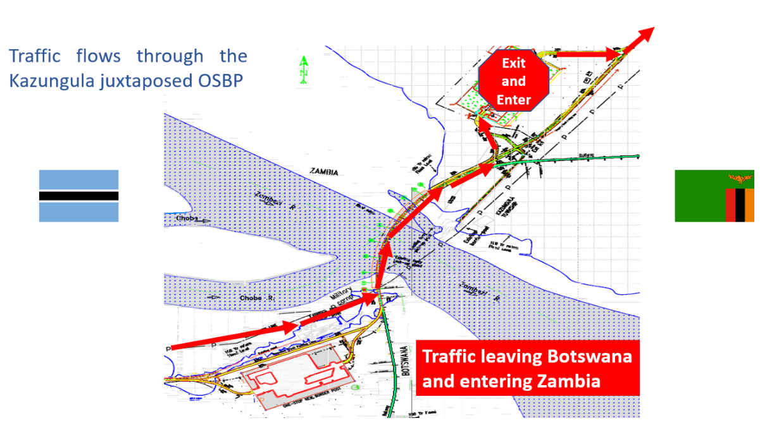

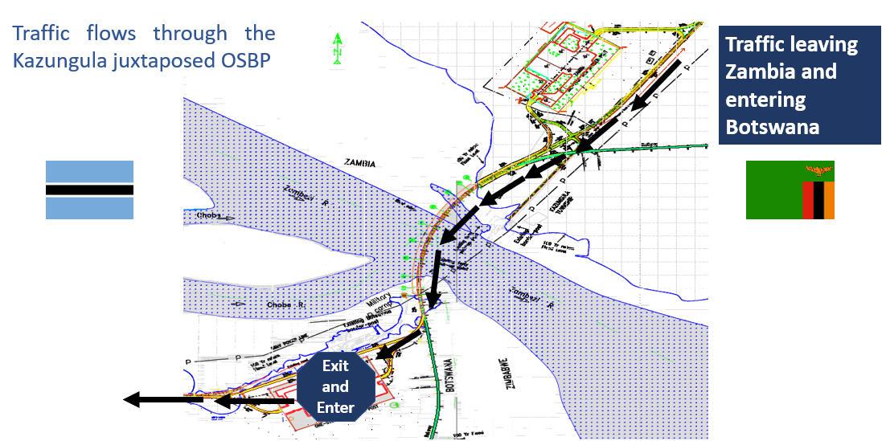
Source: Author, based on Bridge Consultant’s drawings
In both facilities there is provision for the separation of commercial and passenger traffic. The commercial traffic can be further separated into low-risk cargo which can be immediately processed through the border post and not delayed, and medium to high-risk cargo, which needs to be detained, for as short a time as possible, to allow for documentary and physical checks if necessary. There is also provision to separate out abnormal loads, which are processed differently to normal commercial traffic.
Satellite View of the Border Post (Botswana) | Satellite View of Border Post (Zambia)
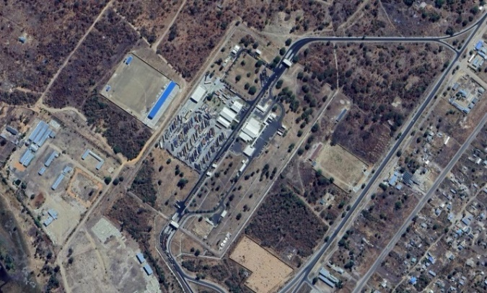 | 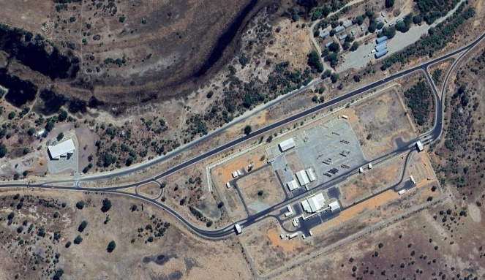
Kazungula Bridge and Zambian and Botswanan OSBPs
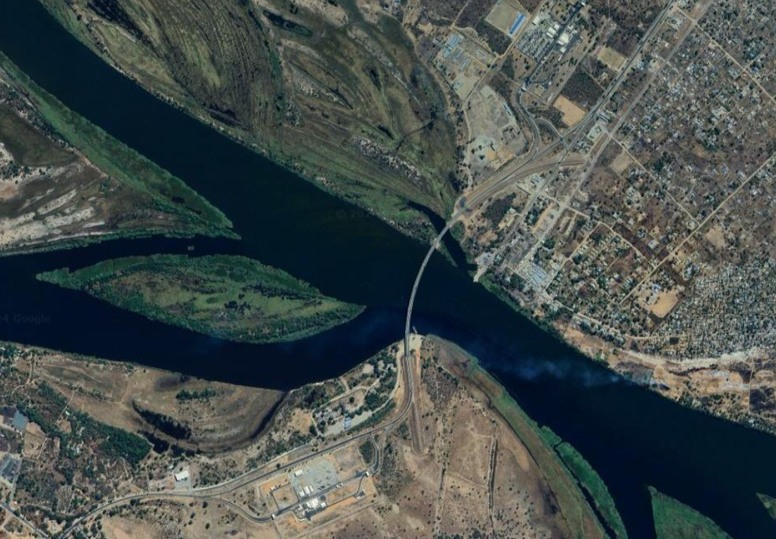
Concessioning: There are no plans to concession the Kazungula OSBP and to bring in a private sector partner.
Corridor Border is on: | North South Corridor
Opening Hours: | 24 hours

Border Post | CHIRUNDU
Description:
Chirundu border post, between Zambia and Zimbabwe, was the first sub-Saharan Africa one-stop border post, commissioned in 2009. Chirundu, on the North-South Corridor, is one of the busiest borders in Zambia, with most goods originating from South Africa, or from overseas but arriving at the port of Durban, and either with Zambia as a final destination, or transiting through Zambia with DR Congo as a final destination.
Satellite View of Border Post
Chirundu border post North (Zambia) and South (Zimbabwe) and Bridge
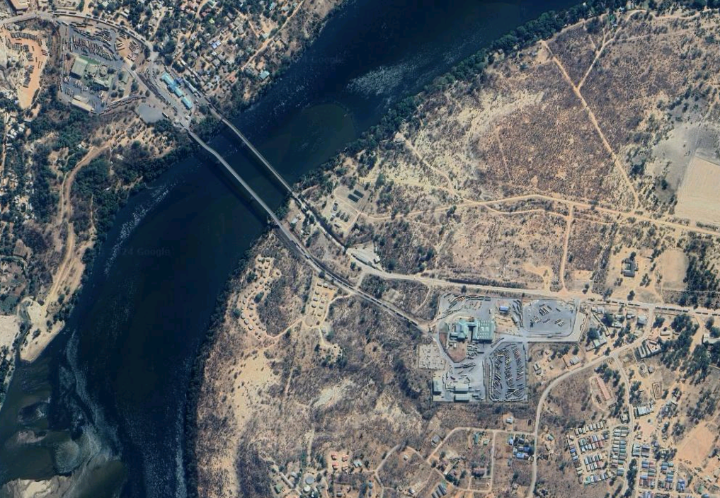

Concessioning: Chirundu Border Post is in the process of being concessioned to Chirundu Borders Consortium in July 2024. The project involves the redevelopment and upgrade of the soft and hard infrastructure at Chirundu One Stop Border Post. The concession is awaiting commercial close.
Corridor Border is on: | North South Corridor

Border Post | SIAVONGA/KARIBA
Kariba border post North and South
Description:
Kariba border post is a very quiet border, with little cargo traffic. On the Zabian side, to get to Siavonga, the truck needs to leave the main Lusaka-Chirundu (T2) road about 20km from Chirundu to travel about 60km on narrow and, at times, roads with steep gradients, cross the border and then travel another 77km in Zimbabwe along narrow, windy roads to join the main (A1) road at Makuti. Because the road runs over the Kariba Dam wall, there are some restrictions on heavy duty cargo trucks.
Map of Location of the Border Post | Satellite View of Border Post
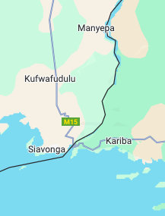 | 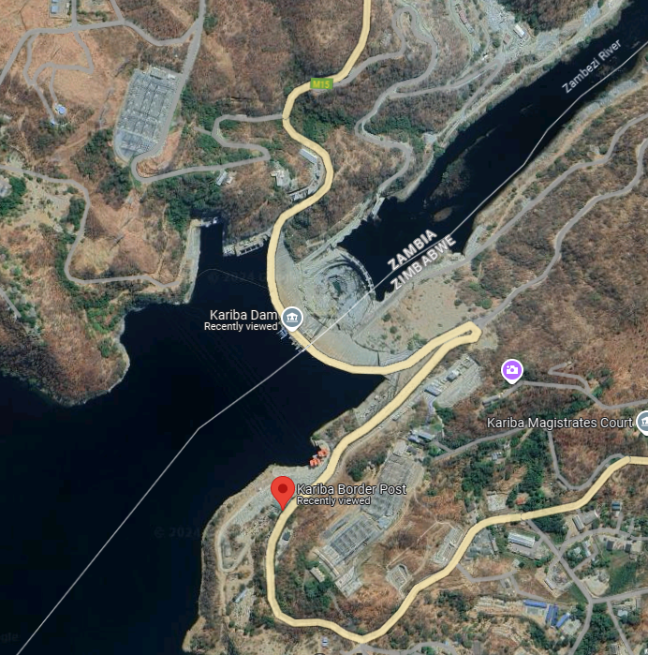
Concessioning: There are no plans to concession this border post
Corridor Border is on: | North South Corridor

Border Post | LIVINGSTONE
Description:
The Zambia Revenue Authority is trying to encourage commercial goods traffic not to use Livingstone border post and, instead, to use Kazungula border post. This is because the facilities at the Livingstone border post cannot handle large volumes of commercial cargo, partly because of limited available parking, and because Livingstone is designated as Zambia’s main tourist destination. About 50 trucks per day cross both ways with about a 1-2 hour wait when all documentation is correct. The Zambian government has issued a statutory instrument (SI) to restrict the axle load passing through the Victoria Falls bridge to less than 18 tons to ty to preserve the bridge.
Map of Location of the Border Post | Satellite View of Border Post
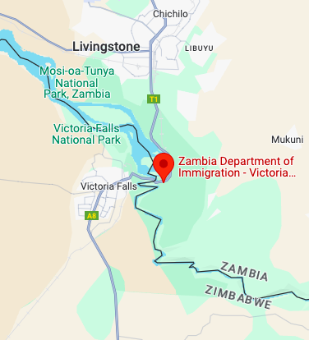 | 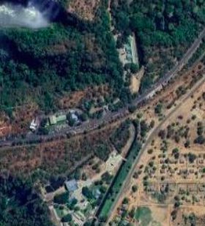
Concessioning: There are no plans to concession this border
Corridor Border is on: | North South Corridor

Border Post | KASUMBLESA
Description:
Kasumbalesa Border Post was first concessioned to ZIPBCC in July 2009, with the concession involving the design, build, operate and transfer of the Kasumbalesa Border Post facilities in the Zambian side of the border. The concession did not address the small-scale trader activities and only addressed commercial activities, mainly by constructing a new building for the use of Customs and other border agencies a truck park and installation of a Vehicle Traffic Management system that allowed the concessionaire to charge trucks entering and exiting the border area. The operations of the border facility by the Zambian (IP) Border Crossing Company (ZipBCC) commenced in March 2011 and, after the expiry of the concession in March 2023, Zambia Revenue Authority has taken over the management of the Vehicle Traffic Management System installed by ZipBCC.

Kasumbalesa is not a “normal” border post and there are three different types of trading activity taking place at Kasumbalesa:
- South-bound commercial traffic, mainly minerals (such as copper) in transit from DR Congo, passing through Zambia on the way to a port, such as Walvis Bay, Durban or Dar es Salaam;
- North-bound commercial goods consigned to mines in DR Congo, or liquid bulk (mainly fuel or chemicals), transiting through Zambia to DR Congo; and
- Break bulk, fast-moving-consumer-goods, and foodstuffs that are either transiting through Zambia (such as fish from Namibia or onions from Tanzania or electrical goods from the Far East) or originating from Zambia. These goods are deconsolidated into smaller consignments and transhipped from Zambia to DR Congo using “bicycles” or tricycles or carts by small-scall cross-border traders who are usually Congolese who cross the border from Congo to Zambia every day to purchase goods from the Zambian marketplace and take them into DR Congo using the services of the bicycles, tricycles or carts who use a specially designated corridor for this transhipping exercise.
Map of Location of the Border Post | Satellite View of Border Post
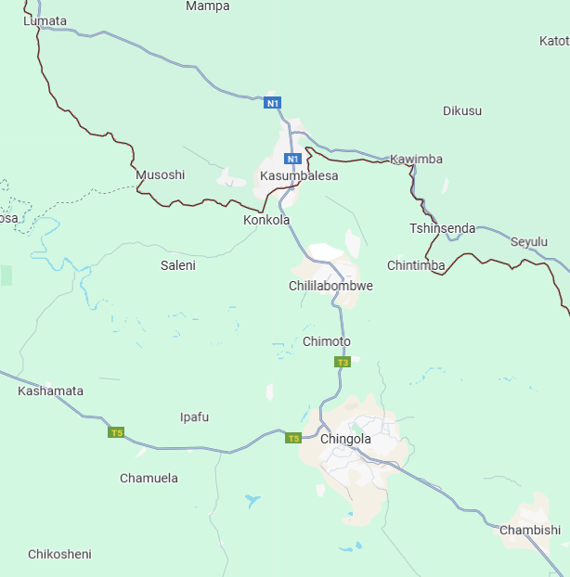 | 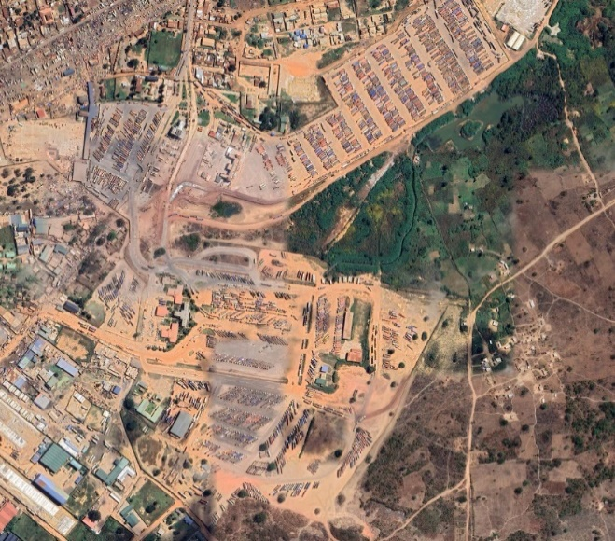
Concessioning: The border post and the Chingola-Kasumbalesa road has been concessioned to ZMART
Corridor Border is on: | North South Corridor

Border Post | KIPUSHI
Description:
The Kipushi-Solwezi road and Kipushi Border Post are on the list of government’s PPP projects. A feasibility study for the development of the 130km Solwezi-Kipushi road and the Kipushi Border post has been concluded and government is in discussion with a potential concessionaire. The road will link the mines around Solwezi to the border at Kupishi (where Ivanhoe is running a high-grade zinc mine) and on to the railhead at Lubumbashi.
Map of Location of the Border Post | Satellite View of Border Post
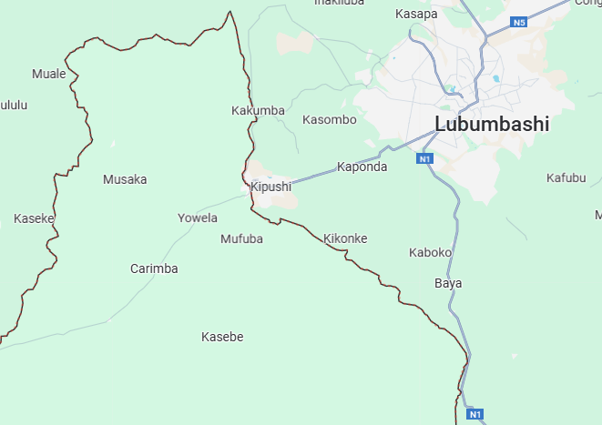 | 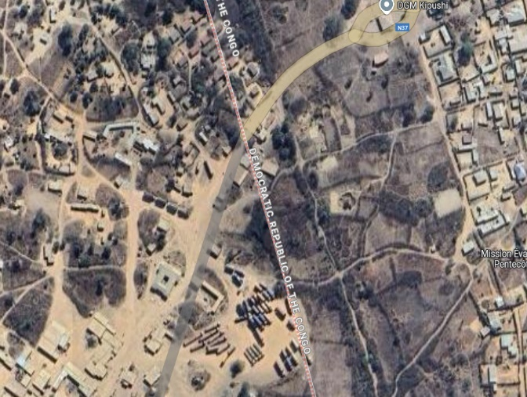
Concessioning: This border post is being concessioned with the road between the border and Solwezi
Corridor Border is on: | Lobito Corridor

Border Post | Kasomeno – Mwenda
Description:
GED Africa Ltd is the ultimate owner of the rights to design, build and operate the GED Africa Route which consists of new road construction from Kasomeno, DR Congo to Mwenda, Zambia, a bridge across the Luapula River and new one stop border posts in each country. The build, operate, transfer (BOT) model stipulates a 3-year construction period, followed by 22 years of operation before transferring the assets to the respective governments.
Map of Location of the Border Post | Artist’s impression of the OSBP
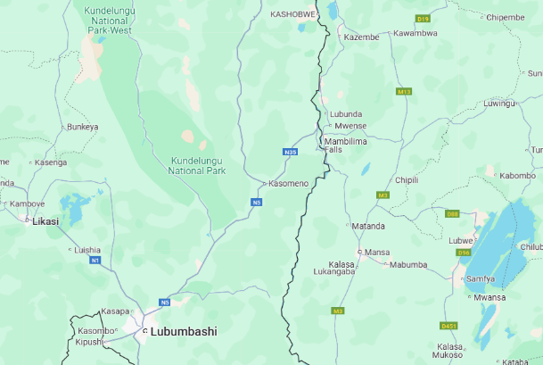 | 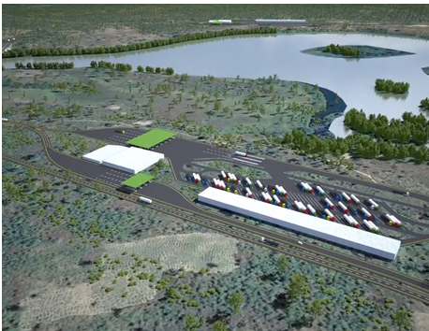
Model of the 345m cable-stay bridge to be constructed over the Luapula River
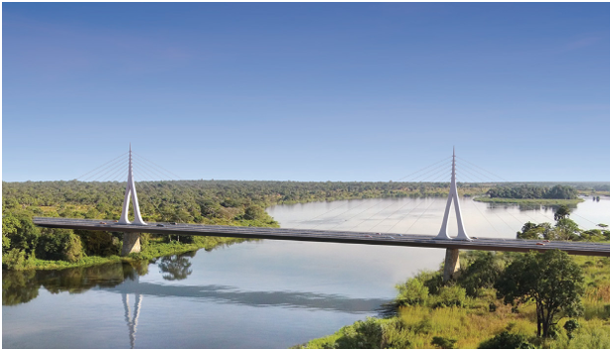

Concessioning: Kasomeno – Mwenda Road (Luapula Province toward DR Congo). The estimated project cost is ISD180 million, and the road was concessioned to Groupe European De Development Africa Investment (GED Africa) in July 2016. The project is a design, finance, construct, operate, maintain and transfer of the Kasomeno – Mwenda Road, including the bridge crossing the Luapula River. The project is awaiting commercial close.

Border Post | KAMBIMBA
Description:

Map of Location of the Border Post | Satellite View of Border Post
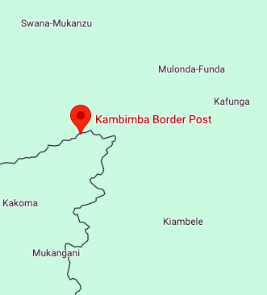 | 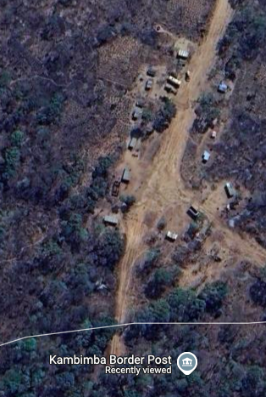
Concessioning: The concession for the 85km Lumwana-Kambimba road joining Lumwana in Northwestern Province with the border between Zambia and DR Congo, and construction of the border post was signed on 26th September 2023 with Sandstone.
Corridor Border is on: | Lobito Corridor

Border Post | MOKAMBO
Description:
Mokambo Border Post connects Zambia to DR Congo. It is 20km from Mufulira in the Copperbelt Province. The Mokambo border used to be primarily used for vehicles crossing the pedicle (Mokambo—Mwende) but DR Congo is upgrading the road link on the DR Congo side of the border from Sakania to Kasumbalesa so trucks crossing at Mokambo could use this upgraded route.
Map of Location of the Border Post | Satellite View of Border Post
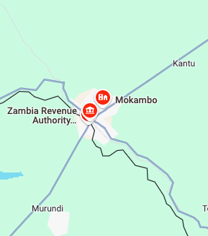 | 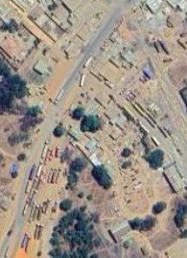
Concessioning: The Government signed a Concession Agreement with Jasworld Ports Limited for the construction of the Mufulira-Mokambo Road, the urban dual carriageway and Border infrastructure at Mokambo in Mufulira District on the Copperbelt in November 2024.
Corridor Border is on: | North South Corridor

Border Post | Katima mulilo
Description:
The bridge between Zambia and Namibia across the Zambezi River was opened in May 2004. The bridge is 900m long and lies about 5km inside Zambian territory. It was financed largely by Germany, who provided 32 million Euros to build the bridge and improve the Sesheke–Livingstone Road in Zambia as part of an infrastructure aid programme.
Zambian Revenue Authority and Immigration staff are present at this crossing. From the North the nearest major centre is Mongu. The eastern roads to Mongu are relatively new and in good condition. The access road from Livingstone via Kazungula district is in a very poor state of repair and it takes about 7 to 8 hours for a truck to move over 150km road stretch.
Map of Location of the Border Post | Satellite View of Border Post
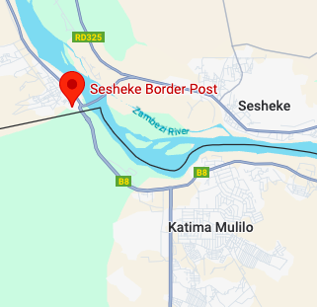 | 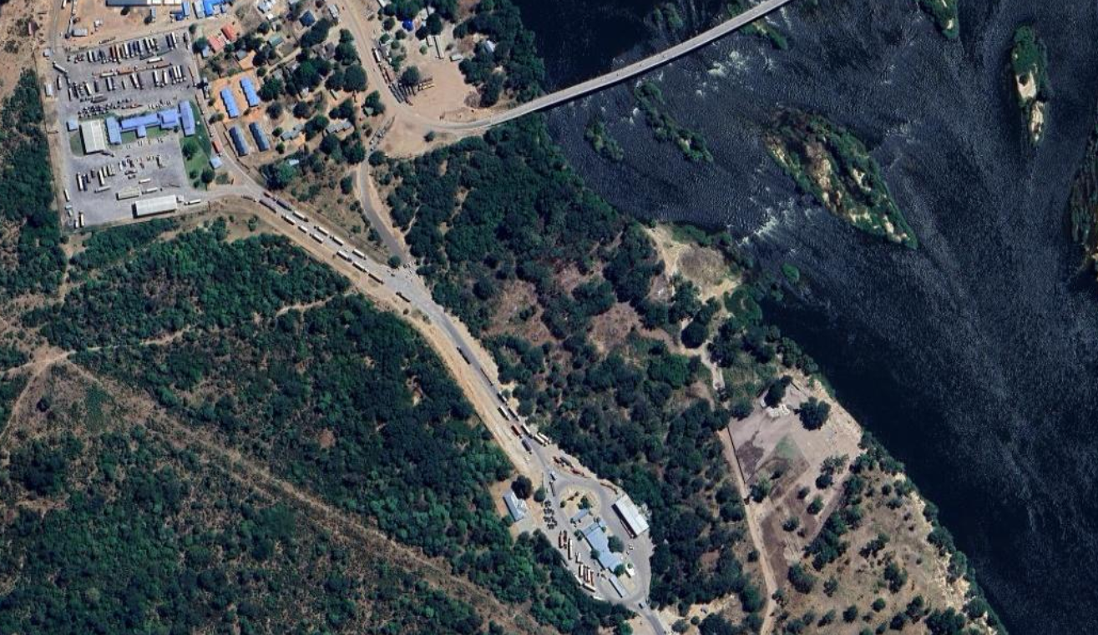
Concessioning: There are no plans to concession the Sesheke border post
Corridor Border is on: | Walvis Bay Corridor
Opening Hours: | 24 hours

Border Post | JIMBE
Description:
Jimbe border post is a small border post where only Zambia Customs and Immigration are present. It has no mains power, and the staff try to use solar power to support the computer system. It is not a commercial border post and cannot handle commercial traffic. The road itself is in poor condition and in even worse condition on the Angolan side of the border.

In 2017, the AfDB started to finance a project, housed in the Ministry of Commence, Trade and Industry (MCTI) that aimed at promoting participation of local SMEs in value chains and economic clusters and profitable trade along the Corridor. The project also aimed to contribute to the implementation of the WTO Trade Facilitation Agreement, the COMESA-EAC-SADC Tripartite Free Trade Agreement and the Continental Free Trade Agreement.
The AfDB project had two components:
- Capacity Building for Trade Facilitation and Corridor Coordination which was aimed at facilitating the development of trade facilitation instruments along the Lobito Corridor, build institutional capacity among Corridor States for coordinated planning of corridor development and convene key stakeholders.
- Technical Assistance for Value Chains and Economic Clusters Development, focusing on supporting local SMEs to participate in the value chains and economic clusters along the corridor.
Map of Location of the Border Post | Satellite View of Border Post
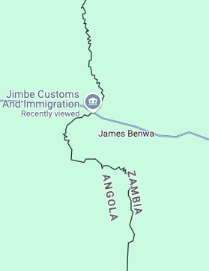 | 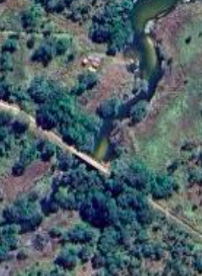
Concessioning: There are no plans to concession the Jimbe border post
Corridor Border is on: | Lobito Corridor

Border Post | NAKONDE
Description:
Nakonde border post is the border between Zambia and Tanzania. The Nakonde/Tunduma border post was declared a one-stop border post (OSBP) in October 2019 and is one of Zambia’s busiest border posts, with about 800 trucks crossing the border daily, with about 750 of these trucks in transit to and from DR Congo.

The Nakonde One Stop Border Post (OSBP) has been handed over to the contractor (China Railway Construction) to commence upgrade works. The site handover follows the signing of a Partner Support Agreement (PSA) between the Government of Zambia and TradeMark Africa in March 2024. The commencement of works marks the first phase of modernising the border post to ease cross-border trade and transit between Zambia and Tanzania. The modernisation works, funded by the UK government through the Foreign, Commonwealth and Development Office (FCDO), include upgrading roads within the OSBP and the truck parking yard, constructing additional office buildings and warehouses, and installing an X-ray cargo scanner. The project also includes digitising clearance processes and installing smart gates to reduce truck dwell times from the current 64 hours to less than 24 hours.
Map of Location of the Border Post | Satellite View of Border Post
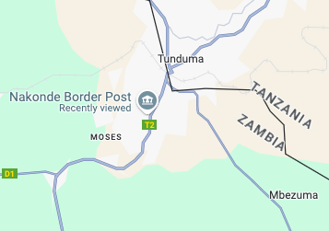 | 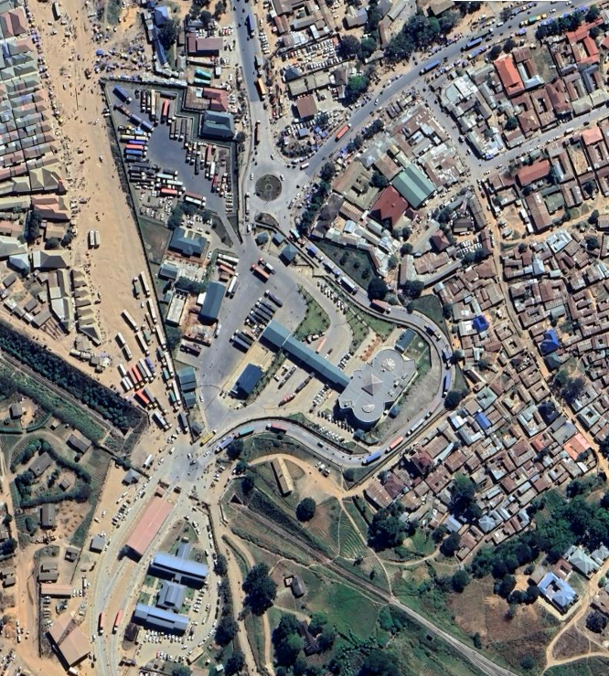
Concessioning: There are no plans to concession the Nakonde border post
Corridor Border is on: | Dar es Salaam Corridor
Opening Hours: | 24 hours

Border Post | CHANIDA
Description:
The Chanida border post is on the Beira Corridor which is used mainly to transport fuel and fertiliser into Zambia and used in the export of copper via Beira.

Map of Location of the Border Post | Satellite View of Border Post
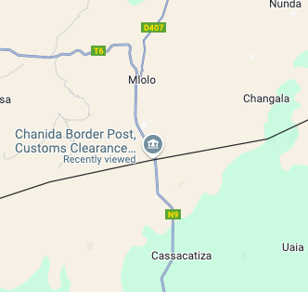 | 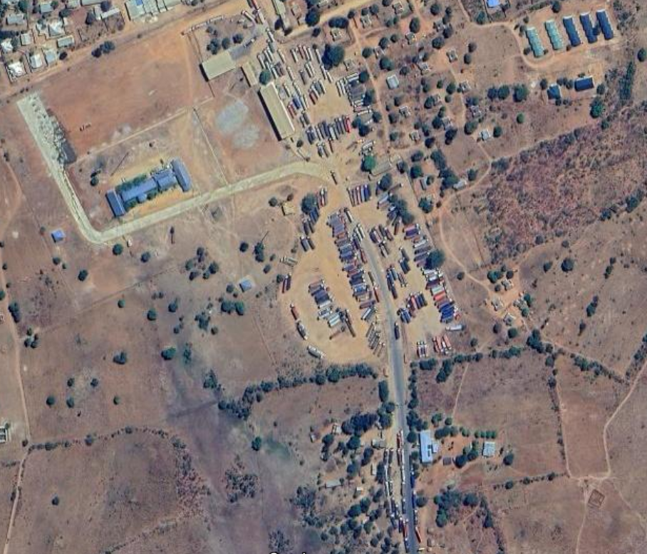
Concessioning: The Chanida Border Post (together with the road from Katete to Chanida) was concessioned on 9th October to Lutembwe Consulting (Sable) Investment. The project involves the design, finance, construct, operate, maintain and transfer of the Katete Chanida Road of 55 km road (T6) from the T4 junction at Katete and Chanida Border Post as well as border post infrastructure. The project is awaiting Commercial Close.
Corridor Border is on: | Beira Corridor

Air Transport Corridors/Routes
The following carriers offer the following routes
- Ethiopian Airlines
  - Routes: Lusaka to Addis Ababa (Hub) and from Addis Ababa to all parts of the world.
  - Frequency: Typically, Ethiopian Airlines has daily flights from Lusaka to Addis Ababa.

- Kenya Airways
  - Routes: Lusaka to Nairobi (Hub) and from Nairobi to various East, Southern and West African cities, European cities and Dubai, Mumbai, Bangkok, Hong Kong and Guangzhou.
  - Frequency: Kenya Airways typically offers daily flights from Lusaka to Nairobi.

- South African Airways
  - Routes: Lusaka to Johannesburg (Hub) and from Johannesburg most parts of the world.
  - Frequency: Typically offers daily flights from Lusaka to Johannesburg.

- Qatar Airways
  - Routes: Lusaka to Doha (Hub) and from Doha to all parts of the world.
  - Frequency: Typically offers 3-4 flights per week from Lusaka to Doha.

- Emirates
  - Routes: Lusaka to Dubai (Hub) and from Dubai to all parts of the world.
  - Frequency: Typically offers daily flights from Lusaka to Dubai.

Zambia Trade Flow Model
A zero-draft of a detailed freight demand model has been compiled. Within this model trade flows have been built up as follows:
- International maritime imports and exports to and from Zambia;
- Intra-regional imports and exports to and from Zambia;
- DR Congo international trade transiting Zambian territory;
- DR Congo inter-regional trade transiting through Zambia;
- Inter-zonal domestic flows within Zambia territory;
- All trade to and from Zambia by corridor; and,
- Trade to and from Zambia by transport mode.
These categories of trade are further broken down by type of cargo, which include the following:
- Agricultural Dry Bulk;
- Mining Dry Bulk;
- Heavy Dry Bulk;
- Light Break Bulk;
- Liquid Bulk;
- Open Skip Bulk;
- Palletised Cargo;
- Roll On-Roll Off; and,
- Refrigerated.
The underlying data is drawn from the detailed Regional African Freight Model (RAFM) that was originally developed by the Wits Innovation Centre, in South Africa in 2021.
Figure 11.1: RAFM Traffic Zones
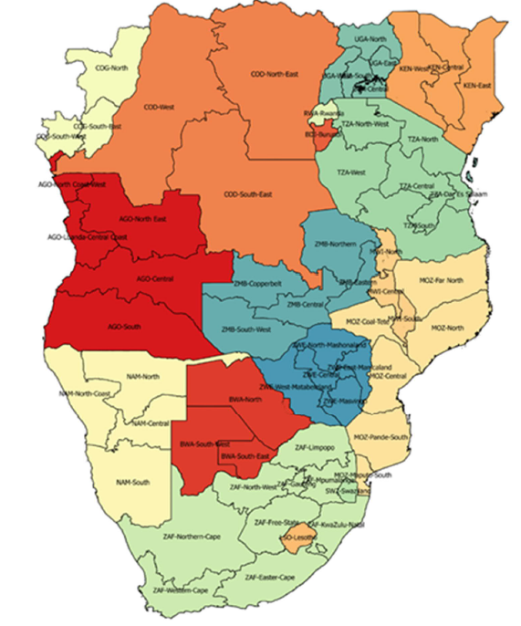
Source: Wits Innovation Centre, 2021
For the model to determine broad Origin-Destination (O/D) flows to/from Zambia the trade analysis used the traffic zones contained in the RAFM. For Zambia there are five zones: Central, Copperbelt, Eastern, Northern and South-West and for the Democratic Republic of Congo (DRC) there are three zones, these being South-East, North-East and West (see Figure 11.1).
In summary, the model presents trade flows by cargo type to/from traffic zones by regional corridor for the benchmark years of 2019 (base year), 2025 (projection) and 2050 (projection).

Table 11.1: Zambia International (2025 and 2050)
INTERNATIONAL | BEIRA | DAR ES SALAAM | NORTH-SOUTH | WALVIS BAY | OTHER | TOTAL | Per Cent
2025
EXPORTS | 286 974 | 379 141 | 554 112 | 1 215 960 | 0 | 2 436 187 | 56.6%
IMPORTS | 990 295 | 665 738 | 267 146 | 129 312 | 0 | 2 052 490 | 47.7%
TOTAL | 1 277 269 | 1 044 878 | 821 258 | 1 345 272 | 0 | 4 488 677 | 100.0%
% | 28.5% | 23.3% | 18.3% | 30.0% | 0.0% | 100%

2050
EXPORTS | 1 014 866 | 1 250 162 | 1 605 011 | 3 188 781 | 0 | 7 058 820 | 45.8%
IMPORTS | 3 620 307 | 3 219 256 | 1 099 447 | 400 178 | 0 | 8 339 188 | 54.2%
TOTAL | 4 635 172 | 4 469 418 | 2 704 458 | 3 588 960 | 0 | 15 398 008 | 100%
% | 30.1% | 29.0% | 17.6% | 23.3% | 0.0% | 100%

2025-2050: AVERAGE ANNUAL GROWTH RATE
INTERNATIONAL | BEIRA | DAR ES SALAAM | NORTH-SOUTH | WALVIS BAY | OTHER | TOTAL
EXPORTS | 5.2% | 4.9% | 4.3% | 3.9% | - | 4.3%
IMPORTS | 5.3% | 6.5% | 5.8% | 4.6% | - | 5.8%
TOTAL | 5.3% | 6.0% | 4.9% | 4.0% | - | 5.1%
Source: Consultants, 2024

Table 11.1 presents the summary for Zambia International Trade for the benchmark years of 2025 and 2050. The key takeaways are
- In 2025 it is expected that Walvis Bay will account for 30 per cent of Zambia’s international trade, Beira 28.5 per cent, Dar es Salaam 23.3 per cent and the North South Corridor 18.3 per cent. Exports will account for 56.6 per cent of Zambia’s international trade, while imports will account for 47.7 per cent of Zambia’s international trade.
- In 2050 it is expected that Walvis Bay will account for only 23.3 per cent of Zambia’s international trade, Beira will account for the highest percentage, at 30.1 per cent, Dar es Salaam will grow to 29 per cent and the North South Corridor will drop to 17.6 per cent. Exports will account for45.8 per cent of Zambia’s international trade, while imports will grow to account for 54.2 per cent of Zambia’s international trade.
- Overall growth rises from 4.5 million tonnes (mt) in 2025 to 15.4mt in 2050
- Growth in imports (5.8 per cent) is expected to outstrip growth in exports (4.3 per cent), with overall growth in aggregate international trade expected to be moderate (5.1 per cent).
Table 11.2 presents the summary for DR Congo’s international transit trade passing through Zambian territory for the benchmark years of 2025 and 2050. The key takeaways are as follows:
- In 2025, of DR Congo’s international transit trade passing through Zambia, 44 per cent is expected to be exports and 56 per cent is expected to be imports. This is expected to be roughly the same in 2050, with 46.9 per cent of DR Congo’s international transit trade passing through Zambia being exports and 53.1 being imports.
- In 2050 Most of DR Congo’s international transit trade passing through Zambia will be on the Dar es Salaam Corridor (56.4 per cent), with the North South Corridor accounting for about half of the trade going through Dar es Salaam (24.2 per cent)
- The total of DR Congo’s international transit trade passing through Zambia will grow modestly at 3.5 per cent, with exports growing at 3.7 per cent and imports growing at 3.3 per cent.
Table 11.3 presents the summary for Domestic flows within Zambian territory, but excludes intra-traffic zone flows, for the benchmark years of 2025 and 2025. The key takeaways are as follows:
- In 2025 the dominant corridor for domestic flows is the North-South Corridor (61.9 per cent), followed by Dar es Salaam (20.4 per cent) and Other (17.7 per cent), and this is expected to remain the same in 2050, with the dominant corridor being North-South (64.3 per cent), followed by Dar es Salaam (19.2 per cent), and Other (16.5 per cent) in 2050.
- Overall growth in Domestic trade rises from 33mt in 2025 to 41.5mt in 2050, an overall growth of 8.6mt, but less than 1 per cent on average per annum, with the largest growth estimated to be on the North-South Corridor (57.3mt), followed by Dar es Salaam (1.2mt), and Other (1mt).
Table 11.4 presents the summary for Domestic flows between traffic zones within Zambian territory for the benchmark years of 2025 and 2025. The key takeaways are as follows:
- Domestic flows within Zambia accounts for 65.6 per cent of all trade in 2025 but is expected to decline to 49.5 per cent in 2050.
- Domestic flows, which include the movement of agricultural produce, are dominated by movement to/from the Southern traffic zone (50 per cent), followed by Eastern (16 per cent), Central (15 per cent), Northern (10 per cent) and Copperbelt (9 per cent) in 2025.

Table 11.2: DR Congo International Transit Trade via Zambia (2025 and 2050)
DRC TRANSIT INTERNATIONAL | BEIRA | DAR ES SALAAM | NORTH-SOUTH | WALVIS BAY | OTHER (LOBITO) | TOTAL | PER CENT
2025
EXPORTS | 109 963 | 887 325 | 877 796 | 35 988 | 88 256 | 1 999 328 | 44.0%
IMPORTS | 507 932 | 1 672 629 | 218 815 | 45 714 | 94 572 | 2 539 662 | 56.0%
TOTAL | 617 895 | 2 559 954 | 1 096 611 | 81 702 | 182 828 | 4 368 868 | 100.0%
% | 13.6% | 56.4% | 24.2% | 1.8% | 4.0% | 100.00%

2050
EXPORTS | 274 877 | 1 993 035 | 1 316 196 | 89 960 | 1 323 692 | 4 997 760 | 46.9%
IMPORTS | 1 132 214 | 2 861 978 | 300 134 | 101 899 | 1 264 845 | 5 661 070 | 53.1%
TOTAL | 1 407 091 | 4 855 014 | 1 616 330 | 191 859 | 2 588 537 | 10 658 831 | 100.0%
% | 13.2% | 45.6% | 15.2% | 1.8% | 24.3% | 100%

2025-2050: AVERAGE ANNUAL GROWTH RATE
EXPORTS | 3.7% | 3.3% | 1.6% | 3.7% | 11.4% | 3.7%
IMPORTS | 3.3% | 2.2% | 1.3% | 3.3% | 10.9% | 3.3%
TOTAL | 3.3% | 2.8% | 1.8% | 3.5% | 11.2% | 3.5%
Source: Consultants, 2024

Table 11.3: Zambia Domestic by Corridor (2025 and 2050)
2025
DOMESTIC | BEIRA | DAR ES SALAAM  to/from Northern Zone | NORTH-SOUTH  to/from Copperbelt, Central & Southern Zones | WALVIS BAY | OTHER  to/from Eastern Zone | TOTAL | %
TOTAL | 0 | 6 738 747 | 20 408 503 | 0 | 5 841 327 | 32 988 577 | 100.0%
% | 0.0% | 20.4% | 61.9% | 0.0% | 17.7% | 100.0%
2050
TOTAL | 0 | 7 983 816 | 26 721 345 | 0 | 6 837 649 | 41 542 810 | 100.0%
% | 0.0% | 19.2% | 64.3% | 0% | 16.5% | 100.0%

2025-2050: AVERAGE ANNUAL GROWTH RATE
DOMESTIC | BEIRA | DAR ES SALAAM | NORTH-SOUTH | WALVIS BAY | OTHER | TOTAL
TOTAL | - | 0.7% | 1.1% | - | 0.6% | 0.9%
Source: Consultants, 2024

Table 11.4: Zambia Domestic by Broad Traffic Zone – 2025 and 2050
ZAMBIA DOMESTIC | 2025 | % |  | 2050 | % |  | Average Annual Growth Rate |  | Change 2025-2050 (Tonnes)
Total (Domestic) | 32 988 577 | 100% |  | 41 542 810 | 100% |  | 0.9% |  | 8 554 233
Copperbelt-Central | 1 714 843 | 5% |  | 2 495 983 | 6% |  | 1.5% |  | 781 140
Copperbelt-Eastern | 106 151 | 0% |  | 153 103 | 0% |  | 1.5% |  | 46 952
Copperbelt-Northern | 672 027 | 2% |  | 875 220 | 2% |  | 1.1% |  | 203 193
Copperbelt-Southern | 468 453 | 1% |  | 657 598 | 2% |  | 1.4% |  | 189 145
Sub-Total (Copperbelt) | 2 961 475 | 9% |  | 4 181 904 | 10% |  | 1.4% |  | 1 220 429
Central-Copperbelt | 3 426 825 | 10% |  | 4 886 914 | 12% |  | 1.4% |  | 1 460 089
Central-Eastern | 166 619 | 1% |  | 217 283 | 1% |  | 1.1% |  | 50 664
Central-Northern | 646 099 | 2% |  | 834 592 | 2% |  | 1.0% |  | 188 493
Central-Southern | 661 146 | 2% |  | 859 723 | 2% |  | 1.1% |  | 198 577
Sub-Total (Central) | 4 900 688 | 15% |  | 6 798 512 | 16% |  | 1.3% |  | 1 897 824
Northern-Copperbelt | 1 241 565 | 4% |  | 1 429 555 | 3% |  | 0.6% |  | 187 990
Northern-Central | 1 374 371 | 4% |  | 1 573 625 | 4% |  | 0.5% |  | 199 254
Northern-East | 89 453 | 0% |  | 102 314 | 0% |  | 0.5% |  | 12 861
Northern-South | 726 160 | 2% |  | 820 237 | 2% |  | 0.5% |  | 94 077
Sub-Total (Northern) | 3 431 549 | 10% |  | 3 925 730 | 9% |  | 0.5% |  | 494 181
Eastern-Central | 2 172 517 | 7% |  | 2 516 864 | 6% |  | 0.6% |  | 344 347
Eastern-Copperbelt | 1 961 267 | 6% |  | 2 272 118 | 5% |  | 0.6% |  | 310 851
Eastern-Northern | 486 033 | 1% |  | 562 279 | 1% |  | 0.6% |  | 76 246
Eastern-Southern | 514 135 | 2% |  | 595 266 | 1% |  | 0.6% |  | 81 131
Sub-Total (Eastern) | 5 133 952 | 16% |  | 5 946 527 | 14% |  | 0.6% |  | 812 575
Southern-Central | 7 394 107 | 22% |  | 9 302 973 | 22% |  | 0.9% |  | 1 908 866
Southern-Copperbelt | 6 743 128 | 20% |  | 8 518 153 | 21% |  | 0.9% |  | 1 775 025
Southern-Eastern | 434 605 | 1% |  | 520 736 | 1% |  | 0.7% |  | 86 131
Southern-Northern | 1 989 072 | 6% |  | 2 348 274 | 6% |  | 0.7% |  | 359 202
Sub-Total (Southern) | 16 560 912 | 50% |  | 20 690 137 | 50% |  | 0.9% |  | 4 129 225
Source: Consultants, 2024

- Domestic flows are expected to reflect the current footprint, with flows dominated by movement to/from the Southern traffic zone (50 per cent), followed by Central (16 per cent), Eastern (15 per cent), Copperbelt (10 per cent) and Northern (9 per cent) in 2050.
- Domestic flows grew the most in absolute terms in the Southern traffic zone (4.1mt), followed by Central (1.9mt), Copperbelt (1.2mt) Eastern (0.8mt) and Northern (0.5mt).
- Domestic flows to/from the Copperbelt traffic zone increased the most on the Copperbelt - Central route (0.78mt), followed by Copperbelt-Northern (0.20mt), Copperbelt-Southern (0.19mt) and Copperbelt-Eastern (0.05mt).
- Domestic flows to/from the Central traffic zone increased the most on the Central - Copperbelt route (1.46mt), followed by Central-Southern (0.20mt), Central-Northern (0.09mt) and Central-Eastern (0.05mt).
- Domestic flows to/from the Northern traffic zone increased the most on the Northern - Central route (0.2mt), followed by Northern-Copperbelt (0.19mt), Northern-Southern (0.09mt) and Northern-Eastern (0.001mt)Domestic flows to/from the Eastern traffic zone increased the most on the Eastern-Central route (0.34mt), followed by Eastern-Copperbelt (0.31mt), Eastern-Southern (0.08mt) and Eastern-Northern (0.08mt).
- Domestic flows to/from the Southern traffic zone increased the most on the Southern - Central route (1.9mt), followed by Southern-Copperbelt (1.78mt), Southern-Northern (0.36mt) and Southern-Eastern (0.09mt).
Table 11.5 gives a summary for all trade (International, Regional, DR Congo Transit and Domestic) passing through Zambia for the benchmark years of 2025 and 2050. The key takeaways are:
- In 2025, the dominant corridor to be used for International, Regional, DR Congo Transit and Domestic trade (so all road and rail trade moving through Zambia) is the North-South (57.3 per cent). followed by Dar es Salaam (22 per cent), Other (13 per cent), Beira (4 per cent) and Walvis Bay (3.7 per cent). This will stay more or less the same, with the dominant corridor being North-South (51.8 per cent), followed by Dar es Salaam (22.3 per cent), Other (12.8 per cent), Beira (7.5 per cent) and Walvis Bay (5.5 per cent) in 2050.
- Overall growth rises from 50.3 million tonnes (mt) in 2025 to 84mt in 2050, an overall growth of 33.7mt, with the largest growth estimated to be on the North-South Corridor (14.6mt), followed by Dar es Salaam (7.7mt), Beira (4.3mt), Other (4.2mt) and Walvis Bay (2.8mt).
- Average annual growth rates are highest for the Beira Corridor (4.7 per cent), followed by Walvis Bay (3.7 per cent), Dar es Salaam (2.1 per cent), Other (2 per cent) and North-South (1.7 per cent).

Table 11.5: International and Regional DR Congo Transit and Domestic (2025 and 2050)
2025
INTERNATIONAL, REGIONAL DRC TRANSIT AND DOMESTIC | BEIRA | DAR ES SALAAM | NORTH-SOUTH | WALVIS BAY | OTHER | TOTAL |  |  | PER CENT
TOTAL | 2 013 411 | 11 057 441 | 28 825 979 | 1 873 947 | 6 533 560 | 50 304 338 |  |  | 100.0%
% | 4.0% | 22.0% | 57.3% | 3.7% | 13.0% | 100.0%
2050
TOTAL | 6 327 841 | 18 759 860 | 43 477 777 | 4 654 291 | 10 760 007 |  | 83 979 776 | 100.0%
% | 7.5% | 22.3% | 51.8% | 5.5% | 12.8% |  | 100.0%

2025-2050: AVERAGE ANNUAL GROWTH RATE
TOTAL | 4.7% | 2.1% | 1.7% | 3.7% | 2.0% | 2.1%
Source: Consultants, 2024

Table 11.6: Preliminary Modal Split Estimates (2025 and 2050)
Corridor | Mode | Per Cent | Tonnes | Per Cent |  | Corridor | Mode | Per Cent | Tonnes | Per Cent |  | Average Annual Growth Rate |  | Change
Beira | Road | 100% | 2 013 411 | 4% |  | Beira | Road | 100% | 6 327 841 | 8% |  | 4.7% |  | 4 314 431
Dar es Salaam | Road | 98% | 10 771 414 | 21% |  | Dar es Salaam | Road | 94% | 17 634 268 | 21% |  | 2.0% |  | 6 862 854
Dar es Salaam | Rail | 2% | 222 313 | 0% |  | Dar es Salaam | Rail | 6% | 1 125 592 | 1% |  | 6.7% |  | 903 279
Dar es Salaam | Road & Rail | 100% | 10 993 726 |  |  | Dar es Salaam | Road & Rail | 100% | 18 759 860 | 22% |  | 2.2% |  | 7 766 133
North-South | Road | 98% | 28 140 216 | 56% |  | North-South | Road | 96% | 41 738 665 | 50% |  | 1.6% |  | 13 598 450
North-South | Rail | 2% | 575 356 | 1% |  | North-South | Rail | 4% | 1 739 111 | 2% |  | 4.5% |  | 1 163 755
North-South | Road & Rail | 100% | 28 715 572 |  |  | North-South | Road & Rail | 100% | 43 477 777 | 52% |  | 1.7% |  | 14 762 205
Walvis Bay | Road | 100% | 1 873 947 | 4% |  | Walvis Bay | Road | 100% | 4 654 291 | 6% |  | 3.7% |  | 2 780 344
Lobito Rail | Rail | 100% | 182 828 | 0% |  | Lobito Rail | Rail | 100% | 2 588 537 | 3% |  | 11.2% |  | 2 405 709
Other | Road | 100% | 6 533 560 | 13% |  | Other | Road | 100% | 8 171 470 | 10% |  | 0.9% |  | 1 637 910
Total (2025) | Road |  | 49 332 547 | 98% |  | Total (2050) | Road |  | 78 526 536 | 94% |  | 1.9% |  | 29 193 988
Total (2025) | Rail |  | 980 497 | 2% |  | Total (2050) | Rail |  | 5 453 240 | 6% |  | 7.1% |  | 4 472 743
Total (2025) | Road & Rail |  | 50 313 044 | 100% |  | Total (2050) | Road & Rail |  | 83 979 776 | 100% |  | 2.1% |  | 33 666 732
Source: Consultants, 2024
Table 11.6 presents the summary for modal split of flows for the benchmark years of 2025 and 2050. The key takeaways are:
- Road based movement accounts for 98 per cent of all trade in 2025 but is expected to decline to 94 per cent in 2050, which indicates that rail-based movement will increase from 2 per cent in 2025 to 6 per cent in 2050.
- Road based movement is expected to increase from 49.3 million tonnes (mt) in 2025 to 78.5 mt in 2050, which represents an increase of 29.2 mt, at an average annual growth rate of 1.9 per cent per annum over the period 2025-2050.
- The dominant road corridor, reflected by the largest increase in road tonnage growth is the North-South (13.6mt), followed by Dar es Salaam (6.9mt), Beira (4.3mt), and Other (1.6mt).
- The fastest growing corridor for road transport is Beira (4.7 per cent), followed by Walvis Bay (3.7 per cent), Dar es Salaam (2.0 per cent), North-South (1.7 per cent) and Other (0.9 per cent).
- Rail based movement is expected to increase from 0.98mt in 2025 to 5.45mt in 2050, which represents an increase of 4.5mt, at an average annual growth rate of 7.1 per cent per annum over the period 2025-2050.
- The two dominant rail corridors, the North-South and Dar es Salaam Corridors, are both road and rail corridors serving Zambia and DR Congo Southwestern markets, with the largest growth occurring on the Lobito Rail (2.4mt), followed by North-South Rail (1.2mt) and Dar es Salaam Rail (0.9mt).
- The fastest growing corridor for rail transport is Lobito (11.2 per cent), followed by Dar es Salaam Rail (6.7 per cent) and North-South Rail (4.5 per cent)
Table 11.7 presents the summary for the rail flows for the benchmark years of 2025 and 2050. The key assumptions made were as follows:
- The allocation to rail-based transport for DR Congo International Transit trade on the SNCC network would increase from 5 per cent in 2025 and 40 per cent in 2050, and the split between Lobito and the Dar es Salaam/North-South Corridors would be 0 per cent/100 per cent in 2019, rising to 25 per cent / 75 per cent in 2025 and 50 per cent / 50 per cent in 2050. Capacity considerations, based on a 3 mtpa limit for the SNCC network that had been upgraded to the point where Temporary Speed Restrictions (TSRs) had been removed from the Dilolo-Sakania (Ndola) section, at an estimated cost of USD125 million.
- The allocation to rail transport from International, Regional and DR Congo Transit trade on the ZRL network would increase from 5 per cent in 2025 to 10 per cent in 2050 on the Dar es Salaam Corridor and an increase from 7.5 per cent in 2019 to 10 per cent in 2050 on the North-South Corridor, based on a 30 per cent / 70 per cent split in 2025 increasing to 40 per cent / 60 per cent in 2050 between the Dar es Salaam and North-South Rail Corridors. Capacity considerations, based on a 4 mtpa limit for the ZRL network that had been upgraded to remove Temporary Speed Restrictions (TSRs) from the Ndola-Kapiri Mposhi-Livingstone section, at an estimated cost of USD110 million.
Capital investment beyond these initial preliminary amounts would increase the allocation to rail on both the SNCC and ZRL networks. Based on these key assumptions the key takeaways are as follows:
- On the SNCC network tonnages are expected to increase from 0.18 million tonnes (mt) in 2025 to 2.6 mt in 2050, growing at an average annual growth rate of 11.2 per cent per annum over the period 2025 to 2050.
- The split on the SNCC network pivots at Tenke, with flows going west on the Tenke-Dilolo-(Lobito) section and east on the Tenke-Sakania-(Ndola + Dar es Salaam and Durban), with the Lobito Rail and North-South / Dar es Salaam Corridors share’s increasing by 1.2mt at an annual growth rate of 14.3 per cent for 9.4 per cent for Tenke-Dilolo and Tenke-Sakania sections respectively, over the period 2025-2050.
- The split on the ZRL network pivots at Kapiri-Mposhi, with flows going north (on the TAZARA line) and south (on the North-South line), with the North-South Rail Corridor increasing by 1.2mt at an annual growth rate of 6.7 per cent and Dar es Salaam Rail Corridor increasing by 0.9mt, at an annual growth rate of 4.5 per cent, over the period 2025-2050.
- If DRC Transit and Zambia trade flows are combined the Ndola-Kapiri Mposhi section on the ZRL network in placed under pressure, with increases estimated at 3.2mt, growing at an annual growth rate of 6.2 per cent over the period 2025 to 2050.
- The dominant port of entry/exit for DRC International Transit trade is Dar es Salaam (56.4 per cent), followed by Durban (24.2 per cent), Beira (13.6 per cent), Lobito (4 per cent) and Walvis Bay (1.8 per cent) in 2025, but this will shift to the dominant port being Dar es Salaam (45.6 per cent), followed by Durban (15.2 per cent), Lobito (.24.3 per cent), Beira (13.2 per cent) and Walvis Bay (1.8 per cent) in 2050.
- Overall growth rises from 4.5 million tonnes (mt) in 2025 to 10.6mt in 2050, an overall growth of 6.1mt, with the largest growth estimated to be on the Lobito Corridor (2.4mt), followed by the Dar es Salaam Corridor (2.3mt), the Beira Corridor (0.8mt), the North-South Corridor (0.5mt) and the Walvis Bay Corridor (0.11mt).
- Growth in imports (3.3%) is expected to lag exports (3.7%), with overall growth in aggregate DRC International Transit trade expected to be moderate (3.5%). Average annual growth rates are the highest for the Lobito Corridor (11.2%), followed by Walvis Bay (3.5%), Beira (3.3%), Dar es Salaam (2.6%) and North-South (1.6%).

Table 11.7: Preliminary Rail Split Estimates (2025 and 2050)
PRELIMINARY RAIL ESTIMATES | 2025 |  |  | 2050 |  |  | 2025-2050
Relevant SNCC and ZRL Sections | Tonnes | Per Cent |  | Tonnes | Per Cent |  | Average Annual Growth Rate
SNCC Network | 182 828 | 100% |  | 2 588 537 | 100% |  | 11.2%
Tenke-Dilolo-(Lobito) | 45 707 | 25% |  | 1 294 269 | 50% |  | 14.3%
Tenke-Sakania-(Ndola) | 137 121 | 75% |  | 1 294 269 | 50% |  | 9.4%
ZRL Network | 797 668 | 100% |  | 2 864 703 | 100% |  | 5.2%
Chingola-Kapiri Mposhi | 221 149 | 28% |  | 1 125 592 | 37% |  | 6.7%
Chingola-Livingstone | 576 520 | 72% |  | 1 739 111 | 63% |  | 4.5%
ZRL Network (plus SNCC transit) | 934 790 | 100% |  | 4 158 971 | 100% |  | 6.2%
Chingola-Kapiri Mposhi-TAZARA | 323 990 | 35% |  | 2 096 293 | 49% |  | 7.8%
Chingola-Kapri Mposhi-Livingstone-North South | 610 800 | 65% |  | 2 062 678 | 51% |  | 5.0%
Chingola-Kapiri Mposhi (both Tazara & North South) | 934 790 | 100% |  | 4 158 971 | 100% |  | 6.2%
Source: Consultants, 2024

Masterplan Hard Infrastructure Projects

Project Identification
In preparing the Transport and Logistics Masterplan, projects have been identified from different sources, including:
- Eighth National Development Plan
- Draft Transport Infrastructure Masterplan
- Zambia Railways Limited 2025-2040 Strategic Plan
- RoadSIP III
- Mpulungu Harbour Corporation Limited Strategic Plan

Project Preparation
The level of complexity and therefore the cost of project preparation varies according to the country risk, project size, (sub) sector focus, market dynamics and cost-of-doing business. Project preparation cost can be measured as a proportion of total investment cost and several estimates of these metrics are available, including:
- ICA/PPIAF (2009) finds that for infrastructure projects funded by Public-Private-Partnerships (PPP), project preparation forms about 3-4 per cent of investment costs for projects less than USD100 million and, about 2 per cent for projects more than USD500 million.
- UNEP (2011) estimates that project preparation is typically about 5 per cent of total project costs for low carbon technology infrastructure projects.
- ICA (2012), citing estimates from the World Bank and INFRACO Africa, estimate that project preparation costs are approximately 5-10 per cent and 10 per cent of total project costs respectively.
- NEPAD-IPPF (2014) estimates that for infrastructure projects prioritised under the Programme for Infrastructure Development of Africa (PIDA) project preparation costs amounted to, on average, approximately 7 per cent of total project costs.
- GIB (2014) reports that on average, project development represents about 3-5 per cent of the project costs, going up to 10 per cent in emerging and/or frontier markets.
Figure 12.1 summarises the broad allocation of costs across the project preparation and development cycle. It shows that approximately 1 per cent of costs are located within the early stages of project preparation, which typically take the project to the end of the pre-feasibility phase, and that approximately 4 per cent of the costs are concentrated in the later stages of project preparation, which culminate in financial closure of the project. Based on the findings of the reports cited above these parameters can be considered to be at the lower end of the estimated resource envelope needed to cover project preparation costs. Nonetheless, they provide a guide for total project preparation costs, which for both earlier and later phases of project preparation is approximately 5 per cent of total project costs.
Figure 12.1: Project Preparation as Percent of Total Project Cost
Cost | USD25m + | USD50m + | USD 100m + | USD200m +
Size | Small | Medium | Large | Very Large
Phase | Project Preparation Costs (US$)
Early-Stage (1%) | 250,000 | 500,000 | 1,000,000 | 2,000,000
Late-Stage (4%) | 1,000,000 | 2,000,000 | 4,000,000 | 8,000,000
All Stages (5%) | 1,250,000 | 2,500,000 | 5,000,000 | 10.000.000
Source: Adapted from UNEP (2011)
Even with these conservative estimates it is clear that considerable resources are required to support project preparation.
Recently, and mainly because of the lack of public finance to prepare and develop infrastructure projects, including infrastructure projects in the transport and transport logistics sector, GRZ, under the Ministry of Finance, has been promoting project preparation development nd implementation under public-private partnerships (PPPs). This means involving the private sector at an early stage in project preparation activities. On its part, Government actively encourages unsolicited PPPs, with the promoters of the unsolicited proposal bearing the project preparation costs and securing financing for the project. In this process, the key issues for Government are:
- affordability of the project to the contracting authority, bankability to financiers and developers;
- value for money;
- optimal risk allocation to the party better able to mitigate/manage the risk; and
- generate appropriate socio–economic benefits.
Figure 12.2 shows the guiding steps for unsolicited proposals as presented by the PPP Unit of the Ministry of Finance.
Figure 12.2: Guiding steps for Unsolicited Proposals
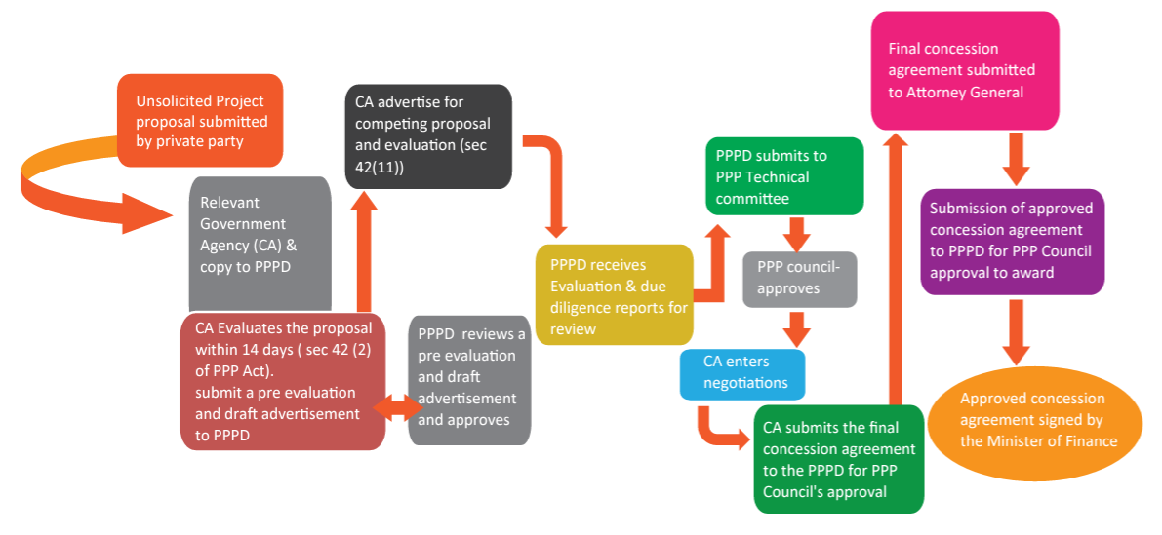
Source: PPP Procurement Process – Unsolicited Proposal
However, all projects, even PPP projects, need to go through project preparation stages. There are slight variations in what project preparation stages entail, but, in this case, we reference the project preparation stages used in the Africa Union’s Programme for Infrastructure Development in Africa or PIDA, which are as follows:
- S1: Project Definition
- S2A: Pre-Feasibility Study
- S2B: Feasibility Study
- S3A: Project Structuring
- S3B: Transaction Support and Financial Close
- S4A: Tendering
- S4B: Construction
- S4C: Operation
Using this project preparation framework, the following project preparation activities, by sector, have been identified:

Roads
The RoadSIP III envisages the outsourcing of funding for large capital projects to the private sector via the procurement of Public-Private Partnerships and, where PPPs are unviable, to increased reliance on external funding from development partners.
The Roads Development Agency (RDA) has identified around 8,913 km of roads from the core road network (CRN-TMD network to be developed through PPP procurement methods. Table 12.3 provides a summary of the 48 PPP projects, amounting to 8,913 kms of the CRN-TMD network.

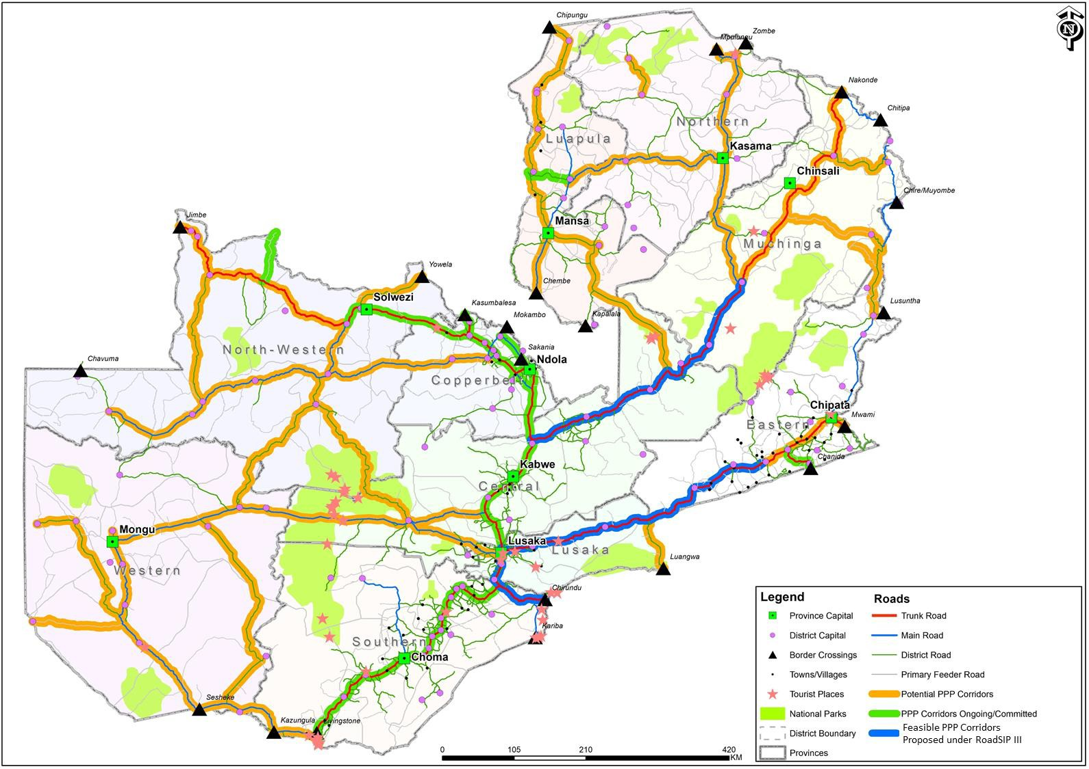
Figure 12.3: Overall PPP Portfolio and Corridors Proposed under RoadSIP III
Source: RoadSIP III, 2024
As can be seen from Table 12.1, of the 48 potential PPP targeted roads, 6 PPP projects, all Trunk Roads, are considered viable, including two that will need to be supported by Viability Gap Funding (VGF). This is summarised in Table 12.2
Table 12.1: GRZ CRN-PPP Targets vs Viability
 | Projects | Kilometres | Percentage of Road Sector
CRN-Trunk Roads |  | 3 117 | 100 per cent
Trunk Road Corridors | 16 | 3 032 | 97 per cent
Viable Trunk Road Corridors | 6 | 1 176 | 39 per cent
CRN-Main Roads |  | 3 730 | 100 per cent
Main Road Corridors | 16 | 3 253 | 87 per cent
Viable Main Road Corridors | - | - | -
CRN District Roads |  | 12 580 | 100 per cent
District Road Corridors | 16 | 2 628 | 21 per cent
Viable District Road Corridors | - | - | -
CRN Roads |  | 19 427 | 100 per cent
All PPP Corridors | 48 | 8 913 | 46 per cent
Viable PPP Corridors | 6 | 1 176 | 6 per cent
Source: Adapted from RoadSIP III, 2024

Table 12.2: Viable PPP projects
PPP | Name | Length (Km) | Cost (USD million) | VGF (USD million/per cent)
Rehabilitation
12 | Chongwe-Luangwa Bridge | 192 | 154.4 | -
13 | Luangwa Bridge-Mwami | 362 | 290.7 | -
6 | Kapiri Mposhi-Serenje | 197 | 157.8 | -
7 | Serenje-Mpika | 238 | 190.5 | -
Upgrade 2 Lanes to 4 Lanes
12 | Lusaka-Chongwe | 40 | 76.2 | 15.3 (25 per cent)
4 | Chirundu-Lusaka | 148 | 288.3 | 34.8 (12 per cent)
Total |  | 1 177 | 1 157.9 | 50.1
Source: Adapted from RoadSIP III, 2024

Railways

Zambia Railways Limited (ZRL)
The SADC Regional Infrastructure Development Master Plan Executive Summary of August 2012 notes that “The SADC regional railways, which are extensive and contiguous, operate on a common gauge (Cape), should be operating as seamless, relatively fast cross-border services, but are instead operated as a collection of national systems. Common technical, operating and safety standards need to be established and enforced in order for railways to operate across borders under the oversight of a regional regulator. The SADC railways generally operate well below their original design capacity, yet they cannot increase their volumes because of poor track condition, lack of locomotive and wagon availability and low operating capital.” This was the case in 2012, and the state of the railways has deteriorated over the intervening years in all aspects. The largest deterioration, by far has been in services provided by Transnet Freight Rail (TFR) which, in its annual report for 2022/2023 said that performance of the entire logistics system was affected by the lack of locomotives, the poor state of infrastructure and the high number of incidents of crime, vandalism and sabotage. It recorded a ZAR5 billion loss, as revenue dropped to ZAR72.9bn from ZAR98.6bn, while operating expenses surged to ZAR45.9bn and borrowing increased to ZAR130bn in the past five years. The massive maintenance backlog, valued at ZAR50bn, added to poor asset health and weak operational performance..
For Zambia Railways Limited (ZRL) to operate effectively it needs to not only have access to adequate and reliable locomotives and rolling stock and a greatly improved track but also good rail linkages with neighbouring countries.
ZRL currently moves approximately 10,000 tonnes of agricultural cargo, such as sugar and wheat, per month; approximately 36,000 tonnes of mine-related cargo, such as copper, zinc, sulphur, limestone and concentrates; approximately 17,000 tonnes per month of fuel and coal; approximately 2,000 tonnes per month of cement and steel and approximately 1,000 tonnes a month of gypsum. In 2023 ZRL moved about 803,000 tonnes of cargo, or 2,200 tons per day which is equivalent to the movement of 75 trucks per day on the roads.
The target for ZRL, when fully recapitalised, is to have a minimum haulage capacity of 6 million tons/annum translating into at least 16,400 tonnes per day, which is equivalent to the movement of 550 trucks per day on the roads.
To allow ZRL to move 6,000 tonnes per annum and achieve train speeds of 80 Km per hour, ZRL is planning a rehabilitation project valued at USD833,400,000. This is broken down as follows:
- Rehabilitation of Existing track
- Chingola to Lusaka (442km) | USD353,600,000
- Inter-mine – Chambishi-Mufulira (34km and Luano Chililabombwe (32km) | USD52,000,000
- Purchase of 30 locomotives | USD105,000,000
- Purchase of 1,800 wagons | USD270,000,000
- Signalling System | USD52,000,000
This will most probably be done in phases, with the first phase, costing about USD110 million focussing on removal of all temporary speed restrictions on the main line.
It is important that ZRL also focusses on rehabilitating the inter-mine track as this would greatly assist the mines to reduce costs as well as reduce the wear and tear on the roads. The inter-mine track could also improve the financial feasibility of construction of the Zambia Lobito Railway, or at least the Chingola-Solwezi section.

TAZARA Concession (CCECC)
China Civil Engineer Construction Corporation (CCECC) has signed a MoU with the governments of Zambia and Tanzania for a concession agreement on TAZARA. As at the end of 2024 the details of the concession agreement are still being discussed but it would appear that CCECC is going to invest in upgrading the track as well as going to run freight trains on the line. However, it seems that TAZARA will remain as an open access railway line and that companies such as Calabash will still be able to run private trains on the TAZARA track.

Lobito Corridor Railway Project
The Lobito Corridor Railway Project entails the finance, build, operate and transfer (FBOT) of a 1,289km brownfield railway main line from Lobito to the DR Congo border; the FBOT of the main line from the border between Angola and DR Congo to Kolwezi; and a greenfield project to build a railway line from Chingola, through Solwezi and link up with the existing railway line to Lobito port from Dilolo on the border between Angola and DR Congo near Luacano. (Figure 13.4)
Figure 12.4 Map of the Lobito Corridor
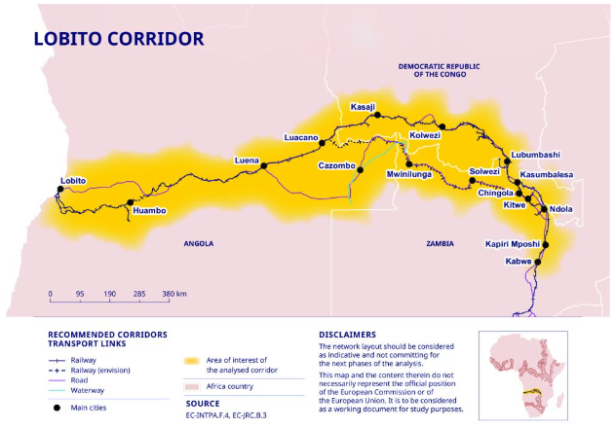
Source: https://international-partnerships.ec.europa.eu/policies/global-gateway/connecting-democratic-republic-congo-zambia-and-angola-global-markets-through-lobito-corridor_en
Lobito Atlantic Railway (LAR)
The Lobito Atlantic Railway (LAR) Concession Agreement was signed in November 2022, and construction is expected to take place imminently after financial close. Lobito Atlantic Railway company, a joint venture between Trafigura, Moto-Engel and Vecturis, has taken over the operation, management and maintenance of the rail infrastructure for the transport of goods for the corridor that runs for approximately 1,300 km, connecting the Lobito port to Luau, in eastern Angola, close to the DRC border of the DRC.
The LAR Consortium have committed to secure 1,555 wagons and 35 locomotives for the Angolan side of the corridor and to invest in training and skills. The Consortium plans to invest USD455 million in Angola and up to USD100 million in DR Congo and there is the potential for additional investment in the future as the opportunity is explored to extend the line further into Zambia, thereby extending its benefits even further across the region.
SNCC has upgraded the railway line between the border and Kolwezi, which already has a multimodal logistics platform where trucks can unload copper and cobalt into wagons. Trafigura (Impala) financed the rehabilitation of 80km of the track and purchased rolling stock (USD100m) which is in exchange for a reduced access fee for use of the Kolwezi-Luau line. There is a need to rehabilitate the remaining 340km to modernise the railway
Ivanhoe Mines, which operates the Kamoa-Kakula mine near Kolwezi, has signed an offtake agreement with LAR. Ivanhoe Mines has acquired a 22,195 sq.km exploration permit in Angola, mostly in Moxico Province on the Angola-DR Congo border and where the LAR line runs. It has also bought warehouses in Lobito port.
The Development Bank of Southern Africa (DBSA) has approved funding of up to US$200 million towards the Lobito Corridor Railway Project in Angola, alongside the U.S. International Development Finance Corporation (DFC). This strategic infrastructure initiative is valued at approximately USD786.4 million.
Zambia Lobito Railway
Figure 12.5: Map of Zambia Lobito Railway showing the route and Zambian copper mine locations
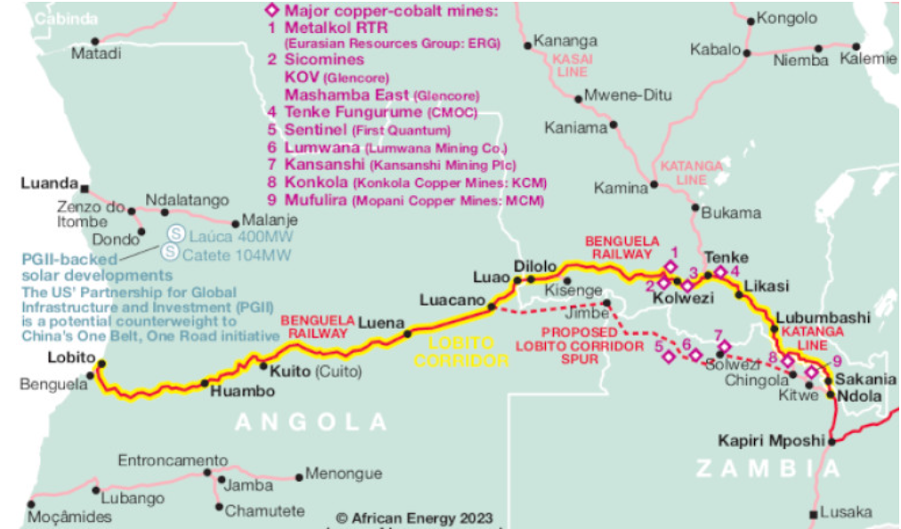
https://www.africa-energy.com/news-centre/article/lobito-corridors-extension-zambia-backed-us-and-eu
The Zambia Lobito Railway (ZLR) is a proposed greenfield railway project that will link Chingola to the port of Lobito in Angola. The railway is planned as an 829km stretch of new, Cape gauge railway line from Chingola, through Solwezi, to the Zambian and Angolan border south of Jimbe, the existing road border. The railway track will cross the border into Angola and join the existing Benguela railway operated by Lobito Atlantic Railway and onto the port of Lobito.
The Zambia-Lobito railway represents Phase 2 of the Lobito Corridor initiative. The railway line is considered strategic as it links mines and smelters in the Zambian Copperbelt and in Northwestern Province with a seaport on Africa’s western seaboard.
The ZLR line is intended to be an open access line, meaning that the operator of the rail services will take full commercial risk, running on infrastructure owned by a third party, which, in the case of the ZLR, will be a consortium led by the Africa Finance Corporation (AFC), who have been the lead developer and who have financed the Feasibility Study. According to a press release by the United States Department of State, AFC signed a concession agreement with the governments of Zambia and Angola to develop and operate the rail and construction will start in early 2026.

Track Expansion to Kazungula and Sesheke
There are plans to construct a railway line from Livingstone to Kazungula so that it can cross the road-rail bridge into Botswana and will join the Botswana Rail track when Botswana completes the construction of this spur. The railway line is then planned to proceed to Sesheke on the border between Namibia and Zambia. When the Namibians build the link from Grootfontein to the border at Katima Mulilo, which is approximately 800km, Zambia and DR Congo will have rail access to the port of Walvis Bay.

Inland Waterways - Mpulungu Harbour
Mpulungu Harbour is located in Zambia at the southern-most end of Lake Tanganika. The Harbour is primarily used to move cargo into DR Congo and Burundi across the lake. Kalemie in DR Congo and Bujumbura in Burundi are the main points of delivery.
Mpulungu Harbour is managed by Mpulungu Harbour Corporation Limited (MHCL), a parastatal company wholly owned by the Industrial Development Corporation (IDC) and has its own Board of Directors.
MHCL has one main loading berth of 20 meters, secondary berths (west and east) of 5 metres and an oil jetty of 16 metres. It has storage capacity inside warehouses and outside.
The MHCL Strategic plan includes:
- Constructing three new 70m piers (210m in total).
- Rehabilitating the fuel jetty and leasing it out to an Oil Marketing Company (OMC)
- Construct four fit-for-purpose warehouses close to the new jetty and pave the port roads and working surfaces.
- Alter the entrance and install automated boom gates.
- Build a new maintenance workshop with administration offices above them which will be used by Customs, other border agencies, shipping agents, clearing agents, freight forwarders and MHCL personnel.
- Construct a small MFEZ within the Harbour area so that it benefits from being in a bonded area.
These works are expected to be done in phases, with Phase 1 estimated to cost about USD20 million and Phase 2, which is dependent on the level of increased traffic generated with the completion of Phase 1, estimated to cost about USD30 million.

Logistics Hubs
With the revival of rail transport happening in Zambia it would be useful to consider the establishment of Logistics Hubs at key points in Zambia where there may be a transfer of goods from road to rail or from rail to road. Bearing in mind that the legislation that stipulates at least 30 per cent of freight should be carried by rail, obvious Logistics Hubs where goods could be transferred from road to rail would be:
- Nakonde border post. Goods destined to DR Congo or the Zambian Copperbelt or any town along the Zambian line of rail could be transferred from road to rail.
- Livingstone. Goods coming through Sesheke, Kazungula and Livingstone border posts and either transiting to DR Congo or destined to a town on the line of rail could transfer to rail.
- Kapiri Mposhi. Goods coming from Dar es Salaam could be off-loaded onto trucks at Kapiri Mposhi and goods going to Dar es Salaam could be loaded from trucks onto the train at Kapiri Mposhi.
- Chipata. There is a small section of railway from Chipata town to the Malawi border. It crosses the border and joins the Nacala Corridor railway line to the port of Nacala in Mozambique.

Aviation
Zambia's aviation policy aims to support the country's economic growth by promoting the safety and security of civil aviation. The policy also aims to ensure that Zambia meets its international obligations as a signatory to the Chicago Convention of 1944.
Key components of Zambia's aviation policy include:
- Safety and security: The policy prioritizes the safety of passengers, crew, and aircraft.
- Compliance with international standards: Zambia must comply with the International Civil Aviation Organisation's (ICAO) standards for air safety and security.
- Economic growth: The policy recognises that aviation creates jobs and connects Zambia to the global economy.
- Regulation: The policy includes the licensing, inspection, and regulation of aircraft, aerodromes, and personnel.
The Civil Aviation Policy (CAA) is responsible for regulating the aviation sector in Zambia and implements ICAO standards and works with other stakeholders to promote civil aviation.
In terms of expanding the sector’s physical infrastructure, Zambia is building new airports and expanding existing ones to improve transportation and economic growth. The Zambia Airports Corporation Limited (ZACL) manages the country's airport infrastructure and has recently commissioned:
- Simon Mwansa Kapwepwe International Airport (SMKIA). This airport replaced the old Ndola International Airport in 2021. It was built to serve the Copperbelt, Luapula, and Northwestern Provinces; and
- Chinsali Airport: Construction on this new airport is scheduled to begin in July 2024 and be completed within three years.
Airport expansions include:
- Kenneth Kaunda International Airport (KKIA): ZACL has been upgrading this airport to meet international standards.
- Harry Mwaanga Nkumbula International Airport (HMNIA): ZACL has been upgrading this airport to meet international standards.
- Mansa Airport: The runway at this airport is being expanded.
- Kasama Airport: This airport has been receiving some aircraft since it opened in August 2023.

Warehouses and Silos
Zambia's national warehouses and silos are primarily held by the Food Reserve Agency (FRA), which has a storage facility, including (usually) metal silos and hermetic bags, in almost every district in the country. The FRA has warehouses storing commodities like rice and soybeans in the regions where they are produced. The FRA maintains a strategic maize reserve of 500,000 metric tons per year.
Zambia has struggled with storage capacity, especially for maize grown by smallholder farmers in rural areas and the FRA has faced challenges with maintenance management, including a lack of a clear policy and technical and financial inadequacies.
The FRA has a few projects that aim to improve storage capacity, including the Effective Grain Storage for Sustainable Livelihoods of African Farmers (EGSP), which is a five-year project that provided metal silos and super grain bags to farmers, and AFGRI Grain Bunker Zambia, which is a project that helped improve grain storage in Zambia, increase structured trade, and contribute to food security.

Table 12.3: Summary of Transport and Logistics Infrastructure Projects
Nos | Sector |  |  | Project Name | Private Sponsor | Est. Cost (USDm) | Financial Close | Project Stage | Project Description
1 | Road |  |  | Dualization of Lusaka-Ndola Road | Macro Oceans Investment Consortium | 649.90 | Yes | S4B: Construction | Project signed in February 2023 for a period of 25 years to Design, Finance, Build, Operate, Maintain and Transfer to upgrade to a dual carriageway the 327km section from Lusaka to Ndola and 45km section from Luanshya-Fisenge-Masangano. Construction commissioned in May 2024.
2 | Road |  |  | Chongwe-Luangwa Bridge Road | - | 154.40 | No | S2A: Pre-Feasibility | Design, Finance, Build, Operate, Maintain and Transfer to rehabilitate 192km section of road from Chongwe to Luangwa Bridge.
3 | Road |  |  | Luangwa Bridge-Mwami Road | - | 290.70 | No | S2A: Pre-Feasibility | Design, Finance, Build, Operate, Maintain and Transfer to rehabilitate 362km section of road from Luangwa Bridge to Mwami.
4 | Road |  |  | Kapiri Mposhi-Serenje Road | - | 157.80 | No | S2A: Pre-Feasibility | Design, Finance, Build, Operate, Maintain and Transfer to rehabilitate 157km section of road from Kapiri Mposhi to Serenje.
5 | Road |  |  | Serenje-Mpika Road | World Bank TRACER Programme | 190.50 | No | S2A: Pre-Feasibility | Design, Finance, Build, Operate, Maintain and Transfer to rehabilitate 238km section of road from Serenje to Mpika.
6 | Road |  |  | Lusaka-Chongwe Road | - | 76.20 | No | S2A: Pre-Feasibility | Design, Finance, Build, Operate, Maintain and Transfer to upgrade from 2 to 4 lanes the 40km section of road from Lusaka to Chongwe. This road is not fully viable and will require ~US$15,30 million in Viability Gap Funding (VGF), amounting to 25% of the project value.
7 | Road |  |  | Chirundu-Lusaka Road | - | 288.30 | No | S2A: Pre-Feasibility | Design, Finance, Build, Operate, Maintain and Transfer to upgrade from 2 to 4 lanes the 40km section of road from Chirundu to Lusaka. This road is not fully viable and will require ~US$34,80 million in Viability Gap Funding (VGF), amounting to 12% of the project value.
8 | Road |  |  | Chingola Mutanda via Solwezi | Bert Motors Investment | 450.00 |  | Awaiting commercial close | 30-year concession to construct the Chingola to Solwezi Dual Carriageway including bypass roads. The agreement was signed in May 2021
9 | Road |  |  | Kalabo-Sikongo-Angola Road Project | No |  | No | S1: Project Definition
10 | Road |  |  | Detailed designs for Lusaka-Luangwa | World Bank TRACER |  | No |  | The World Bank is financing the detailed design of the Lusaka-Luangwa road rehabilitation project
11 | Road |  |  | Detailed designs for Livingstone-Katima  Mulilo. | World Bank TRACER |  | No |  | The World Bank is financing the detailed design of the Livingstone-Katima Mulilo road rehabilitation project
12 | Border Post |  |  | Chirundu Border Post | Chirundu Borders Consortium | 46.00 | No |  | Concession Agreement sign in July 2024. The project involves the redevelopment and upgrade of the soft and hard infrastructure at Chirundu One Stop Border Post.
13 | Road + Border Post |  |  | Chingola-Kasumbalesa Road | Turbo Investment Consortium | 35.60 | Yes | S4C: Operation | Project signed in October 2022 for a period of 18 years to Design, Finance, Build, Operate, Maintain and Transfer to rehabilitate the 35km section from Chingola to the Kasumbalesa Border. Agreement signed on 31st October 2022 and operations were commissioned on 12th April 2024.
14 | Road + Border Post |  |  | Lumwana-Kambimba Road and Border Post | Sandstone Consortium Limited | 119.00 | No | S3A: Project Structuring | Project signed in September 2023 for a period of 25 years to Design, Finance, Build, Operate, Maintain and Transfer to construct a 100km road from Lumwana to the Kambimba Border and to construct new Border Infrastructure.
15 | Road + Border Post |  |  | Katete-Chanida Road and Chanida Border | Lutembwe Consortium | 79.80 | No | S3A: Project Structuring | Project signed in October 2023 for a period of 25 years to Design, Finance, Build, Operate, Maintain and Transfer to rehabilitate 55km of the T6 from the T4 Junction to the Chanida Border and to construct a new One-Stop Border Facility.
16 | Road + Border Post |  |  | Ndola-Sakania Road and Border and Ndola-Mufulira Road | JASWIN Ports Limited | 76.40 | No | S3A: Project Structuring | Project signed in October 2023 for a period of 22 years to Design, Finance, Build, Operate, Maintain and Transfer to rehabilitate the road from Ndola to the Sakania Border, to upgrade Border Infrastructure and to rehabilitate the Ndola-Mufulira Road.
17 | Road + Border Post |  |  | Chingola-Mutanda Via Solwezi Road | Bert Motors Investment | 450.00 | No | S3A: Project Structuring | Project signed in May 2021 for a period of 30 years to Design, Finance, Build, Operate, Maintain and Transfer to upgrade to a Dual Carriageway the section of road from Chingola to Mutanda, via Chingola, including bypass roads in Chingola and Solwezi.
18 | Road + Border Post |  |  | Kasomeno-Mwenda Road, Bridge and One Stop Border Post | Groupe European De Developpement Du Africa (GED) | 180.00 | No | S3A: Project Structuring | Project signed in August 2016 for a period of 25 years to Design, Finance, Build, Operate, Maintain and Transfer to construct to a bituminous standard 92km of a new road from Kaluba to Mwenda, including a One Stop Border Post (OSBP) and Bridge across the Luapula River. The concession agreement was signed on 5th August 2016 and commercial close is awaited, although early works have begun with equity.
19 |  | Railway |  | Phase I: Removal of TSRs and signalling repairs | Grant from EU and other loan finance | 113.0 | No | S3A - Project Structuring | Procurement of civil and construction works, materials (ballast, sleepers, rails, etc), equipment repair and equipment hire and upgrading the signalling equipment to ensure that all TRSs are removed and there are less derailments
20 |  | Railway |  | Phase II: Full track upgrade; purchase of locomotives and rolling stock and signalling equipment | None | 408.53 | No | S1: Project Definition | Upgrading the permanent way (civil and structural works: materials for railway rehabilitation; equipment for infrastructure rehabilitation; labour and professional services; assessments).
 |  |  |  |  | None | 472.80 | No | S1: Project Definition | Upgrading rolling stock and acquiring new rolling stock.
 |  |  |  |  | None | 50.65 | No | S1: Project Definition | Signalling and telecommunications
21 |  | Railway |  | Upgrading inter-mine rail track | None |  | No | S2B - Feasibility | Inter-mine connectivity project to link the new production centres by rail on the Copperbelt Province.
22 |  | Railway |  | Nseluka – Mpulungu railway | None | N/A | No | S1: Project Definition | The proposal is to build a railway line from the TAZARA line from Nseluka station to the port and Mpulungu (194km).
23 |  | Railway |  | Zambia Lobito Railway | Africa Finance Corporation | 3,000,000 | No | S2B - Feasibility | The proposed Zambia Lobito Railway is to build a green field railway from Chingola, via Solwezi, into Angola and link up to the Lobito railway line at Luacano, so linking Zambia Railway with the Lobito Atlantic Railway Concession. The concession for the Zambia Lobito Railway has been awarded to Africa Finance Corporation (AFC).
24 |  | Railway |  | Livingstone-Kazungula-Sesheke Railway Line | None | N/A | No | S1: Project Definition | The proposal is to construct a new railway line connecting Livingstone to Kazungula, utilising part of the existing Mulobezi line, to connect Zambia Railways directly to Botswana Railways across the road/rail bridge at Kazungula. The railway would then extend to Sesheke to link Zambia Railways with Namibia Railways and Walvis Bay port if the Namibian Railways line is extended from Grootfontein to Sesheke.
25 |  | Railway |  | Solwezi-Kaoma-Sesheke | None | N/A | No | S1: Project Definition | The proposal is to construct a new railway line connecting Solwezi, through Kaoma to Sesheke so that the mining areas in Northwestern Province are connected to Namibia Railways and Walvis Bay port if the Namibian Railways line is extended from Grootfontein to Sesheke.
26 |  | Railway |  | 388 km Chipata-Petauke-Serenje railway line | None | 2,300,000 | No | S1: Project Definition | To link the Nacala Port in Mozambique to the Zambian railway network through TAZARA at Serenje
27 |  | River Canal |  | Shangombo–Rivungu Canal Project | None |  | No | S1: Project Definition | The Zambian government has expressed determination to actualize this project, aiming to boost trade by providing a direct waterway link between Angola and Zambia
28 |  | Port |  | Mpulungu port Phase 1 | None | USD 20.00 | No | S3A: Project Structuring | Proposed construction of a new pier, hard stands, container depot and dredging of the shipping channel and purchase of port equipment
29 |  | Port |  | Mpulungu port Phase 2 | None | USD 20.00 | No | S1: Project Definition | Proposed construction of 2 new piers, warehouses, offices and workshop. Proposed construction of a MFEZ in the port area.
30 |  |  | Dry Port | Kapiri Mposhi multi-modal trans-shipment dry port | Dar Corridor Group |  | Yes | S4B  Construction | After winning an open competitive bid, the Dar es Salaam Corridor Group (DCG) and the Tanzania-Zambia Railway Authority (TAZARA) have entered into a build-lease-transfer (BLT) agreement for the development of a Dry Port at the terminal end of TAZARA in Kapiri Mposhi. DCG will take over the four-hectare piece of land, construct the Dry Port, operate (lease) it for 25 years and, thereafter, transfer all the immovable assets to TAZARA.
31 |  |  | Dry Port | Chipata Dry Port | European investment Bank | Euro 25m | Yes | S4B  Construction | The Government of Zambia negotiated a loan from the European Investment Bank (EIB) to reconstruct a section of the Great East Road. Euro 10m of that loan is allocated to the design and build of a Dry Port which is located on the southern outskirts of Chipata Town. The site comprises 12 hectares of undeveloped land adjacent to the Chipata Railway Station within 62 hectares of land belonging to the Zambian Railway Authority. The location is approximately 5 kilometres by road from Chipata town centre and 22 kilometres (west along the Great East Road T4) from the Mwami Zambia - Malawi border post. The project is scheduled to start in April 2025.
PIDA - PAP Project Development Phases: S1: Project Definition; S2A: Pre-Feasibility; S2B: Feasibility; S3A: Project Structuring, S3B: Transaction Support & Financial Close, S4A: Tendering, S4B: Construction and S4C: Operation.

Masterplan Soft Infrastructure Issues
In addition to hard infrastructure projects in the road, rail, inland waterways, logistics hubs, aviation and warehousing and silos sectors there is also a need to address soft issues such as policy coherence and coordination, regulatory issues and trade facilitation issues.

Coordination of Logistics Related Policies and Regulations
Zambia has many comprehensive logistics-related policies in place, including the Zambia National Transport Policy (2019); National Export Strategy (2018); National Trade Policy and Export Strategy; Eighth National Development Plan (2022-2026); the Railways Act; the 2023 PPP Act, with accompanying policies and guidelines; Mining and Critical Minerals legislation, etc. All these policies allow the private sector to plan its activities and create an enabling environment for the logistics sector. But for Zambia to have an efficient Transport Logistics Masterplan in place it is important the policies and regulations that are related to transport and freight logistics are coordinated and trying to reach a common goal.

Public Private Partnerships
Government has recently reformed and revised the PPP act so that it is easier to administer and easier for the private sector to be involved in developing and implementing hard infrastructure projects, which allows the private sector to become involved at an earlier stage in project development and financing of project preparation activities. It also circumvents the usually very heavy requirements (which are costly and time consuming) of environmental and social impact assessment (ESIA) studies required by Development Financing Institutions (DFI) if the project is to be financed partly or wholly through DFI funding.
There is, however, an emerging mismatch between the requirements of the sector and the requirements of the concessionaire, especially as regards concessioning of border posts. The strategy of government seems to be to concession as many border posts as possible, with those not being concessioned (Kazungula, Mwami and Nakonde) being the recipients of substantial amounts of donor financing to pay for their conversion into OSBPs.
Government is concessioning border posts because it is of the opinion that it does not have the necessary resources to modernise and upgrade the infrastructure at border posts. The functions of the border clearing agencies, such as the Customs Service Division of ZRA, Immigration, Port Health, Police, Security, RTSA, etc. are not taken over by the concessionaire and the only support the border agencies will get from the concessionaire is, possibly, office facilities. The role of the concessionaire at a border post is to build infrastructure, such as parking facilities and, in extreme cases, commercial facilities (such as shops, restaurants and hotels which have no place in a border facility where commercial goods and passengers should be move through as quickly as possible). The concessionaire then needs to recover its investment by charging for use of the facilities it has constructed, so charging for parking and traffic control systems, for example. It is in the interests of the concessionaire to maximise the use of the facilities it has built, such as parking facilities, while it is in the interests of the economic development of the country to minimise the use of border facilities.
In encouraging and actively promoting concessioning of border posts, government is apparently not taking international best practices as regards Customs clearance processes into consideration and is encouraging a cost increase in imported goods, which will be inflationary and will also make industrialisation of the economy, upon which graduation from a least developed country to a middle-income country, is dependent.
The Zimbabwean side of the Beitbridge border post has recently been concessioned to a private sector operator and the concessionaire charges USD207 for a heavy goods vehicle to use the facility and USD48 for parking (See Table 13.1). There are also other taxes such as carbon taxes, 3rd party vehicle insurance, road access fees, etc charged per vehicle, whether that vehicle is carrying a load or not. A Zambian registered goods truck will, therefore, pay between USD550 and USD650, depending on the cargo being carried, each time the truck crosses the Zimbabwe side of the border, meaning at least USD550 will be charged when a normal (i.e. not an abnormal) Zambian registered truck crosses the border southbound and again when the Zambian registered truck crosses the border north bound.
Table 13.1: Fees charged at Beitbridge Border (Zimbabwe) for crossing the border
DESCRIPTION OF FEE |  | ZIMBABWE REGISTERED |  | FOREIGN REGISTERED
 |  | NORMAL TRUCK (USD) | ABNORMAL TRUCK (USD) | NORMAL TRUCK (USD) | ABNORMAL TRUCK (USD)
1 | ZimBorders | 207.00 | 307.00 | 207.00 | 307.00
2 | Gate Pass | 23.00 | 23.00 | 23.00 | 23.00
3 | Vehicle Inspection Dept (VID) | - | - | 100.00 | 100.00
4 | Road Access Fees | 20.00 | 20.00 | 20.00 | 20.00
5 | Insurance (Horse & Trailer) | - | - | 70.00 | 70.00
6 | Carbon Tax | - | - | 10.00 | 10.00
7 | Commercial Guarantee/Month | - | - | 50.00 | 50.00
8 | Wooden Pallets | 20.00 | 20.00 | 20.00 | 20.00
9 | Runner Fees | 20.00 | 20.00 | 20.00 | 20.00
10 | ZIMRA Seals | 30.00 | - | 30.00 | -
Totals |  | 320.00 | 390.00 | 550.00 | 620.00
ADDITIONAL CHARGES BASED ON TYPE OF GOODS
DESCRIPTION OF FEE |  | ZIMBABWE REGISTERED |  | FOREIGN REGISTERED
 |  | NORMAL TRUCK (USD) | ABNORMAL TRUCK (USD) | NORMAL TRUCK (USD) | ABNORMAL TRUCK (USD)
1 | Port Health | 20.00 | N/A | 20.00 | N/A
2 | Agriculture - Plant Quarantine Services | 20.00 | N/A | 20.00 | N/A
3 | Environmental Management Agency | 46.00 | N/A | 46.00 | N/A
4 | National Biotechnology Authority | 20.00 | N/A | 20.00 | N/A
Source: Compiled by Authors
South Africa is also in the process of concessioning its border post at Beitbridge and Zimbabwe is concessioning its side of the Chirundu border post and Zambia is doing the same on its side of Chirundu border post. The concessionaire for both sides of the Chirundu border has shareholders in common with the shareholders of the company which is the concessionaire of the Zimbabwe side of Beitbridge so it is not unreasonable to expect that similar charges as those now applied on the Zimbabwean side of Beitbridge will also apply to both sides of Chirundu border post. The South African side of Beitbridge does not charge for crossing the border but it is understood that it will also concession its border post in the future.
If all concessionaires and all countries adopt the fees adopted by the Zimbabwe concessionaire at Beitbridge, this will add over USD4,000 to the costs of a round trip between Durban and Lusaka and over USD6000 to the costs of a return trip by road between Durban and Lubumbashi in DR Congo. This means that, in effect, the costs of the journey from Durban to Zambia and DR Congo and return for a heavy goods vehicle will be so expensive that importers and exporters will start to consider different routes to and from seaports.

Railway Policies and Regulation
Zambia has two railway systems:
- Zambia Railways Limited (ZRL)
Zambia Railways Limited (ZRL), which started as a region of Rhodesia Railways (RR), headquartered in Bulawayo, with the regional headquarters in Kabwe. The line operated as RR with joint ownership with Southern Rhodesia (present day Zimbabwe) until after the dissolution of the Federation of Rhodesia and Nyasaland in 1963. RR operated as a Unitary Railway System with assets remaining jointly owned by Zambia and Southern Rhodesia until 1967 when the Zambian Government passed the Railways Act, which established the Zambia Railways Board. Zambia Railways was incorporated as a limited company through the Railways Act of 1982 and remained as a parastatal company until 2003, when it was concessioned to Railway Systems of Zambia (RSZ). In 2012 the Government rescinded its decision and repossessed ZRL from RSZ because RSZ was not performing as it was expected to and there had been a deterioration of the railway infrastructure during the concession period. Up until the 1990s ZRL was the main carrier of bulk cargo and passengers in the country. Today, trucks are the dominant mode of transport for both passengers and freight.

- Tanzania-Zambia Railway (TAZARA):
Tanzania-Zambia Railway (TAZARA) was built and paid for by the Chinese Government and Chinese companies to allow Zambia to have rail access to the sea without having to use the southern route through Rhodesia, which unilaterally declared its independence from Britain in 1963 and so had sanctions applied, and apartheid South Africa. In 1967, an Agreement for the construction of TAZARA was concluded in Beijing, China, between the three Governments of China, Tanzania and Zambia. The Tanzania-Zambia Railway Authority was established in March 1968, construction started in 1970, and full operations commenced in July 1976. The line is designed to carry 5 million tons per annum, but the line has never carried more than 20 per cent of its design capacity.
For many reasons, including issues related to climate change (rail transport is about 4 times more fuel efficient than road transport, meaning less fuel is burned per ton kilometre in rail transport than road transport so less climate damage and less expensive on longer journeys) and the damage being done to road infrastructure and the time wasted owning to congestion on the roads and at the borders, there has been strong interest from both public and private sector stakeholders to take action to revitalise the railway systems and to get freight especially back onto the railways.
In April 2018, the then Transport and Communications Minister introduced a Statutory Instrument which compelled mining companies and other bulk cargo firms to transport at least 30 per cent of their freight by railway, aiming to revive the rail sector by significantly increasing cargo movement from road to rail transport. However, this SI has not been enforced, mainly because the railway systems in Zambia (ZRL and TAZARA) do not have the capability or capacity to move 30 per cent of Zambia’s freight by rail. This SI is, therefore, aspirational in intent rather than an SI which can be practically enforced.
Government is now actively working to revitalise and recapitalise the Zambia Railways system through strategic partnerships and investments, aiming to improve its infrastructure and operations across the network.
Zambia Railways Limited (ZRL) has developed a new Strategic Business Plan to guide the revitalisation efforts, including addressing immediate needs like repairing locomotives and wagons.
The Government is also actively seeking partnerships with private companies and multilateral development institutions to support the recapitalisation of the railway system. To promote this, the Railway Act of 1994 in Zambia has been revised to promote open access to the railway and to encourage participation from both the public and private sectors.
Currently the business model for the railway sector is a vertically integrated railway model in which ZRL owns and operates both the railway infrastructure (tracks, signals, stations) and the trains that run on it. ZRL controls all aspects of rail service from track maintenance to train operation.
Vertically integrated railways have the advantage of there being a single company controlling the full value chain, so ensuring coordination between railway operations and infrastructure. The disadvantage of this model is that it is monopolistic and, in the case of ZRL, it has not allowed more than one operator. This in itself may not be a problem but, in the case of ZRL, because it is insufficiently funded to maintain the track and to keen sufficient locomotives and rolling stock on the rails, its monopoly position means that the failings of ZRL translate into the failings of the national railway system.
TAZARA also operates under a vertically integrated model, but it has allowed other operators, including ZRL and Calabash Freight, to operate services on the line it owns, so does not act as a monopoly service provider.
A vertically integrated model, with a parastatal operator, as is the case for ZRL, requires strong funding from government budgets and if this is not the case, the railway infrastructure and service delivery will decline.
There are instances of privately owned and managed vertically integrated railways, such as in the USA, meaning that there is little or no costs that need to be covered by taxpayers but lower income countries, such as Zambia, lack the governance and regulatory structures required to make this type of model work effectively.
Vertically segregated railways, where there is a separation of infrastructure, which usually belongs to the State and is a natural monopoly, and operations. This model allows competition between railway operators and is a model that has been implemented in many countries.
In a vertically segregated model the ownership and maintenance of the track is the responsibility of the State, either through a state-owned company or through a manager recruited by the State-owned company or the Government itself. The track owner/operator receives fees from the operators that use the infrastructure.
This model requires coordination among different parties. The model can either operate with an independent regulator to assure fair and transparent conditions to market access, or this can be done through contracts between the track owner/manager that specify the access fee, the composition and specifications of a train, etc.
Most often, infrastructure managers are public sector undertakings. A private sector infrastructure manager was experienced at the early stages of privatization in the UK and the model was partially reversed after it was blamed for prioritizing returns to shareholders over maintenance and safety, resulting in several accidents involving fatalities.
The African Development Bank’s Rail Infrastructure in Africa Financing Policy Options gives ten objectives for a railway sector framework and policies:
Project identification and selection:
- Railway financing should prioritise projects that focus on identified markets generating high volumes;
- Freight railway projects should take account of the whole logistics chain;
Railways finance:
- A new approach to passenger services is required;
- A systematic approach to maintenance is mandatory as it underpins railway performance;
- Insufficient funds and financial commitment to concessions;
- Railways’ economic, social and environmental contributions should be monetised;
- New approaches to railway concessions should be explored;

Institutional structure:
- Enhanced technical and business capabilities should be encouraged;
- Railway industry should be corporatised and regulated; and
- Larger railway markets in Africa should be promoted through increased cross-border cooperation.

Mining and Minerals Policies and Regulation
Critical Minerals Strategies and Policies: Despite its abundant mineral resources, Zambia has not been able to fully exploit these resources to help in the economic transformation of the country for the benefit of the Zambian people. It is against this background that Zambia has developed a strategy that aims to allow the country to derive maximum benefits from its critical mineral resources. The National Critical Minerals Strategy 2024-2028 calls for structural transformation of the mining sector in Zambia through effective and timely management of the critical minerals value chain. The Strategy aims to enhance linkages between the production of critical minerals and the local economy, increased value addition, promotion of local content, increased industrialisation and manufacturing, and growing of revenue streams through the export of critical minerals as well as semi to finished products.
According to the Critical Minerals Strategy, the country has potential to play an important role in the global supply and processing of critical minerals, as well as the manufacturing of advanced technologies that utilise these processed minerals. Critical minerals in Zambia include:
- Lithium: occurrences are located in Chilobe, Chankumba, Sialumba in Mapatizya of Southern Province, Nyimba and Lundazi in Eastern Province and Chama in Muchinga Province. There are also reported occurrences of Lithium in Chitambo, Mkushi, Luano and Serenje in Central Province.
- Tin: occurrences are reported along the Choma-Kalomo Block batholith in Southern Province and in Lundazi-Chama areas of Eastern Province.
- Graphite: occurrences are widespread in Zambia, with the most prospective areas located in Petauke and Chama-Lundazi areas. Other areas with known graphite occurrences include Lumezi (Njoka), Petauke (Mkonda and Mvuvye) in the Eastern Province, Mwalamba and Kajimba in Mkushi area of Central Province, as well as Mapatizya area of Southern Province.
- Coltan (Columbite-Tantalum): reported occurrences of coltan include in Misika in Mapatizya area of Southern Province and Lundazi-Chama area in Eastern Province.
- Rare Earth Elements (REEs): occurrences of rare earth elements in Zambia include Isoka (Nkombwa Hills) in Muchinga Province and Misika, Chankumba in Mapatizya areas of Southern province.
- Manganese: occurrences of manganese mineralisation in Zambia are many, although most of them are confined to Luapula and Central Provinces. The main occurrences are found in Kawambwa, Samfya, Chembe, Mansa (Bahati and Mashimba) Districts, Chiwefwe, Kampumba, Lubemba, Serenje, Mkushi and Mumbwa Districts.
- Nickel: deposits which are currently being exploited are the Munali Nickel deposit in Mazabuka District in Southern Province and Enterprise Nickel deposit in Kalumbila District in Northwestern Province.
Both DR Congo and Zambia are supporting a joint Battery and Electric Vehicle (BEV) initiative at the highest levels and DR Congo has already established the Congolese Battery Council. In Zambia, the Ministers of Commerce, Trade and Industry (MCTI), Finance and National Planning, Mines and Minerals Development and Technology and Science were tasked by the President to spearhead the initiative and a technical committee to support the processes on the initiative was inaugurated. Following the signing of the framework agreement in March 2023, Afreximbank and UNECA retained ARISE Integrated Industrial Platforms to prepare a prefeasibility study on the Transboundary Special Economic Zone. ARISE submitted the draft prefeasibility report to the two member States in December 2023 for their review.
The BEV initiative, which focusses on the production of nickel, manganese and cobalt (NMC) battery precursors, is still under discussion, the main points being discussed being:
- Location of the BEV plant – the initial proposal was to set up in a cross-border special economic zone, but it seems that this shared site may be unviable.
- Mineral sourcing: The initial aim of the two governments was to source all the required nickel, manganese and cobalt only from the two countries. However, the plant that was initially envisaged would be large by global standards, producing around 100,000 tonnes of NMC precursors (one of the most common types currently demanded) a year. This would require around 48,000 tonnes of nickel, 15,000 tonnes of manganese and 16,000 tonnes of cobalt that has been refined into sulfate. This may be difficult for the two countries to produce.
It is also important to take account of trade deals where precursors made in Zambia and DR Congo could benefit. For example, only minerals processed in the U.S. or a country with which it has a free trade agreement qualify for the Inflation Reduction Act’s electric vehicle tax credits. US is supporting the construction of nickel refining facilities in Tanzania, but the deal stipulates that the battery-grade nickel will be exported to the US
Finally, the BEV plant would need financing, which could, according to Bloomberg, be as low as USD39 million, for a plant with an annual capacity of but could also be much higher and in the range of USD100 million or more.
Although the intention of government in introducing the National Strategy on Critical Minerals 2024-2028 has been to harness and utilise the critical minerals to underpin Zambia's socio-economic development towards the attainment of an industrialised middle-income country by 2030 the way the Critical Minerals Strategy is implemented is crucial. For example, proposed strategic interventions include:
- Establish a Government Special Purpose Vehicle as an investment arm in the critical minerals’ subsector;
- Develop a production sharing mechanism of a minimum of 30 per cent for Government’s Special Purpose Vehicle in critical minerals sub-sector;
- Establish an investment framework of a minimum of 30 per cent Government’s SPV in all greenfield projects in critical minerals sub-sector;
- Establish regional and national value chains in critical minerals exploitation; and
- Formulate local content threshold of at least 35 per cent of the annual procurement for the critical minerals’ sub-sector.
It is unlikely that any investor will oppose any of these proposed strategic interventions but there are concerns over the way they will be implemented, and this uncertainty may be a threat to investment which will affect the logistics sector and the economy as a whole. For example, it is not clear how government will implement the establishment of an investment framework of a minimum of 30 per cent Government’s SPV in all greenfield projects in the critical minerals sub-sector. This could be interpreted as a 30 per cent free carry, or the SPV having the right to obtain 30 per cent of a greenfield project at the market value, or a combination of these. Similarly, it is difficult to calculate the effect a production sharing mechanism will have on a company’s profits until more information on how such a mechanism will be implemented in practice is provided. It is also difficult to estimate what a 35 per cent local content rule will mean in terms of operational issues until local content is adequately defined. The threat is, because of uncertainty, a potential investor will not be able to satisfactorily evaluate risk of an investment, so will not invest until that risk can be evaluated and, in the meantime, if an attractive investment opportunity arises elsewhere, they will take advantage of that opportunity rather than risk the Zambian investment.
Accurate and Consistent Messaging on Metal Production
The stated aim of the Zambian government is to increase copper production from the current 830,000 metric tonnes to 3 million per year in the next ten years. There are, however, sceptics who suggest that this is not an attainable target, primarily because of unresolved challenges facing the country’s two biggest mines Mopani and Konkola Copper Mines and because of the lack of proven reserves that the 3 million tonne production target is dependent on and because of the shortage of power being experienced by the country. There are also indications that copper production is reducing rather than increasing. According to the Ministry of Mines, Zambia produced a total of 565,806.9 tons of copper between January and September 2022 compared to a total of 593,500.42 tons for the same period in 2021.
The Africa Report refers to the target of reaching copper production of 3 million tons in ten years as “wishful thinking”. However, there is little doubt that, as the world gears up for a transition to renewable energy, a copper boom is on the horizon and the government of Zambia believes it is poised to reap the benefits as green energy technologies all require large quantities of copper.
The government’s strategy paper about how the 3 million tonne target will be achieved, with a budget allocation of ZMW4.25bn (USD223m) to implement it, identifies three main sources for rapidly increasing production as being expanding existing mines, opening new mines and reprocessing material from the dumps left by over a century of mining. This will all be facilitated by a more stable investment climate, swift resolution of any disputes in the sector and better geological mapping that will reveal more deposits.
The challenges faced in verification of these targets as realistic lie in the fact that the targets are at variance with the expansion plans or announced investments of the mines themselves and in the lack of known reserves that can be brought into production in the next 10 years to reach the 3 million production target.
The threats are how to verify the 3 million target as being realistic as if Zambia is to ramp up production almost four-fold in less than 10 years, investments in logistics systems and in processing systems along the value chain need to be taken immediately. But until projected production figures can be verified it is unlikely that the required investments in the logistics and production systems will take place.
Consistency in Mining Laws
The proposed reform, contained in the Minerals Regulation Commission Bill, aims to establish a new regulator to oversee and regulate mineral-related activities and to ensure transparent and efficient management of mineral resources.
However, the bill has prompted concerns in the mining industry around its potential to deter mining investment in Zambia. Two industry bodies, the Association of Zambian Mineral Exploration Companies and the Zambia Chamber of Mines, have issued a joint statement calling for amendments to the bill, as the bill in its current form will revert Zambia to “long-term policy instability and mining investment stagnation”, as well as “drive up the perception of investment risk in Zambia”, according to the statement. The Bill will enable the state to acquire an interest in an exploration license before the license is granted to a private party. If viable mineral deposits are identified and the private party converts the exploration license into a mining license, the state will retain its interest. The Bill also empowers the Minister of Finance to acquire mining rights for investment by the government over “identified areas”. These “identified areas” are reserved for investment by the State and won’t be subject to the normal application process to acquire the rights. This lack of clarity in the Bill may deter investments in the mining sector and so affect the logistics of the mining sector.

Recommendations

Recommendation 1: Lead the Process of Operationalising a Corridor Management Institution
Zambia has a strong transport and logistics industry that not only services the mines in Zambia and DR Congo but also services consumers in both Zambia and DR Congo. However, this industry is under threat and the industry and policy makers need to be aware of these threats which include loss of market share. This would be as a result of on-going investments in neighbouring countries, namely DR Congo and Tanzania, that might result in through traffic being diverted away from Zambia, which would isolate Zambia and make the ambition of making Zambia a regional logistics hub a lot more difficult to achieve. These investments include:
The Dar es Salaam – Kigoma Standard Gauge Railway.
The Dar es Salaam – Kigoma standard gauge (1435mm) main railway line is being constructed to link Dar es Salaam port with Kigoma port, which is a Tanzanian port on Lake Tanganyika. The plan is to also link the port at Mwanza on Lake Victoria to the main Dar-Kigoma line and to also extend the line from Kigoma northwards to Bujumbura in Burundi and Kigoma in Rwanda. The Standard Gauge Railway (SGR) is expected to accommodate passenger trains traveling at 160 kilometres per hour and cargo trains traveling at 120 kilometres per hour. There are further planned extensions to take the railway into Burundi and Rwanda.
The construction of this railway will allow Burundi to intensify the exploitation of nickel, of which the country has the 10th largest deposit in the world in the Musongati mining fields. The country also has resources such as lithium and cobalt, which are expected to generate significant revenue for the country through the rail link with the port of Dar es Salaam which currently accounts for 80 per cent of the country's import and export trade. This will add value to the national GDP and allow Burundi to have additional resources to accelerate its social and economic development.
The Dar es Salaam – Kigoma SGR will also offer a route-to-market for the lithium concentrate exports that are expected to come from the Manono Project, which covers 188 square kilometres and located 500km north of Lubumbashi. The Manono Project refers to a larger lithium and tin project in DR Congo (DRC) that encompasses multiple pegmatites which was owned by AVZ (75 per cent) and La Congolaise d’Exploitation Minière SA (25 per cent) However, AVZ has now lost ownership and the mine is being developed by a combination of mining houses, including Zijin, who are expected to start production in 2026 and it is anticipated that it will produce about one million tons of lithium concentrate that will be exported via road from Manono to the port of Kalemie, across Lake Tanganyika to the port of Kigoma in Tanzania and then by train on the SGR to Dar es Salaam. Another mining consortium, Rio Tinto in collaboration with KoBold Metals, are rumoured to be interested in developing Roche Dure, which is a specific, large pegmatite located within the Manono project.
The challenge facing Zambia is that if the multimodal route from the DR Congo Copperbelt to the port of Kalemi by road (or road/rail or, in the future, rail), then the Lake crossing by ship from Kalemie to Kigoma and then the rail journey from Kigoma to Dar es Salaam becomes the cheapest and most efficient route to the port of Dar es Salaam from the Congolese Copperbelt then traffic will be diverted away from all Zambian routes. The same would apply for Burundi, which currently makes use of the shipping route from Bujumbura to Mpulungu in Zambia and onto the road/rail networks in Zambia.
The Lobito Corridor.
There are two proposed rail routes on the Lobito Corridor:
- The route from Kolwezi to Dilolo to Lobito (Lobito Atlantic railway or LAR), which is an existing (brownfield) project and already a bankable project, with a few access or concession issues to resolve in DR Congo; and
- The route from Chingola to Solwezi and across the border to join the Lobito-Dilolo railway line at Luacano (Zambia Lobito railway or ZLR), which is a greenfield site and, currently, far from being a bankable project.
The Feasibility Study that was commissioned by AFC and prepared by CPCS/Zutari suggests that the ZLR will take cargo from LAR, but it is at least as likely that the LAR will be the dominant route and will take cargo from Zambia. The distance by road from Solwezi, the mining centre of North Western Province to Lubumbashi via Kipushi is about 170km. Currently, copper from DR Congo is short hauled from DR Congo to Ndola but if the Lobito Corridor becomes an attractive route, then it is likely that copper will be transported from the mines around Solwezi by road to Lubumbashi and then by rail to Lobito. Given that the area with potentially increased copper output is around Solwezi, such a scenario would significantly reduce the amount of cargo transited southwards or eastwards from Zambia. In addition, an efficient LAR may also result in goods being imported into Zambia via Lobito and the LAR so reduce the traffic from South Africa and the ports of Walvis Bay, Durban, Beira and Dar es Salaam.
Deterioration of Transport Logistics Systems in Zimbabwe and South Africa
Another threat to the Zambian transport logistics systems is the deterioration of the transport systems particularly in South Africa but also in other countries to and from the port of Durban. Of particular concern is the poor operational performance of Transnet Freight Rail and Transnet National Ports Authority. If South Africa’s ports and railway network are not functioning efficiently then the North South Corridor no longer becomes an attractive transport or transit route. This will mean that there will be less demand for freight services on both Zambia’s road and rail network which will result in a loss of business and revenue for transporters and the logistics industry in Zambia.
Recommendation
Zambia needs to be pro-active in addressing its freight transport logistics challenges and one way in which this could be done is to establish a Corridors Sub-Committee within the National Trade Facilitation Committee (NTFC) to ensure that the Zambia’s main trade, transit and transport corridors will be addressed in a multi-sectoral way. The work of the Corridors Sub-Committee would include:
- Carrying out a detailed assessment of what corridor logistics initiatives, in all modes of transport, are taking place in neighbouring counties, including Angola, Botswana, DR Congo, Malawi, Mozambique, Tanzania, Zimbabwe and South Africa and what possible impact this may have on the Zambian freight logistics industry.
- Carrying out a detailed SWOT analysis involving all relevant stakeholders on Zambia’s main corridors to the sea and make recommendations on how Zambia’s strengths and be made even stronger, how to mitigate weaknesses, what the main opportunities are and how they can be taken advantage of and how threats can be mitigated. This SWOT analysis should be complemented with a PESTEL analysis that will examine, in detail, specific types of issues that impact on implementation of projects and identify the political, economic, social, technological, environmental and legal factors and identifying trends.
- Construct a freight projection model that addresses multiple scenarios that are highlighted from the SWOT and PESTEL analysis.
- On the basis of the freight project model prioritise investments in transport modes and trade and transport facilitation issues.
- Work with regional like-minded states to establish a regional Corridor Management Institution (CMI) which would need to be a rules-based institution rather than the normal African CMIs which are based on “best effort”, meaning that there are not penalties or sanctions applied to parties who do not implement agreed policies, regulations and programmes. The regional Corridor Management Institution would need to have supra-national authority so that it has the power to ensure that what regional policies and agreements are in place are actually implemented and if they are not implemented then the Corridor Management Institution needs to have the power and authority to impose sanctions on institutions that are not complying with agreed policies and agreements.

Recommendation 2: Design and Implement a Cross-Border Trade Facilitation Programme
Zambian has made significant progress in moving towards establishing a Single Window system which will make the process of final clearance and transit much easier, quicker and cheaper than it is at present. To finalise the process of establishing the Single window there is need to:
- Fully digitise all border agencies and make sure that the digitised system is robust and is operational all of the time, meaning that there must be back up systems and backup systems to the backup systems. The current situation where ASYCUDA is “down” on a regular basis is not acceptable.
- Ensure that the risk assessment register is up-to-date, and that one risk register is used by all Zambian border agencies so that one risk assessment can be done for each set of entry documents and each transit document and not have different border agencies using their own risk assessment methods to assess risk independently of other border agencies. As much as possible, risk assessment should be done before cargo reaches the border. As much as possible all cargo inspections and documentary inspections need to be done before the cargo reaches the border.
- As a rule, all cargo should be pre-cleared before it gets to the border, whether it is an import (final clearance) or export or goods in transit. This means that the importer or exporter or clearing agent or freight forwarder needs to submit a full set of documentation, including the cargo manifest and an estimated time of arrival at the border post, electronically to customs to allow customs to pre-clear cargo. In this scenario, it is not necessary to stop the trucks or trains at the border. It is only necessary to ensure that the goods and truck and driver are cleared for entry or exit, and this can be done using a unique identifier such as a radio-frequency identifier (RFID) or a bar code or QR code that can be scanned on entry and exit of the border post.
- All road Border Posts must have a dedicate physical Green Lane for all goods in transit (with transit documents in electronic form and in order and available to customs before the vehicle and goods arrive at the border); cargo, vehicles and drivers designated as low risk; and “Trusted Traders”.
- The COMESA Yellow Card should be used in all Corridor Countries as the main third-party motor vehicle insurance scheme.
- Zambia Customs implements Advance Rulings.
- Zambia uses cross-border electronic payment facilities and regulations at all border posts.
- Customs allows separation of release from final determination of Customs Duties procedures;
It would also be advantageous if Zambia was part of a regional Authorised Economic Operator Scheme and that Zambia’s neighbours are also part of the same regional scheme. Currently there are two operation regional schemes, these being the SACU AEO scheme and the EAC AEO scheme.
Recommendation
Implementation of the Transport Logistics Masterplan should include a project to design and implement a system that allows all goods at the border to pre-clear, whether these goods are exports, imports or goods in transit. In addition, discussions should be had with Transport and Transit Corridor Countries to devise a system where all border posts along all Transport and Transit Corridors should implement pre-clearance systems for all cargo.

Recommendation 3: Review the Road Sector PPP Financing Model
The Road Sector is almost totally reliant on public-private partnership financing and mainly on unsolicited funding requests where a private sector operator makes an unsolicited offer to government to upgrade or rehabilitate a road. Once this is done, Government and the private sector operator design the project and sign a concession agreement. Often the road is combined with another infrastructure asset such as a border post.
The challenge with this approach is in the lack of bankable or viable projects in the roads sector. Of the 48 potential PPP roads targeted by Government, through the PPP Unit in the Ministry of Finance, 6 PPP projects, all Trunk Roads, are considered viable, including two that will need to be supported by Viability Gap Funding (VGF).
In addition to this, it appears that the Concessionaires are utilising revenue from the concession to finance the rehabilitation of the roads that are concessioned. For example, there are three toll gates on the Lusaka to Ndola Road and all three have been handed over to Macro Ocean Investment Consortium, the Concessionaire, even before the construction of the road is complete. The main financier of the concession is the National Pension Scheme Authority (NAPSA), which is lending USD300 million of the USD650 million that is being spent on upgrading the 372-kilometre road to a dual carriageway. Two new toll plazas will be constructed, one on the Masangano-Fisenge-Luanshya Section, and the other between Chibombo and Kabwe. It is also possible that the toll charged on the Lusaka-Ndola Road will increase. For example, the concessionaire who has the concession for the Chingola-Kasumbalesa road and Kasumbalesa Border Post, has increased the toll fee for heavy goods trucks from K250 to K1,250, a 500 per cent increase.
The reason why roads are being concessioned is because the public sector does not have the resources to build new roads and maintain the existing road network. However, it could also be argued that the Lusaka-Ndola Road was the main revenue earner for the National Road Fund Agency (NRFA) and the NRFA could also have got a loan from NAPSA and raised the toll fees both by increasing the toll amount and increasing the number of plazas as the existing Concessionaire is going to do. NRFA could then have used the revenue from the Lusaka-Ndola Road to finance new roads and maintain roads that are not as profitable as the Lusaka-Ndola Road.
Recommendation
Carry out a study that will:
- Clarify how the current PPP model will apply to the remaining 44 roads that are either not viable as PPPs or which require Viability Gap Funding, which is another term for subsidies.
- Review the Ministry of Finance and National Planning’s Dismantling of Domestic Arrears Strategy of 2024-2029 to ensure that the debt dismantling programme is sufficient to clear historic debts over six years and that it takes account of “pipeline” debt which is not yet showing up as a NRFA creditor. The reason for this study is to ensure that the roads debt balance does not exponentially increase because of higher than projected interests rates and because of lower income into the National Road Fund because the most profitable roads have been concessioned as PPPs and the state is left to pay for the unprofitable roads.

Recommendation 4: Implement a Vertical Separation Model in the Railway Sector and Recapitalise the Rail Sector
The following recommendations are made for the Rail Sector
- When doing an economic and financial assessment of a railway it is important to base this on accurate demand studies to make sure that the project is at least economically viable if not financially viable. If non-viable railways are promoted as strategic railway corridors this will have a detrimental effect on the viable railways in that it will divert resources and attention away from the financially and economically viable railway infrastructure investments and viable railway operations. In the same way, it is recommended that priority is given to existing railways, especially track maintenance, to ensure the nation maximises its return on investment. Prioritising greenfield projects delays the rehabilitation of existing assets Figure 14.1 shows that the investment risks involved in greenfield investments are significantly more than those involved in brownfield investments
Figure 14.1: Investment Risk of Various Railway Investments
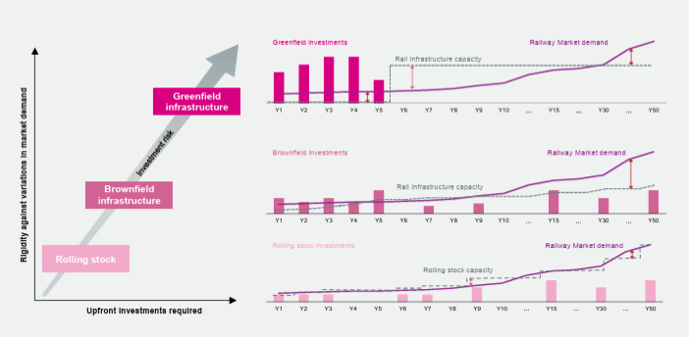
Source: Rail Infrastructure in Africa Financing Policy Options
- Operate the nation’s railways as vertically segregated, public infrastructure and private operator systems. This means that the private sector would be the service providers (so do the operation and maintenance of trains – locomotives and rolling stock) and the public sector would be responsible for the operation and maintenance of infrastructure and infrastructure investment and be the ultimate owners of the infrastructure. This would result in an open access system for the railways.
- Find innovative funding solutions. Usually sovereign financing is the most commonly used railway financing method. In this case a public sponsor (usually the Ministry of Finance or the Ministry of Transport) borrows/guarantees the required loans for the railway project. However, in the case of Zambia, the Government cannot provide sovereign guarantees and cannot increase the level of public sector debt. Nor is ZRL or TAZARA considered to be credit worthy by private sector financiers or by DFIs. Under these circumstances Zambia has few options other than use a PPP model to invest in the track. In this instance, ZRL would look for a partner to invest in the track and try to raise money (this would need to be off-balance sheet) so that it was an equal equity investor or, preferably, a majority shareholder. The financing agreement would need to be negotiated with an exit strategy so could be a debt/equity financing agreement. The loan would be serviced from revenue collected by the track owner from access fees charged to operators. Debt can also be raised through project bonds, a financial mechanism widely used for infrastructure projects in most developed countries.
- Update and renegotiate interchange agreements with neighbouring rail operators. Currently, there is very little traffic on the North South Corridor railway for many reasons, but the main reason is because of the difficulty of “change-over” between SNCC to ZRL to NRZ (and then the BBR concession) to Transnet. This change-over involves a change of personnel on the train, a change-over of locomotives and, sometimes, a change-over of rolling stock, at the border.
- Pilot Block Trains: One possible solution to have trains running from origin to destination could be to promote a “block train” solution. The North South Corridor block chain could deal with end-to-end traffic between Lubumbashi/Ndola and Durban. A block train is defined as an end-to-end (terminal to terminal), scheduled (regular service), standardised (20ft containers), seamless (in-bond), non-stop (stopping only for normal operational requirements like refuelling) operation along the entire North South Corridor and across the borders between DR Congo and Zambia, Zambia and Zimbabwe and Zimbabwe and South Africa.

Recommendation 5: Modernise Mpulungu Harbour
Mpulungu Harbour is a port on the southern-most end of Lake Tanganyika. Traditionally it has supplied sugar, fuel, cement and clinker and fast-moving consumer goods mainly to Bujumbura. Bit, for various reasons, market opportunities for Mpulungu Harbour are changing and management and the Board have developed a new strategy which focuses on serving the following markets:
- Fuel into DR Congo and Bujumbura. Currently all fuel going into the southern Provinces of DR Congo are trucked in from mainly the ports of Dar es Salaam and Beira and through the border post of Kasumbalesa. But the TAZAMA pipeline from Dar es Salaam to Ndola, which used to be used to pump crude oil for refining at the Indeni refinery at Ndola, now carries diesel, with offtake points at Mpika and Ndola. There is significant market opportunity for Mpulungu port to supply fuel across Lake Tanganyika to Kalemie in DR Congo and Bujumbura in Burundi.
- Lithium concentrates from the Manono Project in DR Congo. Zijin Mining Company are developing the Manono lithium mine and expect to start producing lithium in 2026. The lithium will be exported as a concentrate to China and Mpulungu harbour could be one gateway for this lithium in transit to Dar es Salaam.
- Containerised Fast Moving Consumer Goods (FMCGs) into DR Congo. The southern Provinces of DR Congo are heavily reliant on FMCGs and food transported into DR Congo from overseas and other neighbouring states (Zambia, Namibia and Tanzania) through the Kasumbalesa Border Post. Mpulungu Harbour could offer an alternative route into DR Congo through the port of Kalemie.
Recommendation
For Mpulungu Harbour to take advantage of these market opportunities it will need to significantly revamp its infrastructure (including new piers, warehouses, office building and workshop, container depot and a level working surface throughout the port and a MFEZ within the port). This could be done in phases, as could the purchase of fit-for-purpose equipment such as forklifts, tractors and trailers, reach stackers and mobile cranes for the port to become fully mechanised and automated and a modern port. This will require a total of about USD50 million and it is recommended that Mpulungu Harbour Corporation Limited (MHCL), through its holding company, IDC, find innovative ways to raise the necessary funds to modernise the port.

Recommendation 6: Restructure the Air Freight Business for Perishable Products
Improving the competitiveness of airfreight from Zambia, especially for perishable products, involves addressing various challenges and optimising the supply chain, including:
- Improving the facilities at Kenneth Kaunda International Airport and other relevant airports to support efficient handling of perishable goods, including better cold storage facilities and more efficient cargo handling systems.
- Develop better road infrastructure to facilitate faster and more reliable transportation of goods from farms and packhouses to the airport.
- Encourage private sector providers to invest in refrigerated trucks to keep perishable goods at the correct temperature from the farm to the airport and to utilise technology such as real-time temperature tracking and monitoring systems to ensure the integrity of the cold chain throughout the supply chain.
- Enhance quality and consistency by providing training to farmers and packhouse operators on best practices for harvesting, handling, and packaging perishable products to maintain quality and reduce spoilage.
- Develop and enforce quality standards for perishable goods to meet international requirements and improve marketability.
- Simplify export procedures by organising the private sector to work with government authorities to streamline export procedures and reduce bureaucratic delays. This includes faster processing of phytosanitary certificates and other necessary documentation.
- Enhance coordination with customs authorities in both Zambia and destination countries to expedite clearance processes and reduce delays.
- Develop Strategic Partnerships by collaborating and building partnerships with airlines to secure better rates and more frequent flights (airlines may offer dedicated freighter services or prioritise space for perishable goods) and work with experienced freight forwarders who specialise in perishable products to ensure efficient logistics and handling.
- Airlines (freighters) carrying freight out of Zambia could be given incentives such as reduced air navigation charges, ramp fee, and landing fee and this benefit MUST be passed on to the exporter in terms of reduced freight charges.
- Use logistics software and data analytics to optimize routes, manage inventory, and reduce lead times. This helps in planning and reduces costs.
- Foster better coordination between all stakeholders in the supply chain, including farmers, packhouses, transporters, and distributors, to ensure smooth operations and quick response to any issues.
- Explore and develop new markets beyond Europe to diversify export destinations. This reduces dependence on a single market and opens up additional revenue streams.
- Invest in marketing and promotional activities to raise awareness about the quality and unique aspects of Zambian perishable products. This can help in gaining better market share and premium pricing.
- Engage with government authorities to create favourable policies and incentives for airfreight operations, such as tax breaks or subsidies for cold chain investments.
- Utilise government programmes and trade facilitation initiatives that support exporters in improving their competitiveness and accessing international markets.
- Adopt sustainable practices in farming, packaging, and transportation to appeal to environmentally conscious consumers and meet international sustainability standards.
- Invest in research for innovative packaging solutions that extend the shelf life of perishable products and reduce waste.
- Explore new product offerings and value-added products that can be airfreighted to enhance the appeal of Zambian exports.
Recommendation
Carry of an in-depth study on how to optimise the cold chain and transport networks from origin to destination so that Zambia can take advantage of exports of perishable products to regional markets as well as emerging markets in the Middle East and elsewhere.

Recommendation 7: Construct Dry Ports and MFEZs at Strategic Locations
Zambia would benefit from a strategy aimed at building dry ports and Special Economic Zones (or Multi-Facility Economic Zones) in strategic location near major transport corridors.
Key aspects to focus on include:
- Location and Infrastructure: locations need to be close to major highways, rail lines, and, if possible, seaports (Zamcargo has dry ports at Dar es Salaam and Walvis Bay ports) to maximize connectivity and reduce transportation costs.
- Multimodal facilities: integrated infrastructure, including container handling yards, warehouses, customs clearance areas, and dedicated rail sidings to facilitate seamless cargo transfer between different modes of transport could be developed.
- Modern technology: There is a need to use advanced cargo tracking systems, electronic data interchange (EDI), and automation to streamline operations and reduce delays and implement a Single Window clearance process.
- Regulatory Environment: Dry ports and MFEZs operate most efficiently using simplified customs procedures.
- Where possible, offer tax benefits and concessions to companies operating within SEZs to attract investment.
- Use Public-Private Partnerships (PPPs) models and leverage private sector expertise and funding through PPPs to develop and operate dry ports and SEZs.
- Encourage the development of value-added services within SEZs like warehousing, packaging, and product customisation.
- Promote environmentally friendly practices like green logistics, renewable energy sources, and waste management within SEZs.
Specific recommendations for dry ports include:
- Ensuring smooth integration with road, rail, and maritime transport networks to facilitate multimodal cargo movement.
- Provide secure bonded warehouse space for temporary storage of goods awaiting customs clearance.
- Establish dedicated customs clearance zones within the dry port to expedite cargo processing.
Specific recommendations for SEZs or MFEZs include:
- Identify and attract industries with high export potential, considering local strengths and market demand.
- Invest in education and training programmes to equip the local workforce with necessary skills for SEZ operations.
- Foster an environment that encourages research and development activities within the SEZ.
Recommendation
Prepare a strategy to build dry ports and Special Economic Zones (or Multi-Facility Economic Zones) in strategic location near major transport corridors.

References:
AfCFTA and WEF An Action Plan to Accelerate Global Business and Investment in Africa. White Paper. January 2024
https://www.weforum.org/publications/an-action-plan-to-accelerate-global-business-and-investment-in-africa/#::text=Projects per cent20profiled per cent20in per cent20this per cent20action,chain per cent20to per cent20the per cent20continent per cent2C per cent20and

AfDB Rail Infrastructure in Africa Financing Policy Options. 2015.
https://www.afdb.org/fileadmin/uploads/afdb/Documents/Events/ATFforum/Rail_Infrastructure_in_Africa_-_Financing_Policy_Options_-_AfDB.pdf

AfDB Zambia Economic Outlook
https://www.afdb.org/en/countries-southern-africa-zambia/zambia-economic-outlook

AfDB Lake Tanganyika Transport Corridor Development Project Phase I Rehabilitation of Bujumbura Port - Project Appraisal Report. 12 December 2019.
https://www.afdb.org/en/documents/multinational-lake-tanganyika-transport-corridor-development-project-phase-i-rehabilitation-bujumbura-port-project-appraisal-report

CBRTA Country Profile for Zambia
https://cbrta.co.za/uploads/files/Zambia-Country-Handbook.pdf

COMESA Border Profiling Survey Report – Mwami, Chirundu, Kasumbalesa, Nakonde. November 2023.
https://www.comesa.int/wp-content/uploads/2024/02/Border-Profiling-Survey-Report_-Nov-2023.pdf

De Melo, Jamie et al Implementing the Trade Facilitation Agreement should boost trade among African Continental Free Trade Area members. CEPR. January 2024
https://cepr.org/voxeu/columns/implementing-trade-facilitation-agreement-should-boost-trade-among-african

Dubea, Kaitano and Evaluating climate change’s impact on hydroelectricity in the Zambezi River Nhamob, Godwell Basin. Heliyon. December 2023.
https://pdf.sciencedirectassets.com/313379/

ECDPM Green Industrialisation: leveraging critical raw materials for an African battery chain. Discussion paper No. 359. Poorva Karkare and Alfonso Medinilla. November 2023.
https://ecdpm.org/application/files/4017/0108/2796/Green-Industrialisation-Leveraging-Critical-Raw-Materials-African-Battery-Value-Chain-ECDPM-Discussion-Paper-359-2023.pdf

ECORYS/PMTC Maritime Trade on Lake Tanganyika Trade Opportunities for Zambia. Commissioned by the Netherlands Enterprise Agency. Rotterdam, July 2019
https://www.rvo.nl/sites/default/files/2019/08/Final-report-Maritime-Trade-on-Lake-Tanganyika.pdf

Erasmus/3S Group Lake Tanganyika: turning corridors into sustainable opportunities A study on maritime corridor development at Lake Tanganyika. Commissioned by the Netherlands Enterprise Agency. 2021.
https://www.rvo.nl/sites/default/files/2021/06/Lake-Tanganyika-Turning-Corridors-into-Sustainable-Opportunties.pdf

Erasmus Report on the workshop for the presentation of the results of Lake Tanganyika Regional Corridor Evaluation Study and the Development of a Roadmap for the Implementation of the Recommendations of the Study Best Outlook Hotel, Bujumbura, Burundi 23-24 February 2023 Commissioned by the Netherlands Enterprise Agency.
https://www.rvo.nl/sites/default/files/2023-07/Report-on-the-workshop-for-the-presentation-of-the-results-of-Lake-Tanganyika.pdf

Geopolitical Monitor The Lobito Corridor: Washington’s Answer to Belt and Road in Africa
https://www.geopoliticalmonitor.com/the-lobito-corridor-washingtons-answer-to-belt-and-road-in-africa/

GIZ Action Plan for the Full Migration of the Farmer Input Support Programme to an Electronic Agricultural Input Support System. December 2022.
https://www.agriculture.gov.zm/wp-content/uploads/2022/12/FISP_Action_Plan_27.12.2022-Final-7.pdf

Gregor Dobler, Swiss extractivism: Switzerland's role in Zambia's copper sector. The Journal
Rita Kesselring of Modern African Studies Volume 57, Issue 2, June 2019, pp. 223-245. Published online by Cambridge University Press: 24 July 2019.
https://www.cambridge.org/core/journals/journal-of-modern-african-studies/article/swiss-extractivism-switzerlands-role-in-zambias-copper-sector/8DF2B9E7BF6B9126BEE463233894395F

GRZ Zambia National Transport Policy. 2019
https://www.motl.gov.zm/?wpfb_dl=7

GRZ National Export Strategy (2018)
https://www.zda.org.zm/wp-content/uploads/2020/09/National-Export-Strategy.pdf

GRZ National Trade Policy and Export Strategy

GRZ Eighth National Development Plan (2022-2026). August 2022.
https://www.sh.gov.zm/wp-content/uploads/2022/09/EIGHTH-NATIONAL-DEVELOPMENT-PLAN-2022-2026-05-07-2022.pdf

IPCS/USAID Analysis of the interactive map of artisanal mining areas in eastern Democratic Republic of Congo. 2022 update. International Peace Information Service.
https://reliefweb.int/report/democratic-republic-congo/analysis-interactive-map-artisanal-mining-areas-eastern-democratic-republic-congo-2022-update

JICA The Study of Master Plan for Port Sector in the Republic of Burundi. Final Report. September 2012.
https://openjicareport.jica.go.jp/pdf/12082509_01.pdf

Krishnan, Sudha Bala; 2017. Zambia Jobs in Value Chains: Opportunities in Agribusiness. Jobs Series
Peterburs, Teresa. No. 6. © World Bank, Washington, DC. http://hdl.handle.net/10986/27007 License: CC BY 3.0 IGO.
https://openknowledge.worldbank.org/server/api/core/bitstreams/204d7ab3-e0b8-58e0-8245-6365b5ac837a/content

MHCL Management Report to the Board of Directors of Mpulungu Harbour Corporation Limited for Quarter 3 of the year 2023.

MOFND Frequently asked questions on Public-Private Partnerships in Zambia. https://www.mofnp.gov.zm/?wpdmpro=ppp-faqs

Merotto, Dino. 2017. Zambia Jobs Diagnostic: Analytics. © World Bank, Washington, DC. http://hdl.handle.net/10986/27008 License: CC BY 3.0 IGO.
https://openknowledge.worldbank.org/server/api/core/bitstreams/17eab067-64a1-5650-9108-fdbbede6f263/content

NRGI The DRC-Zambia Battery Plant: Key Considerations for Governments in 2024. National Resource Governance Institute. 20th December 2023. https://resourcegovernance.org/publications/drc-zambia-battery-plant-key-considerations-governments-2024

Nsomba, G and Building competitive agricultural markets for Zambia: Unlocking export Roberts, S potential. IGC. November 2023.
https://www.theigc.org/sites/default/files/2023-11/Nsomba per cent20and per cent20Roberts per cent20Final per cent20report per cent20November per cent202023.pdf

Phiri, M and Special economic zones in Southern Africa: white elephants or latent drivers
Manchishi, S. of growth and employment? The case of Zambia and South Africa.
SA-TIED Working Paper #152 | December 2020
https://sa-tied-archive.wider.unu.edu/sites/default/files/SA-TIED-WP-152.pdf

Williams, David A melancholy, long, withdrawing roar. Railways in the Economy of Southern Africa. Report for The Brenthurst Foundation. December 2023
https://www.thebrenthurstfoundation.org/uploads/148b65b6-b9fc-471e-923b-66b3b5f01626.pdf

Sikazwe et al A situational Analysis of Transport Usage in Zambia: A Modal Perspective of Railway Freight Services from 1960’s to 2018. Proceedings of the 2nd African International Conference on Industrial Engineering and Operations Management Harare, Zimbabwe, December 7-10, 2020. Chikusela Sikazwe, Erastus Mishengu Mwanaumo, Richard Kasongo Mwale. University of Zambia, Lusaka, Zambia.
https://www.ieomsociety.org/harare2020/papers/356.pdf

South China China on track to control African Tazara railway despite geopolitical needling
Morning Post over control of mineral trade routes. https://amp-scmp-com.cdn.ampproject.org/c/s/amp.scmp.com/news/china/diplomacy/article/3241095/china-track-control-african-tazara-railway-despite-geopolitical-needling-over-control-mineral-trade

UNCTAD Harnessing the Potential for Trade and Sustainable Growth in Zambia 2016
https://unctad.org/system/files/official-document/ditctncd2015d4_en.pdf

World Bank Group Agribusiness Indicators: Zambia. December 2012.
https://documents1.worldbank.org/curated/en/481731468166490328/pdf/825080WP0ABIZa00Box379865B00PUBLIC0.pdf

World Bank Group Measuring Rural Access Using New Technologies. 2016
https://documents1.worldbank.org/curated/en/367391472117815229/pdf/107996-REVISED-PUBLIC-MeasuringRuralAccessweb.pdf

World Bank Group Port Access in the Lake Tanganyika: Key Challenges and Recommendations. Report prepared by Aleix Serrat-Capdevila, Marie Laure Lajaunie, Laura Bonzanigo, Pedro Figueira, Reynaldo Bench.
https://documents1.worldbank.org/curated/zh/579761517257429349/pdf/P161717-01-29-2018-1517257422674.pdf

Zambia Railways Ltd. Zambia Railways Annual Report 2021. Published 13 January 2023.
https://zrl.com.zm/publications/?tax per cent5Bwpdmcategory per cent5D=report

Zambia Railways Ltd. Zambia Railways Annual Report 202. Published January 2024.
https://zrl.com.zm/wp-content/uploads/2024/01/2022-ANNUAL-REPORT_14_08.pdf

Zambia Railways Ltd ZRL Strategic Business Plan 2021-2025
https://zrl.com.zm/download/zrl-strategic-business-plan-sbp-2021-2025-2/

ZamStats The Monthly Bulletin. Volume 247. October 2023
Vol-247-of-2023-The-Monthly-October.pdf (zamstats.gov.zm)

ZamStats Zambia 2022 Census of population and Housing. Summary report. Volume Two.
https://www.zamstats.gov.zm/wp-content/uploads/2024/09/2022-Census-of-Population-and-Housing-Summary-Report-Part-2.pdf

ZCILT Zambia Chartered Institute of Logistics and Transport (ZCILT) Strategic Plan 2021-2025.
https://ciltinternational.org/wp-content/uploads/dlm_uploads/2022/01/ZAM-BP2021.pdf

Websites and Portals:
AfDB Data Portal | https://projectsportal.afdb.org/dataportal/
Carbon Border Adjustment | https://taxation-customs.ec.europa.eu/carbon-border-adjustment-mechanism_en
EU Emissions Trading System (EU ETS) | https://climate.ec.europa.eu/eu-action/eu-emissions-trading-system-eu-ets_en
GRID3 Data Hub | https://data.grid3.org/maps/zambia-risk-indicators-aggregated-to-district-and-provinces/about  https://data.grid3.org/datasets/GRID3::zambia-risk-indicators-aggregated-to-district-and-provinces/explore?layer=0&location=-12.116568 per cent2C28.418474 per cent2C6.80
International Peace Information service | https://www.ipisresearch.be/mapping/webmapping/drcongo/v6/
PIDA Projects Dashboard | https://www.au-pida.org/pida-projects/
PMRC | https://www.au-pida.org/pida-projects/
Maersk Integrated Logistics Portal | https://www.maersk.com/insights/integrated-logistics
Science Direct | https://pdf.sciencedirectassets.com/313379/
Zambia Railways Limited | https://zrl.com.zm/
Population by Province | https://www.citypopulation.de/en/zambia/admin/)
Population by District | https://www.zamstats.gov.zm/wp-content/uploads/2023/05/2022-Census-of-Population-and-Housing-Preliminary.pdf)

See, for example, the hydrological map of Zambia at: https://www.bgr.bund.de/EN/Themen/Wasser/Projekte/abgeschlossen/TZ/Zambia/map_hygeo_zambia.pdf?__blob=publicationFile&v=3
The 2022 Census put Zambia’s population at 19.69 million. https://www.zamstats.gov.zm/wp-content/uploads/2024/09/2022-Census-of-Population-and-Housing-Summary-Report-Part-2.pdf
“Building competitive agricultural markets for Zambia: Unlocking export potential” Grace Nsomba and Simon Roberts. IGC publication. https://www.theigc.org/sites/default/files/2023-11/Nsomba per cent20and per cent20Roberts per cent20Final per cent20report per cent20November per cent202023.pdf
https://www.railways.africa/zambia-is-aiming-to-be-the-regional-transport-hub/
https://www.facebook.com/znbctoday/videos/zambia-has-the-potential-to-become-a-logistics-hubzanis-dubai-ports-one-of-the-h/896031375593444/
https://www.sh.gov.zm/wp-content/uploads/2022/09/EIGHTH-NATIONAL-DEVELOPMENT-PLAN-2022-2026-05-07-2022.pdf
Zambia’s National Industrial Policy focuses on eight manufacturing sub-sectors as priority drivers of Industrialisation, these being 1) Processed Foods 2) Textiles and Garments 3) Engineering Products 4) Wood and Wood products 5) Leather and Leather Products 6) Mineral (metallic and non-metallic) processing and products (beneficiation) 7) Pharmaceuticals; and 8) Blue Economy. In addition to the eight priority sub-sectors, Construction, Agriculture, Tourism, Education, Energy, ICT and Health, are considered to be the key supportive sectors in the Industrialisation process. Interestingly enough, the transport and logistics sector is not considered to be a priority sub-sector, despite the reliance of the industrial sector on the efficient supply of raw materials and intermediate goods to factories and the distribution and possible export of the processed or finished goods.
The Development Economics of Landlockedness. Understanding the development costs of being landlocked. UN-OHRLLS. https://www.un.org/ohrlls/sites/www.un.org.ohrlls/files/lldcs_publications/dev-costs-of-landlockedness.pdf
The challenges of relying on the efficiencies of regional freight logistics systems have been recently highlighted with the challenges faced by Transnet, the custodian of all South African ports. In November 2023 the backlog at the port of Durban, which is one of the main ports serving Zambia, was so severe that importers were facing delays of over 20 days for offloading cargo, a threefold increase from typical turnaround times. In addition to adding costs to Zambia’s imports and exports, the situation was worsened because, to mitigate the additional expenses borne due to the congestion, including increased fuel consumption and maintenance costs, MSC, Maersk, CMA-CGM, and Hapag Lloyd implemented a “Port Congestion Surcharge” so increasing costs even more. (See https://www.shippingandfreightresource.com/guess-whos-back-back-again-its-the-port-congestion-surcharge/)
https://www.afdb.org/en/countries-southern-africa-republic-zambia/zambia-economic-outlook
https://www.unfpa.org/data/world-population/ZM
https://oec.world/en/profile/country/zmb
Switzerland and the Pitcairn Islands are referenced as major export destinations for Zambia’s copper, but no copper actually goes to Switzerland or the Pitcairn Islands. The reason why Switzerland and the Pitcairn Islands are mentioned as major destinations for Zambia’s copper is because the trading houses buying the copper from the mines in Zambia are registered in these locations, so the destination of the copper is assumed to be the address of the registered office of the trading house until the copper is sold to the final buyer.
https://www.boz.zm/Direction_of_Trade_Report_Third_Quarter_2023.pdf
https://tis.sadc.int/french/regional-integration/tifi/sadc-free-trade-area/fta-brochure/
https://trade.ec.europa.eu/access-to-markets/en/content/everything-arms-eba
https://agoa.info/images/documents/15930/zambia-agoa-guide-and-trade-overview-.pdf
https://www.motl.gov.zm/?wpfb_dl=7
This is derived and adapted from the National Trade Facilitation and Logistics Compendium prepared for the Ministries of Commerce Trade and Industry and the Ministry of Transport and Logistics by Vision RI
The application form, guidelines and checklist is at www.zda.org.zm. The application must be submitted with a non-refundable ZMW 2,133.00 application processing fee
A Multi-Facility Economic Zone (MFEZ) is a special economic zone that promotes industrialisation and competitiveness. The Zambian government established MFEZs in 2005 to encourage domestic trade, exports, and an attractive business environment
For more information on investment incentives please see https://www.zda.org.zm/wp-content/uploads/2023/01/Trade-Investment-Prospects-with-ZDA-Investment-Licence-Incentives.pdf or visit the ZDA website.
https://www.wto.org/English/docs_e/legal_e/tfa-nov14_e.htm
https://unctad.org/topic/transport-and-trade-logistics/trade-facilitation/national-trade-facilitation-bodies/country-detail?country=ZM
https://www.motl.gov.zm/
https://www.parliament.gov.zm/node/9014
The NCC covers all types of contractors, is self-regulating and derives its authority through the Minister of Housing and Infrastructure directly from Parliament
RUCs include the Fuel Levy, Inland Tolls, Port of Entry Tolls (International Transit Fees), License and Registration Fees and Weighbridge Fees and Fines.
Funding for roads, from RUCs, Local and External Sources, has declined from about USD540 million in 2017 to about USD390 million by 2023.
Verified debt is estimated at about USD470 million, which is currently scheduled to be paid off over a period of six years from 2024 to 2029 and unverified debt is estimated at USD180 million, bringing total sector debt to about USD 650 million, which has not been projected forward.
Routine maintenance expenditure declined to 7 per cent of the sector budget in 2023, with 4 per cent allocated to RDA roads and 3 per cent to MoLGRD roads.
https://share.ansi.org/Shared%20Documents/Standards%20Activities/International%20Standardization/Standards%20Alliance/Zambia%20RIA%202018/Presentations/Railwaysroads.pdf Accessed in January 2025.
https://zrl.com.zm/download/zrl-strategic-business-plan-sbp-2021-2025-2/
According to the market study done under Phase 1 of the TSR Project in 2022, the market size for heavy and bulk cargo along the line of rail is 21 million tons. ZRL currently moves about 800,000 tons per annum. This represents 4 per cent of the market share.
https://tazarasite.com/performance-results-20192020
The primary focus of Calabash Freight is to be a value-add partner to TAZARA and Zambia Railways Limited (“ZRL”) to increase their rail rolling stock capacity, thus providing an effective rail transport solution to regional clients. See: http://calabashfreight.com/
https://tazarasite.com/press-release-ccecc-invest-usd-14-billion-tazara-revitalisation
https://www.motl.gov.zm/?wpfb_dl=77
Mafuta means oil in Kiswahili, the main language spoken in Tanzania.
https://faolex.fao.org/docs/pdf/zam174991.pdf
Maize Trade Policies in Zambia: Options for Growth. World Bank Group. http://documents.worldbank.org/curated/en/099845009122237020/P1770680cbdc81030a9e4092dc8bf6311f
https://www.pdu.gov.zm/blog/zambias-wheat-rovolution-aiming-for-a-million-tonnes-by-2027#::text=Zambia's per cent20wheat per cent20yields per cent20have per cent20been,increase per cent20from per cent20the per cent20previous per cent20year.
https://www.times.co.zm/?p=127614
https://www.linkedin.com/pulse/maize-production-zambia-insights-now-fnb-zambia/
https://www.worldometers.info/world-population/zambia-population/
https://apps.fas.usda.gov/newgainapi/api/Report/DownloadReportByFileName?fileName=Zambia per cent20Depends per cent20on per cent20Corn per cent20Imports per cent20to per cent20Maintain per cent20Food per cent20Security_Pretoria_Zambia_ZA2024-0001.pdf
South Africa is the main producer of maize in southern Africa, and despite the impact of the El Niño induced drought, has excess maize of more than 1 million MT available for export.
https://www.openzambia.com/politics/2024/8/7/dmmu-partners-with-fqm-to-import-650000-mt-of-maize
https://english.news.cn/africa/20240815/b547d3d8cc0341b985f5a3ecc537bb96/c.html
See https://www.parliament.gov.zm/sites/default/files/images/publication_docs/Ministerial per cent20Statement per cent20- per cent20On per cent20the per cent20Farm per cent20Block per cent20Development per cent20Programme.pdf
https://projectsportal.afdb.org/dataportal/VProject/show/P-ZM-AA0-025
For more information on FISP refer to https://www.agriculture.gov.zm/wp-content/uploads/2022/12/FISP_Action_Plan_27.12.2022-Final-7.pdf
This information is adapted from https://www.wikiwand.com/en/articles/List_of_mines_in_Zambia
Doré gold is usually a product of the mining and refining process and is not pure (bullion) gold but contains a mixture of other metals, such as silver. Doré gold is 50 per cent to 75 per cent gold and needs further refining.
https://www.transnetportterminals.net/ports/pages/durban_container.aspx
https://www.pdu.gov.zm/blog/modernisation-of-nakonde-border-post-underway
Infrastructure Consortium for Africa (ICA) / Public Private Infrastructure Advisory Facility (PPIAF) 2009: Attracting Investors to African Public-Private Partnerships – A Project Preparation Guide.
United Nations Environment Programme (UNEP) 2011: Catalysing Early State Investment.
Infrastructure Consortium for Africa (ICA) 2012: Assessment of Project Preparation Facilities for Africa.
New Partnerships for African Development (NEPAD) Infrastructure Project Preparation Facility (IPPF) 2014: Mobilising Domestic Financial Resources for Implementing NEPAD National and Regional Programmes and Projects.
Global Infrastructure Basle (GIB) 2014: Unleashing Private Capital Investments for Sustainable Greenfield Projects.
https://www.sadc.int/sites/default/files/2021-08/Regional_Infrastructure_Development_Master_Plan_Executive_Summary.pdf
This is as reported in the report written by David Williams (https://www.thebrenthurstfoundation.org/publications/a-melancholy-long-withdrawing-roar-railways-in-the-economy-of-southern-africa/)
https://www.trafigura.com/news-and-insights/press-releases/2023/concession-for-railway-services-transferred-to-lobito-atlantic-railway-in-angola/
https://www.africaintelligence.com/southern-africa-and-islands/2023/12/15/trafigura-and-mota-engil-all-set-to-upgrade-lobito-corridor per cent2C110119582-eve?cxt=PUB&utm_source=AIA&utm_medium=email&utm_campaign=AUTO_EDIT_SOM_PROS&did=52373162
DBSA Approves $200 Million for the Lobito Corridor Railway Project | Development Bank of Southern Africa
Chingola is actually west of the Copperbelt’s copper mines and smelters and to establish a rail link with this existing infrastructure, Zambia Railways Limited’s (ZRL) inter-mine rail network will need to be rehabilitated and brought back into operation.
Partnership for Global Infrastructure and Investment Lobito Corridor: Supporting Transcontinental Connectivity - United States Department of State
It should be noted that the Dar Corridor Group have recently invested in a Logistics Hub at Kapiri Mposhi
The previous Government strategy regarding border posts was to establish one-stop border posts (OSBP) at all Zambian borders. But, to establish an OSBP there needs to be close cooperation between the governments of the two countries the border post separates; joint planning of the infrastructure of the border post by both countries concerned; legislation in each country that allows the operation of an OSBP; and an agreement between the two countries that allows them to share facilities and, in particular, data. The current process of concessioning Zambia’s border posts does not take these considerations into account so, de facto Zambia seems to have moved away from implementing OSBPs as a policy measure.
According to PMRC, quoting SADC (https://pmrczambia.com/wp-content/uploads/2019/08/Analysis-of-Zambia-Railway-Sector-%E2%80%93-Structural-Deficiencies-the-way-forward.pdf), the performance in the tonnage moved on rail declined drastically from 1,323,191mt in 2004 to 690,793 metric tonnes in 2009.
SI number 7 of 2018, (https://media.zambialii.org/media/legislation/42030/source_file/10b03a54399b8f83/zm-act-si-2018-7-publication-document.pdf0 as amended by SI number 98 of 2020 (https://www.zambialaws.com/Zambia2020Pdfsi/SI%2098%20of%202020.pdf)
https://zrl.com.zm/wp-content/uploads/2024/09/ZAMBIA-RAILWAYS-LIMITED-STRATEGIC-BUSINESS-PLAN-2024-2028_PC-Revised-June_10.pdf
Infrastructure managers are usually public sector undertakings. According to the AfDB Report, a private sector infrastructure manager was used in the early stages of privatisation in the UK but the model was partially reversed after it was blamed for prioritizing returns to shareholders over maintenance and safety, resulting in several accidents involving fatalities.
https://www.afdb.org/fileadmin/uploads/afdb/Documents/Events/ATFforum/Rail_Infrastructure_in_Africa_-_Financing_Policy_Options_-_AfDB.pdf
https://www.uneca.org/stories/zambia-and-drc-to-implement-an-innovative-transboundary-battery-and-electric-vehicle-special
Currently, neither DR Congo nor Zambia refines any cobalt production into sulfate, but there are plans to set up cobalt sulfate plants in both DR Congo and Zambia. According to an Africa Confidential report published on 24th March 2024, a Congolese company, Buenassa plans to build a USD350m cobalt refinery in Lualaba province. The firm and US investment fund, Delphos International, signed a memorandum of understanding on 25 September 2023 for the smelter scheduled to start production in 2027. When Buenassa and Delphos signed their memorandum, plans were for the refinery to be supplied with artisanal cobalt from Entreprise Générale du Cobalt (EGC), a Gécamines subsidiary which has a monopoly on cobalt in DR Congo. But Africa Confidential now reports that Buenassa plans to buy most of its cobalt from one of the 18 industrial mining companies in DR Congo. EGC is currently focused on starting production at five pilot artisanal mines in Lualaba whose cobalt it will gradually purchase and distribute and has signed a distribution agreement with Switzerland's Trafigura. EGC's state-owned parent company, Gécamines is also preparing its own cobalt refinery project.
https://resourcegovernance.org/publications/drc-zambia-battery-plant-key-considerations-governments-2024
https://reglobal.org/advantage-africa-low-cost-of-producing-lithium-ion-battery-precursors-in-the-drc/#::text=Building per cent20a per cent2010 per cent2C000 per cent20metric per cent2Dton,million per cent20and per cent20 per cent2465 per cent20million per cent2C per cent20respectively.
Finance Minister, Hon. Situmbeko Musokotwane, announced in his 2022 budget speech that Zambia will aim to increase annual copper production from the 760,000 tonnes mined in 2022 to 3 million tonnes by 2030.
https://www.lusakatimes.com/2022/11/09/zambia-is-ill-prepared-to-attain-3-million-tonnes-of-copper-annually-in-10-years/
https://www.theafricareport.com/318857/zambias-copper-fantasy/
The Minerals Regulation Commission Bill, 2024 | National Assembly of Zambia (parliament.gov.zm)
http//mines.org.zm
This issue is discussed further at https://www.google.com/search?q=association+of+zambian+mineral+exploration+companies+and+the+zambia+chamber+of+mines%2C+have+issued+a+joint+statement&rlz=1C1CHZL_enZM836ZM836&oq=&gs_lcrp=EgZjaHJvbWUqCQgBECMYJxjqAjIJCAAQIxgnGOoCMgkIARAjGCcY6gIyCQgCECMYJxjqAjIJCAMQIxgnGOoCMgkIBBAjGCcY6gIyCQgFECMYJxjqAjIJCAYQIxgnGOoCMgkIBxAjGCcY6gLSAQkyMzM0ajBqMTWoAgiwAgE&sourceid=chrome&ie=UTF-8
https://www.wikiwand.com/en/Tanzania_Standard_Gauge_Railway
https://www.afdb.org/en/news-and-events/press-releases/african-development-bank-approves-69641-million-financing-burundi-and-tanzania-build-650-kilometers-rail-infrastructure-develop-central-corridor-network-67028
There are reports that construction on this this 446km Kalemie-Manono road project started in October 2024. https://centralcorridor-ttfa.org/a-new-road-to-regional-prosperity-kalemie-manono-road-a-catalyst-for-economic-growth/
Zambia is a founder member of both COMESA and SADC, both of which have corridor management as part of their mandates. However, although both COMESA and SADC are responsible for management of regional corridors, neither organisation has any power to implement any decisions taken at the regional level, although there is a possibility of using the COMESA Court of Justice to enforce a ruling. In addition to the mandates of COMESA and SADC to manage regional corridor activities there are also corridor management bodies established to manage the Walvis Bay-Ndola-Lubumbashi Development Corridor (WBNLDC) Tripartite Agreement and the Dar es Salaam Corridor Management Group. Despite attempts particularly by Zambia and Zimbabwe to establish a Corridor Management body to manage the North South Corridor, there has not been a corridor management institution established for the North South Corridor.
The Commissioner General of ZRA announced in February 2023 (https://www.zra.org.zm/zra-to-introduce-mandatory-electronic-customs-bond-e-bonds/) that ZRA would introduce mandatory electronic customs bonds in 2023 to address numerous challenges of bonds management. The automation of the customs bond system will ultimately improve data quality and integrity, increase compliance and improve customer experience and also foster open collaboration among the three parties of the bond contract. The intention is for the custom bonds to be submitted, confirmed and approved electronically, followed by automated capture of bond utilisation.
The assumption here is that all rail traffic will travel between Bulawayo and Beitbridge and not between Bulawayo, into Botswana and into RSA.

